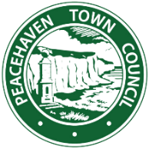
PUBLIC RIGHTS OF WAY FORM
Ref: PAE 26, Valley Lane, Peacehaven

For many years a track was in use along part of Valley Lane, shown on the Estate Plan, leading from The Lookout to Valley Road. This stretch of track is currently obstructed at both ends.
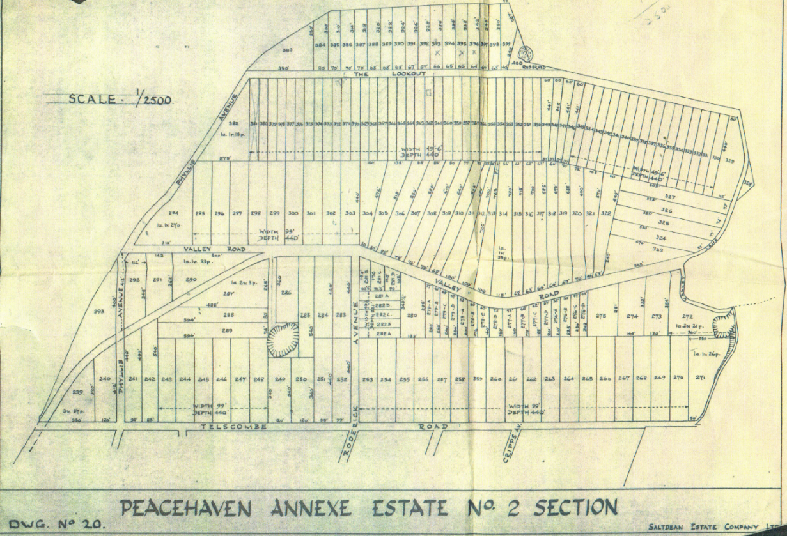
Estate Plan

Evidence of past usage is now being gathered with the aim of making an application to the County Council for the whole stretch to be added to the map of public rights of way and securing its reopening.
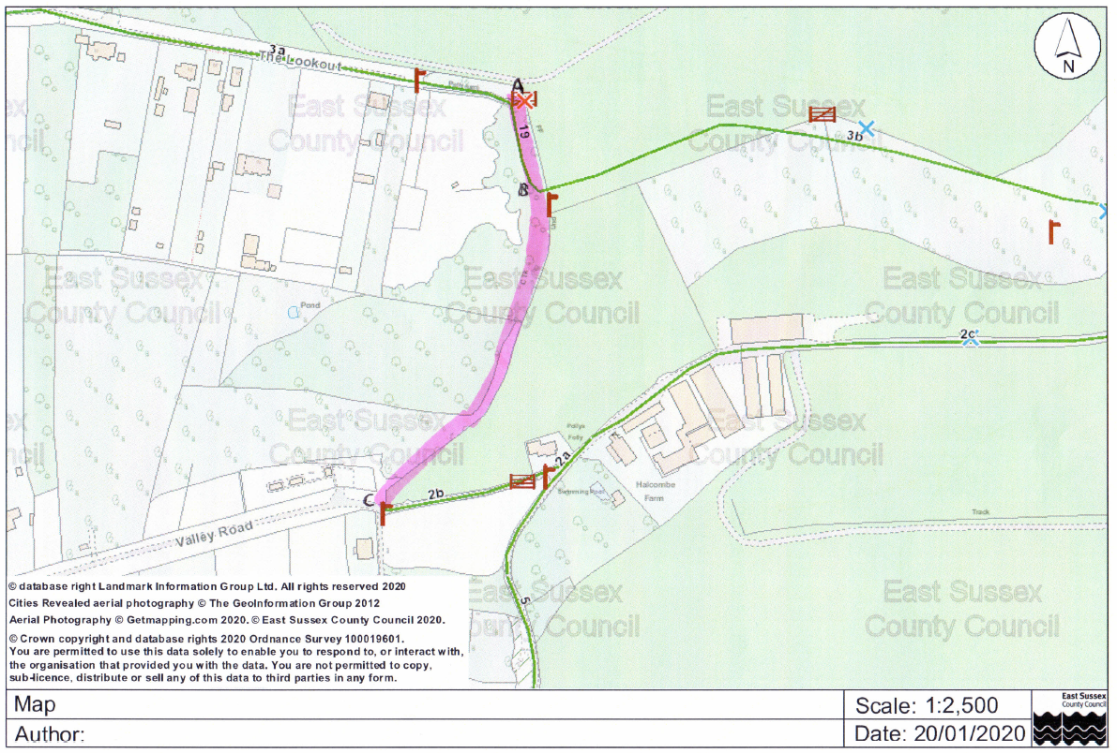
If you have used any part of this stretch of Valley Lane in the past, please mark the stretch used on the map below, initial and date it and answer the questions that follow.
A

B

C

The answers on this form are about a track in Peacehaven between The Lookout and Valley Road
- Did you use all of the route or just A – B or just B – C?

- Please give your name and age

- Please give your address

- During what period did you use the route?
From _________________ To _________________

- How did you use the route? On foot/bicycle/horse/motor vehicle?

- How often did you use the route? e.g. Daily/Weekly/Monthly. Please avoid using vague words like occasionally, try to be precise.

- What did you use the route for? e.g. Exercise, walk the dog, visit friends, go to the shop/school/bus etc

- How wide was the route?

- Did you encounter any gates or stiles on the route? If yes, please give details.

- Did you see any notices such as ‘Private’, ‘No Trespassing’, No Right of Way’ or similar on the route? If so please give dates and wording.

- Were you ever asked not to use the track? If so please give date and who asked you not to use it.

- Have you ever asked someone for permission to use the path? If yes please give date(s) and name(s) of person(s).

- The council may wish to talk to you to find out more about your use of the route. Would you be willing to talk to them about your knowledge of the route? If yes please give your telephone number or email address.

- Please give any further information you think may be relevant to your usage of the track.

Please sign here ………………………………………………….. Date …………………………….
Please return the form by hand or post to Peacehaven Town Council, Meridian Centre, Meridian Way, Peacehaven BN10 8BB or email a scanned and signed version to townclerk@peacehaventowncouncil.gov.uk
Peacehaven Town Council is committed to ensuring that your privacy is protected and will only use and store your personal data in line with the Data Protection Act 2018. We collect and use your personal data only for the purpose that you have provided it to us. We will not disclose your personal data to any third parties unless we need to do so to provide a service to you. This may include sharing your personal data with Peacehaven Town Council staff or Councillors, and East Sussex County Council.
Peacehaven Town Council’s Privacy Policy sets out how we collect, use, and securely hold your data, and can be viewed on the Council website or by visiting the Information Office at Community House, BN10 8BB, phone number 01273 585493. We will submit this form to East Sussex County Council (ESCC) who will process the information subject to their own data protection policy, which you can access by contacting ESCC directly. Information provided may pass into the public domain and therefore cannot be treated as confidential.

