Advertising Assets Specification
& Request Form

This document was agreed and adopted at Full Council on 19th March 2024.

Contents

Advertising Procedure………………………………………………………...........3
Planters………………………………………………………………………......4 & 5
A1 boards……………………………………………………………………......6 & 7
The Banner Boards at The Dell………………………………………………..8 & 9
Peacehaven Town Council’s Monthly E-News………………………………….10
Prices and Request Form……………………………………………………11 - 12

ADVERTISING PROCEDURE
2.1 Businesses who advertise with Peacehaven Town Council must:-
- Adhere to Peacehaven Town Council’s Advertising Policy.
- Adhere to the relevant specifications within this document.
- Complete and return the Advertisement Assets Request Form within this document to the Town Clerk at Peacehaven Town Council.
- On approval of the Advertisement Request Form, design their business advert, adhering to the relevant specifications within this document.
- Send a proof of the design to the Town Clerk for approval.
- Arrange production of the approved advert with a supplier of their choice, following the specifications within this document.
- Send the final advert to the Town Clerk.
2.2 This document will be reviewed at least once a year.

PLANTERS

The advertiser must arrange the production, and purchase, of their own sign, adhering to the specifications within this document.

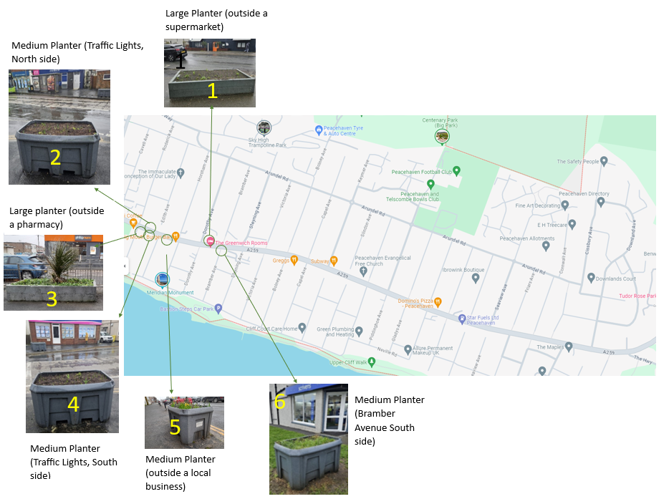
- Locations

south
- Location and Size

 | Item | Location (along A259) | Signage Size (inches)
1 | Large Planter | Outside a supermarket | 45w x 12h
2 | Medium Planter | Traffic Lights - North side | 30w x 16h
3 | Large Planter | Outside a pharmacy | 45w x 12h
4 | Medium Planter | Traffic Lights - South side | 30w x 16h
5 | Medium Planter | Outside a local business | 30w x 16h
6 | Medium Planter | Bramber Avenue - South side | 30w x 16h

Note: Each planter is available to one advertiser only.
- Medium Planter Signage Design

The design template below can be used as an example to follow.

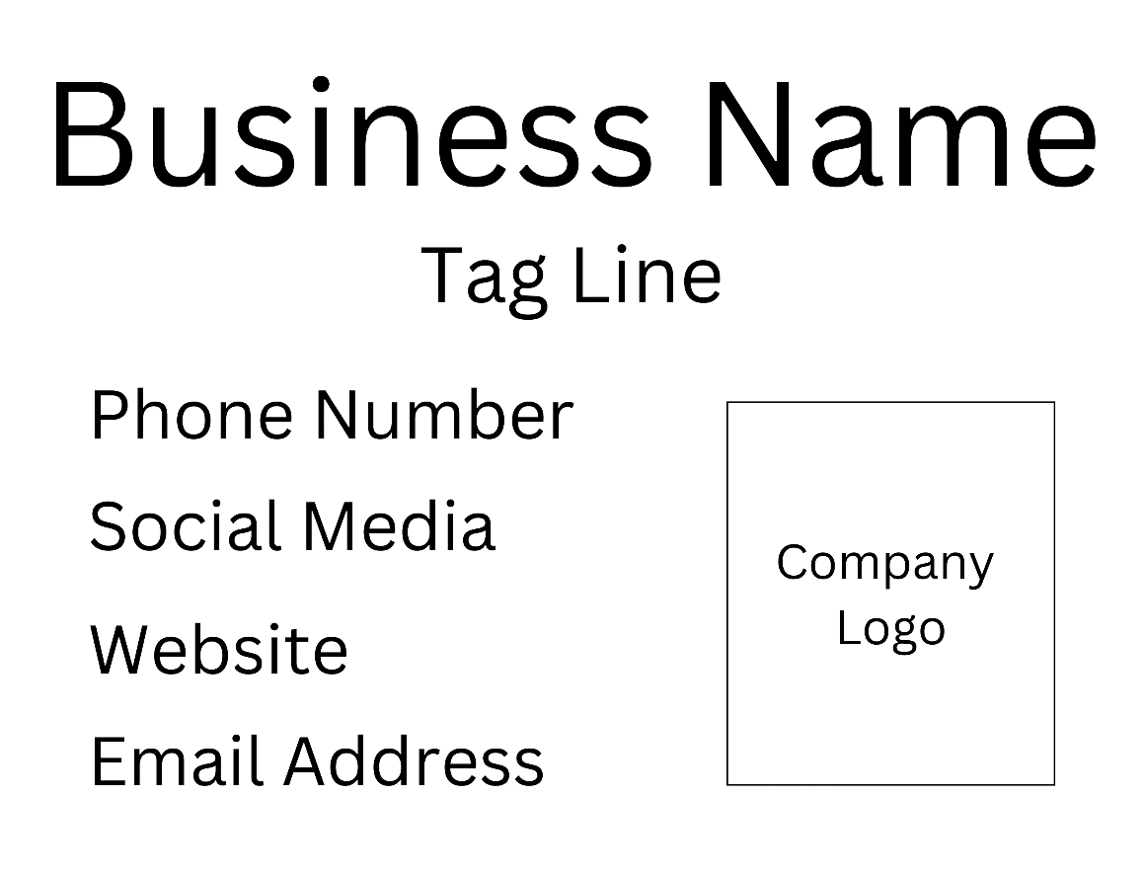

- Large Planter Signage Design

The design template below can be used as an example to follow.

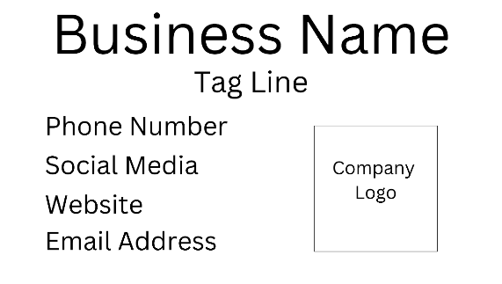

- Planter Signage Colours

- Background: White
- Font: Advertiser’s brand typeface
- Font colours: Advertiser’s brand colours
- Image (optional): Advertiser’s logo

- Planter Signage Physical Specification

- Aluminium Composite
- 3mm thickness
- 1 hole in each corner

A1 BOARDS

The advertiser must arrange the production, and purchase, of their own sign, adhering to the specifications within this document.

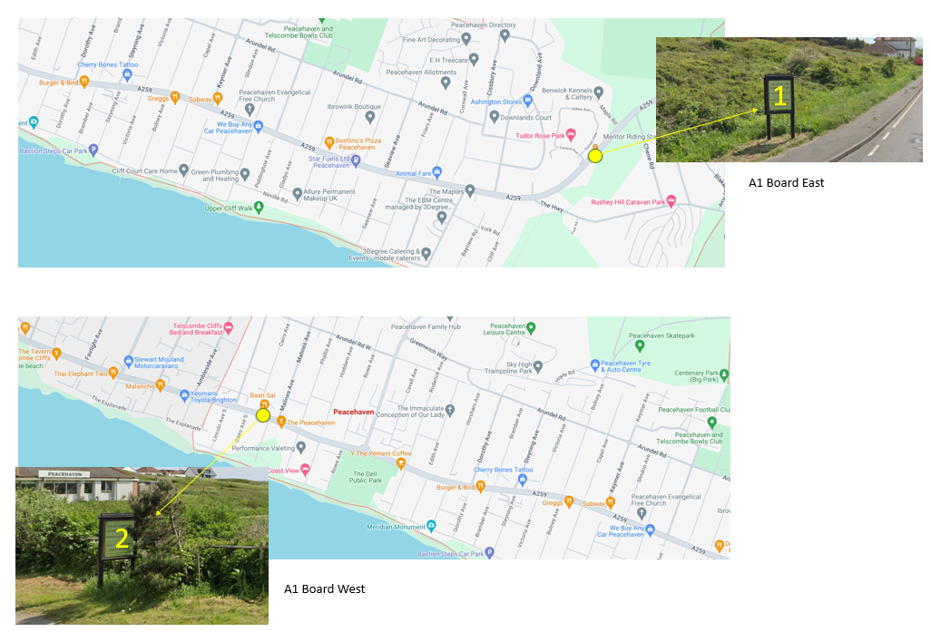
- Locations

2. Location and Size

 | Item | Location (along A259) | Signage Size
1 | A1 board East | East end of A259 | A1
2 | A1 board West | West end of A259

- A1 Boards Signage Colours

- Background: Advertiser’s own (for accessibility purposes a light bright background using black/dark font, or vice versa, is recommended).
- Font: Advertiser’s brand typeface
- Font colours: Advertiser’s brand colours
- Image (optional): Advertiser’s logo

- A1 Boards Physical Signage Specification

- Waterproof material
- To adhere to Peacehaven Town Council’s Single Use Plastic Policy

THE BANNER BOARDS AT THE DELL

The advertiser must arrange the production, and purchase, of their own banner, adhering to the specifications within this document.

1. Location

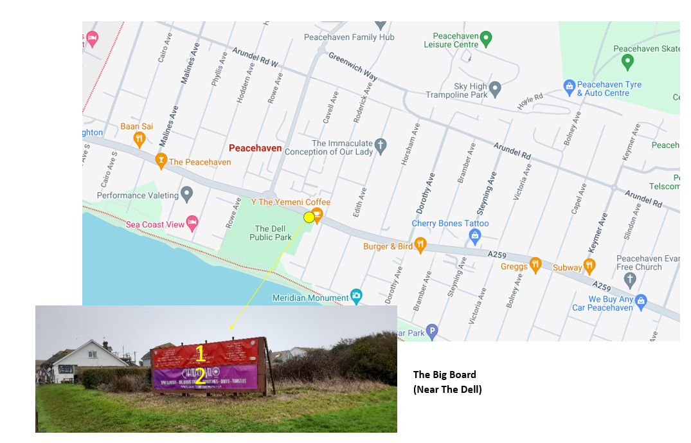
2
1

2. Location and Size
 | Item | Location (along A259) | Signage Size (cm)
1 | Banner Board Top | East end of A259 | 455w x 82.5h
2 | Banner Board Bottom | West end of A259

- Banner Board Colours
- Background: Advertiser’s own (for accessibility purposes a light bright background using black/dark font, or vice versa, is recommended).
- Font: Advertiser’s brand typeface
- Font colours: Advertiser’s brand colours
- Image (optional): Advertiser’s logo

- Banner Board Physical Signage Specification
- Waterproof material
- Eyelets
- Adhere to Peacehaven Town Council’s Single Use Plastic Policy

PEACEHAVEN TOWN COUNCIL MONTHLY ENEWS

The advertiser must provide the advert, adhering to the specifications within this document.

1. Location
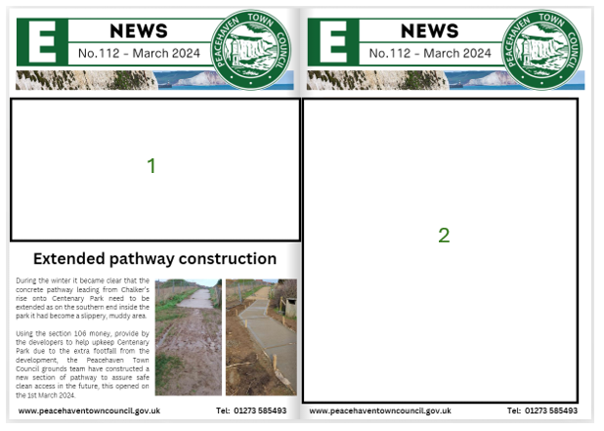

2. Size and Contract Duration

 | Item | Location
1 | E-News | Half Page
2 | E-News | Full Page

PRICES AND REQUEST FORM
Please complete the requested duration and total cost, and return to info@peacehaventowncouncil.gov.uk, or by post to:-
Information Desk, Peacehaven Town Council, Meridian Centre, Meridian Way, Peacehaven, East Sussex BN10 8BB

Item | Advertising Asset | Location (A259) | Minim Duration | Minimum Fee (ex VAT) | Requested Duration | Total Cost
1 | Large Planter | Outside Sainsbury’s | 1 year | Pavement side £200
2 | Medium Planter | Traffic Lights - North side | 1 year | Roadside/Pavement side  £200 for 1st sign,  £150 for a 2nd sign.
3 | Large Planter | Outside Kamsons | 1 year | Pavement side £200
4 | Medium Planter | Traffic Lights - South side | 1 year | Roadside/Pavement side  £200 for 1st sign,  £150 for a 2nd sign.
5 | Medium Planter | Outside a local business | 1 year | Roadside/Pavement side  £200 for 1st sign,  £150 for a 2nd sign.
6 | Medium Planter | Bramber Avenue - North side | 1 year | Roadside/Pavement side  £200 for 1st sign,  £150 for a 2nd sign.
1 | A1 board East | East end of A259 | Weekly | £15 total for both
2 | A1 board West | West end of A259 | Weekly
1 | Banner Board Top | The Dell | Weekly | £40
2 | Banner Board Bottom | The Dell | Weekly | £40
1 | E-news | Half Page | Monthly | £30
2 | E-news | Full Page | Monthly | £50

By signing this form I agree to adhere to this document, along with the Advertising Policy, and to be invoiced for the requested advertisement as soon as it is installed/published.
Potential Advertiser

Company Name: ______________________________
Contact Name: ______________________________
Job Title: ______________________________
Address: ______________________________
Email address: ______________________________
Contact Number: ______________________________
Date: ______________________________
Signature: ______________________________

For Completion by Peacehaven Town Council
Contact Name: ______________________________
Job Title: ______________________________
Email address: ______________________________
Date: ______________________________
Signature: _______________________

