Councillors on this Committee:
EX OFFICIO
Cllr D Seabrook, Cllr I Sharkey

Cllr N Fabry, Cllr A Harman, Cllr D Donovan, Cllr D Seabrook, Cllr I Sharkey,

19th April 2024
Dear Committee Member,

You are summoned to a meeting of the Grants Sub-Committee which will be held in the Anzac room, Community House on Thursday 25th April 2024 at 7:30pm

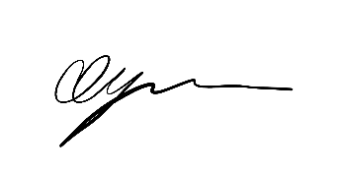

George Dyson
Town Clerk

A G E N D A

GENERAL BUSINESS

- GSC091 CHAIRS ANNOUNCEMENTS
- GSC092 PUBLIC QUESTIONS
There will now be a 15 minute period when members of the public may ask questions on any matters that affect the Town.
- GSC093 TO CONSIDER APOLOGIES FOR ABSENCE & SUBSTITUTIONS
- GSC094 TO RECEIVE DECLARATIONS OF INTEREST FROM COMMITTEE MEMBERS
- GSC095 TO APPROVE & SIGN THE MINUTES OF THURSDAY 16th NOVEMBER 2023
- GSC096 TO APPROVE SERVICE LEVEL AGREEMENTS (SLA) WITH CAB
- GSC097 VERBAL UPDATE ON GRANT RECEIPTS FOR 2023
- GSC098 TO DISCUSS AND AGREE RECOMMENDATIONS FOR GRANT APPLICATIONS FOR
ROUND 1 2024/2025
9 GSC099 DATE OF NEXT MEETING 14TH NOVEMBER 2024

