Councillors on this Committee:
EX OFFICIO
Cllr. D Seabrook, Cllr. I Sharkey

Cllr S Griffiths, Cllr D Donovan, Cllr D Seabrook, Cllr A Harman, Cllr I Sharkey

9th November 2023
Dear Committee Member,

You are summoned to a meeting of the Grants Sub-Committee which will be held in the Anzac room, Community House on Thursday 16th November 2023 at 7:30pm

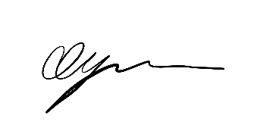

George Dyson
Town Clerk

A G E N D A

GENERAL BUSINESS

- GSC084 TO ELECT A CHAIR & VICE-CHAIR FOR THE SUB-COMMITTEE
- GSC085 PUBLIC QUESTIONS
- GSC086 TO CONSIDER APOLOGIES FOR ABSENCE & SUBSTITUTIONS
- GSC087 TO RECEIVE DECLARATIONS OF INTEREST FROM COMMITTEE MEMBERS
- GSC088 TO APPROVE & SIGN THE MINUTES OF THURSDAY 20TH APRIL 2023
- GSC089 TO DISCUSS AND AGREE RECOMMENDATIONS FOR GRANT APPLICATIONS FOR
ROUND 2 2023/2024
7 GSC090 DATE OF NEXT MEETING – THURSDAY 25TH APRIL 2024

