Councillors on this Committee:
EX OFFICIO
Cllr. L Symonds, Cllr. D Seabrook

Cllr C Cheta (Chair), Cllr S Griffiths, Cllr C Collier, Cllr A Milliner, Cllr D Seabrook, Cllr L Symonds

12th April 2023
Dear Committee Member,

You are summoned to a meeting of the Grants Sub-Committee which will be held in the Anzac room, Community House on Thursday 20th April 2023 at 7:30pm

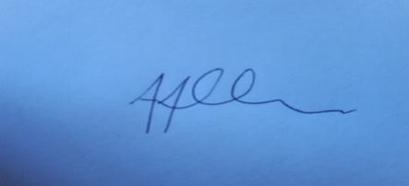

Tony Allen
Town Clerk

A G E N D A

GENERAL BUSINESS

- GSC074 CHAIRS ANNOUNCEMENTS
- GSC075 PUBLIC QUESTIONS
There will now be a 15 minute period when members of the public may ask questions on any matters that affect the Town.
- GSC076 TO CONSIDER APOLOGIES FOR ABSENCE & SUBSTITUTIONS
- GSC077 TO RECEIVE DECLARATIONS OF INTEREST FROM COMMITTEE MEMBERS
- GSC078 TO APPROVE & SIGN THE MINUTES OF THURSDAY 11TH JANUARY 2023
- GSC079 TO APPROVE SERVICE LEVEL AGREEMENTS (SLA) WITH CAB & CTLA
- GSC080 TO RECEIVE AN UPDATE REGARDING A PROPOSED SERVICE LEVEL AGREEMENT
- GSC081 TO NOTE THE GRANT RECEIPTS FOR SECOND ROUND 2022
- GSC082 TO DISCUSS AND AGREE RECOMMENDATIONS FOR GRANT APPLICATIONS FOR
ROUND 1 2023/2024
10 GSC083 DATE OF NEXT MEETING 16TH NOVEMBER 2023

