Councillors on this Committee:

EX OFFICIO Cllr. L Symonds (Chair of Council), Cllr. D Seabrook (Vice Chair of Council),

Cllr L Duhigg (Chairman), Cllr W Veck (Vice chair), Cllr L Symonds, Cllr J Harris, Cllr G Hill, Cllr K Sanderson

25th April 2023

Dear Committee Member,

You are summoned to a meeting of the Civic and Community Events Committee which will be held in the Anzac Room, Community House, Peacehaven on Tuesday 2nd May 2023 commencing at 7.00pm

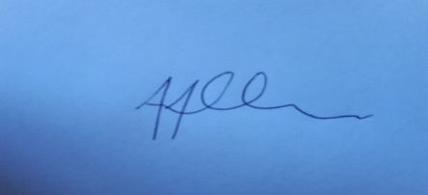
Tony Allen
Town Clerk
A G E N D A

- CCE280 CHAIRMAN’S ANNOUNCEMENTS

- CCE281 PUBLIC QUESTIONS
There will be a 15-minute period whereby members of the public may ask questions, on any relevant Civic & Community Event matters.

- CCE282 TO CONSIDER APOLOGIES FOR ANY ABSENCES AND SUBSTITUTIONS

- CCE283 TO RECEIVE DECLARATIONS OF INTERESTS FROM COMMITTEE MEMBERS

- CCE284 TO ADOPT THE MEETING MINUTES OF 11TH APRIL 2023

- CCE285 TO NOTE THE BUDGETARY UPDATE

- CCE286 TO NOTE COMMUNICATION REGARDING THE CAR BOOT SALE AT THE SUMMER FAIR.

- CCE287 TO RECEIVE A VERBAL UPDATE ON THE PLANNING OF THE SUMMER FAIR

- CCE288 TO DECIDE ON A WINTER EVENT

- CCE289 TO AGREE THE DATE OF THE NEXT CCE COMMITTEE 27TH JUNE 2023

