Councillors on this Committee:

EX OFFICIO Cllr. D Seabrook (Chair of Council), Cllr. I Sharkey (Vice Chair of Council),
Cllr Veck (Chairman) Cllr Donovan (Vice Chair), Cllr Alexander, Cllr Norcott-Jones,
Cllr Smith, Cllr Harman

14th June 2023

Dear Committee Member,

You are summoned to a meeting of the Civic and Community Events Committee which will be held in the Anzac Room, Community House, Peacehaven on Tuesday 20th June 2023 commencing at 7.30pm

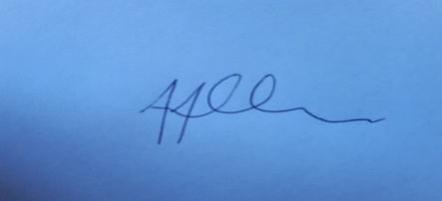
Tony Allen
Town Clerk
A G E N D A

- CCE305 CHAIRMAN’S ANNOUNCEMENTS

- CCE306 PUBLIC QUESTIONS
There will be a 15-minute period whereby members of the public may ask questions, on any relevant Civic & Community Event matters

- CCE307 TO CONSIDER APOLOGIES FOR ANY ABSENCES AND SUBSTITUTIONS

- CCE308 TO RECEIVE DECLARATIONS OF INTERESTS FROM COMMITTEE MEMBERS

- CCE309 TO ADOPT THE MEETING MINUTES OF 25TH MAY 2023

- CCE310 TO NOTE THE BUDGETARY UPDATE

- CCE311 TO RECEIVE AN UPDATE REGARDING PREPARATIONS FOR THE SUMMER FAIR

- CCE312 TO NOTE FEEDBACK FROM THE RECENT MEETING WITH PCS

- CCE313 TO RECEIVE AN UPDATE FROM THE HALLOWEEN TFG AND AGREE NEXT MEETING DATE

- CCE314 TO NOTE 2024 FLAG FLYING DATES

- CCE315 TO NOTE COMPLAINTS RELEVANT TO COMMITTEE RECEIVED SINCE LAST MEETING

- CCE316 TO AGREE THE DATE OF THE NEXT CCE COMMITTEE MEETING AS THE 1ST AUGUST 2023

