Dear Committee Member, 29th June 2022

You are summoned to LEISURE, AMENITIES & ENVIRONMENT COMMITTEE meeting to be held in the Anzac Room, Community House, Peacehaven on Tuesday 5th July 2022 at 7:30pm

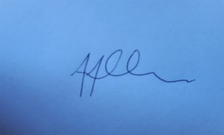

Tony Allen
Town Clerk

A G E N D A
GENERAL BUSINESS

- LA 695 CHAIRS ANNOUNCEMENT
- LA 696 PUBLIC QUESTION TIME
- LA 697 TO CONSIDER APOLOGIES FOR ABSENCE & SUBSTITUTIONS
- LA 698 TO RECEIVE DECLARATIONS OF INTEREST FROM COMMITTEE MEMBERS
- LA 699 TO APPROVE AND SIGN THE MINUTES OF THE MEETING OF THE LEISURE AND AMENITIES COMMITTEE MEETING HELD ON 31ST MAY 2022
- LA 700 BUDGET UPDATE
- LA 701 TO NOTE THE ACTION PLAN UPDATE
- LA 702 TO AGREE PARK RUN SIGNAGE REQUEST
- LA 703 TO DECIDE ON THE MUGA COURT SUMMER OPENING TIMES
- LA 704 VERBAL UPDATE CHANGING PLACES TOILET PROJECT
- LA 705 TO NOTE THE ALLOTMENT UPDATE
- LA 706 TO DECIDE THE OVAL AND EPINAY PARK SURVEY REPORT
- LA 707 TO NOTE THE GREEN INFRASTRUCTURE UPDATE REPORT
- LA 708 TO NOTE AND DECIDE ALLOTMENT POLICY
TO CONFIRM DATE OF NEXT MEETING AS THE 16TH AUGUST 2022

