Councillors on this Committee:

EX OFFICIO Cllr. L Symonds (Chair of Council), Cllr. D Seabrook (Vice Chair of Council),

Cllr L Duhigg (Chairman), Cllr W Veck (Vice chair), Cllr D Paul, Cllr E Simmons, Cllr L Symonds, Cllr J Harris, Cllr G Hill, Cllr K Sanderson

6th July 2022

Dear Committee Member,

You are summoned to a meeting of the Civic and Community Events Committee which will be held in the Anzac Room, Community House, Peacehaven on Tuesday 12th July 2022 commencing at 7.30pm

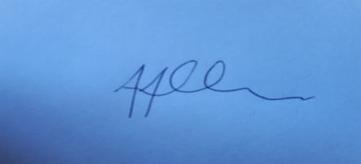
Tony Allen
Town Clerk
A G E N D A

- CCE190 CHAIRMAN’S ANNOUNCEMENTS

- CCE191 PUBLIC QUESTIONS
There will be a 15-minute period whereby members of the public may ask questions, on any relevant Civic & Community Event matters
Please email the Town Clerk to attend this meeting

- CCE192 TO CONSIDER APOLOGIES FOR ANY ABSENCES AND SUBSTITUTIONS

- CCE193 TO RECEIVE DECLARATIONS OF INTERESTS FROM COMMITTEE MEMBERS

- CCE194 TO ADOPT THE MINUTES OF 17th MAY 2022

- CCE195 TO NOTE THE BUDGETARY UPDATE

- CCE196 TO NOTE TO SELECT MEMBERS TO SERVE ON THE PEACEHAVEN HISTORY TASK AND FINISH GROUP (SEE AGENDA ITEM CCE174 & CCE182) – SUE MOSCATELLI
- CCE197 – TO NOTE A VERBAL UPDATE ON T&C’S FOR COMMUNITY HOUSE AND THE HUB – SUE MOSCATELLI
- CCE198 TO RECEIVE A VERBAL UPDATE ON PEACEHAVEN COMMUNITY SUMMER FAIR – SUE MOSCATELLI

- CCE199 TO NOTE CONTROL OF EVENTS BETWEEN PTC COMMUNITY AND MAYOR CIVIC - SUE MOSCATELLI / GEORGE DYSON

- CCE200 TO NOTE CIVIC UPDATE ON MAYOR, CHARITIES & EVENTS (SEE AGENDA ITEM CCE187) – GEORGE DYSON

- CCE201 TO AGREE CHRISTMAS PROPOSAL 2022 – SUE MOSCATELLI
- CCE202 TO DISCUSS COFFEE MORNINGS APPLICANTS AT COMMUNITY HOUSE - SUE MOSCATELLI
- CCE203 - TO NOTE THE UPDATED EVENTS CALENDER – SUE MOSCATELLI
- CCE204 – TO DECIDE AND APPROVE THE CREATION OF SOCIAL MEDIA ACCOUNTS FOR THE MAYOR

DATE OF NEXT MEETING OF THE COMMITTEE – 6th SEPTEMBER 2022

