18th May 2022

ANNUAL TOWN MEETING

Thursday 26th May 2022
At 7 p.m.
Main Hall, Community House

The 2022 Peacehaven Town Annual Assembly is being convened by
The Town Council.

All residents of Peacehaven are invited to attend.

A G E N D A

- Welcome delivered by Peacehaven Town’s Mayor, Councillor Lucy-Jo Symonds
- To approve and Sign the Minutes of the Annual Town Assembly, Tuesday 19th March 2019
- Address by Lloyd Russell-Moyle, MP
- Refreshment Break
- Public Questions to The Council
- Meeting Closes
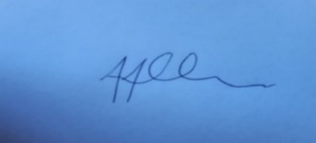

A. Allen, Town Clerk
A copy of the Annual Town Report is on the Council’s web site or available by request

