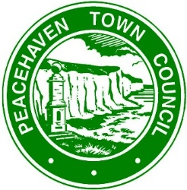
ASSISTANT CARETAKER REQUIRED

Peacehaven Town Council require a part-time caretaker to work a minimum of 15 hours, to include some evenings and Saturdays.
Based at the Council Building, Community House, you will also be required to operate from all PTC facilities. You will work within a team so a flexible approach to work is required as there will be a need to cover any sickness and holidays for colleagues. The nature of the work requires flexibility in outlook and approach to the work and the allocated shifts across the whole day.
A full driving licence is a requirement.
Your main tasks will include:
- cleaning offices
- toilets
- changing rooms
- kitchens
- meeting rooms
- working on a rota basis, possibly out of hours call out.
- knowledge of Health and Safety, including First Aid and Fire Warden
- security, locking and unlocking.
- Interpersonal skills a public facing role.
- minor maintenance
- setting up and un-setting meeting rooms
- lifting and moving furniture and equipment
- full training is available for the successful candidate.
The Council offers 22 days Annual Leave, Local Government Pension Scheme. Salary scale will be SCP5 – SCP8.

For an application form and job description, please either; telephone 01273 585493, call into the Information Office (Meridian Centre) or download from the PTC website. Closing date: for applications 12.00 noon on Friday 30th July 2021. Interviews will take place during week commencing 2nd August 2021. If your application is successful, you will be contacted and offered an interview.

