CIVIC OFFICE OF THE YEAR
2020

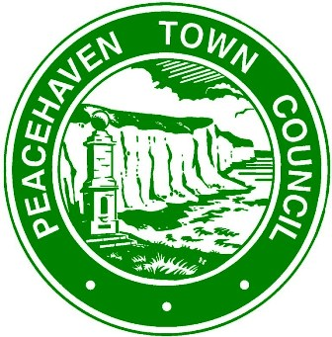

The Town’s History (in brief)
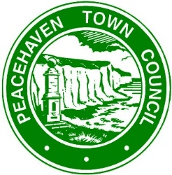
- In the week commencing 8thJanuary 1916 a series of advertisements appeared in local and national newspapers, inviting the public to name a new seaside resort. With this unusual public notice, the town of Peacehaven was conceived and unlike most babies it actually took a year to be born. Initially it was known as New Anzac-on-Sea, but due to a change in the law, it was changed by Mr Neville to Peacehaven on 12th February 1917.
- It was in the second half of 1915, that a certain Charles William Neville drove from Bexhill on Sea to Brighton and spotted the fields that became Peacehaven. Contrary to some reports in 1881, William Charles Neville Ussher was born in London, before changing his name. He is known to have spent his formative years in Canada. It was here that he learnt the businesses that became his career, real estate, as he would have called land development. With various partners he started to develop parts of Canada, he may even have tried his hand as a property developer in Australia. There are some mysteries about the man, such as when he returned to England? When he did it was as Charles William Neville land developer & financier.
- In 1915 there were very few buildings, a couple that may have looked like temporary buildings at the Friars Bay end of Peacehaven around Cissbury Avenue (this was initially known as – friars bay small holders’ cooperative colony). While at Telscombe a sales office for Cavendish Land Co. with just a very few other buildings. It was this “waste land” as it was that reminded Mr Neville of the wildernesses he had developed in Canada. He had an idea and immediately made arrangements to purchase 600 acres of Cavendish Land’s Piddinghoe estate. This was the basis of his new seaside resort.
- Advertisements were placed in nearly all newspapers offering a competition to name this new town, with a £100 first prize and fifty runners up prizes each of plots of land on the estate being sold for £50. However, each plot winner had to pay three guineas for the conveyance of the land. Interestingly there were 2 winners declared both of whom chose the name New Anzac-on-Sea. More surprisingly, the South Coast Land & Resort Company which at that point in time was the trading name of Mr Charles Neville decided to give away to 12,500 runners up the £50 plots on payment of £3 and 3 shillings, over 2000 people took up the offer.
- It was this change in competition rules along with a valuation of worthless that brought about a 3-year set of court cases between the Daily Express and Charles Neville. These cases went as far as The House of Lords at the time the highest court in the land. The result was immaterial in the end as Peacehaven as it became in 1917 was a huge success because of the court case publicity, the only downside was that the County War Agricultural Committee did not had back the land for building until early 1921, when the land was again divided into building plots and Peacehaven as we know it began in earnest. Today of course the land is not as claimed in court of no value, we all wish we could buy a plot for £50 or even 100 times that value!

- Our thanks to Peacehaven resident Stanley Bernard for producing this copy.
Introducing the
Mayor of Peacehaven
Cllr. Claude Cheta was elected Town Mayor in 2019.
Fig 1 (see Appendix)
During his 2019/20 term in office Claude raised an outstanding £12,000 which was shared with 4 charities: -
- The Community Transport scheme – this bus collects residents from their homes to take them shopping or to the doctors.
- Kempton House – this organisation arranges weekly lunches and entertainment for the elderly in the town
- CHILAX – a youth group, supporting all ages
- Know Dementia – A group for residents with Dementia or Alzheimer’s who started out with just 5 visitors when the group formed but with the support from the Mayor the group now holds a full subscription (over 50).
Our residents connected with the Mayor and to responded by sending him messages of gratitude.
The Mayor explained, that although he was due to hand over his Mayoral Chain to another member of the council in May (2020) he was asked to remain in office to keep stability. He received overwhelming support from his fellow councillors, organisations and the general public.
Claude was determined to extend his sincerity during 2020.
The Mayors support
(& the background)
Peacehaven is a small coastal town with a council consisting of just 14 members of staff and 17 Councillors. Councillors and staff strive to ensure that all Council operations are delivered in the most effective and efficient manner and comply with regulation and best practice.
The role of the Town Council is to ensure Peacehaven is a thriving community and a healthy, vibrant and attractive place in which to work, live and visit. The Town Council does this by working collaboratively, not only as an ambitious and committed team of councillors and officers, but also with a range of external strategic partners.
The Town Council is committed to providing excellence in the services and facilities which it delivers, aiming to be responsive, innovative, visible, accessible and straightforward in its approach.

Communication with the community is one of the council’s top priorities – hosting the Town Council website and social media feeds, responding to requests for information, consultations and promoting events.
The Council’s Civic Officer, Deborah Donovan supports the Mayor, keeps his diary, plans events to support and raise funds for his charities and keeps a tight rein on all social media posts.
Deborah also holds the responsibility of managing the office and caretaking staff. She has worked for the council for 19 years starting with just 9 hours a week. Over the years her hours suddenly increased and for the past 8 has worked full-time supporting the Mayor and managing the council’s marketing.
With new ideas and projects rapidly growing Deborah enrolled the help of Matt Gunn, the Council’s Communications Officer along with the Council’s Information Officer, Karen Bray. Figs 2, 3 & 4 (see Appendix)
Both Deborah & Matt have other responsibilities within the organisation too, so sometimes Civic life can be quite challenging, juggling a lot of balls is a regular occurrence!
Deborah is always available and enjoys her Civic position.
How we overcame lockdowns 1, 2 & 3
Engaging, celebrating, commemorating, promoting & supporting
Engaging:
It was essential to continue engaging with our Community and local businesses.
It became apparent through the first few weeks of coronavirus that some of our residents were finding it hard to survive. People’s wellbeing started to affect their everyday lives. Those who were used to spending time outdoors were now being cooped up at home.
However, Civic Officer, Deborah Donovan put her thinking cap on and encouraged the Mayor, Cllr. Claude Cheta to arrange weekly broadcasts to connect with the town’s folk.
The Mayor made compassionate videos each week which were broadcast on social media, giving our residents information and up-dates on what the council were doing behind the scenes to support the community during these uncertain times.
Our Civic and Community Events Chair thought that a time capsule could be buried with various charms and documents ascertaining to the changing world, but of course no-one was allowed out to meet with other people to enable us to meet and gather the materials together, so Deborah compiled and published a children’s time capsule workbook which could be completed at home with the family.
We decided to highlight a resident who had contributed towards helping the community each week. An example was a lady who made masks for our local hospital. We wanted to include those who were interested in photography so launched a daily walk photo which also encouraged residents to exercise. Figs 5 & 6 (See Appendix)
We kept in touch with our local businesses by attending the Chamber of Commerce breakfast meetings via zoom and social media. Most of our business was conducted either via zoom or teams, we actually found that we were far busier throughout the year. Our relationship with the Chamber became much stronger and we found their support invaluable especially their contribution towards our Children’s Christmas Box Appeal later on in the year.
The Mayor attended zoom meetings with the Lord Lieutenant and other local Mayors where possible.
Figs 7 & 8 (see Appendix) shows the Mayor visiting Barratt Homes new development in Peacehaven.

Celebrating & Commemorating

We found our planned events were soon put on the back burner, but this didn’t deter the Civic Officer; Deborah was determined to include the community in celebrating V E Day on 8th May and V J Day on 15th August.
The Mayor attended short private services on both occasions and laid wreaths to commemorate these important events and encouraged residents to hold their own celebrations in their front gardens.
These events proved to be very successful. Red, White & Blue lit up the town in every street, avenue & road. We posted residents pictures on social media and in our council’s magazine.
Figs 9, 10 & 11 (see Appendix)
On 16th June we marked Sussex Day, our county day – this was a chance to celebrate our rich heritage and culture, it’s also St Richard's Day, The Patron Saint of Sussex, we celebrated a lovely little slice of this amazing county! Fig 12 (see Appendix)

Check out our social media platforms and website:
Facebook account: Peacehaven Town Council
@PeacehavenMayor and @PTCinformation
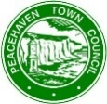 www.peacehaventowncouncil.gov.uk
Peacehaven Town Council Newsletter
Contact: Mayors PA, Deborah Donovan, civicandmarketing@peacehaventowncouncil.gov.uk

Promoting and supporting

By the time we reached May it was pretty evident that some of our residents were finding life hard, especially those who were shielding or finding it difficult to cope with the situation we were experiencing.
The Mayor, Claude Cheta connected with our local Covid-19 Mutual Aid Group to find out how he could help get food parcels to the right people, he decided, to make an immediate donation of £1,000 to the Seahaven Food Bank, he decided this would be the only charity to support for during his second term. The urgent need for supplies were vital for residents in Peacehaven and the surrounding areas.
Claude was so passionate about helping the locals that he decided to launch his own campaign to help those in need. Our social media posts made the newspapers:
The Mayor of Peacehaven, Cllr. Claude Cheta has launched a campaign asking residents to donate either a tin or jar of food which will be delivered to the Seahaven Food Bank.
Cllr. Cheta has picked this charitable organisation to support whilst in post as Peacehaven Town Mayor.
Peacehaven Town Council are open for donations every weekday morning at Community House, Meridian Centre; however, we understand that the normal way of life has drastically changed over the past three months and it may be difficult to carry out a shopping trip to the supermarket. Bearing this in mind, we have also set up a GoFundMe account so you can donate direct to the Mayor’s appeal without having to leave the house.
Either way it will help this vital cause. The Seahaven Foodbank covers the Havens which includes Peacehaven clients.
Seahaven Foodbank, also known as Newhaven Foodbank, provides food parcels to families and individuals in Newhaven, Sussex, and the surrounding areas.
The falloff in food donations caused by the Covid-19 crisis and the jump in demand that we have seen for the service has meant that the food bank has had to start buying food and other essential products. This, together with the need to move to a delivery model and the widening of the geographical area served, has increased costs significantly. A financial donation will enable supplies to be purchased and distributed to those who are struggling and vulnerable. A food parcel for an individual for one-week costs £14, or £18 with toiletries.
All donations to the Mayor’s GoFundMe page will go directly to the food bank.
More information about Sussex Community Development Association:
SCDA works across East Sussex delivering community based services aimed at addressing the needs of the most vulnerable in the community, including Young people's activities, youth club, specialist counselling Info and Advice Hub in Newhaven Seahaven Food Bank Counselling services Support for survivors of suicide Safe from Harm Community activities, courses and events Employability projects Denton Island Nursery Family and children's activities and events for BAME communities
See www.sussexcommunity.org.uk for more information.

Seahaven Food Bank – The Mayors Charity
Fig 13 (see Appendix)
We almost achieved our GoFundMe money target, but all the time Claude was thinking of new ways to help the residents of Peacehaven. So, In August we launched the 5k Walk, cycle or run campaign. Every week the Mayor would run 5k and publish a video to encourage the public to exercise during these uncertain times. All he was asking for was a donation to the food bank.
Figs 14 & 15 (see Appendix)
As soon as the government gave permission to hold outdoor markets and car boot sales, Deborah arranged the first event for Claude on 1st August. It was a fantastic success raising £254 towards the food bank. And we were once again engaging with the community.
Claude continued to run throughout August & suddenly we found that our residents were running with him too. It was a great feeling of satisfaction and the food bank was receiving extra donations at the same time.
The Mayors video broadcasts were reaching up to 6k readers on social media which was fantastic promotion for the Civic Office.
September was soon upon us; our office staff were continuing to work from home where possible. Children were able to go back to school, so we wondered how we could interact with our younger residents. As Halloween was fast approaching, we decided that we should promote a pumpkin competition. We advertised and received a number of scary entries along with donations for the food bank. It was a fantastic incentive for the children, see Figs 16, 17 & 18 (see Appendix)
Our local horticultural society also joined in and decorated our indoor garden. Fig 19 (see Appendix)
Footballer Marcus Rashford’s campaign to support free school meals during the Autumn holiday raised a lot of interest throughout the country, and in our small town too! We did everything we could to support this project which was run locally by Peacehaven & Telscombe Football Club. Our local schools also donated warm coats which had been left unclaimed in their lost property for some time. Claude wanted to personally thank everyone who was involved in this project, he made a visit to the Football Club and was astounded to see such a fantastic response from our residents; bags & boxes of donated food & drinks, he was overwhelmed. We can honestly say ‘No child went without’ in Peacehaven. Figs 20 & 21 (see Appendix)
The Mayor also dropped into our local after school club (CATS CLUB) to show his support, he spent an hour talking to children. Figs 22 & 23 (see Appendix)

During the same week Claude made a visit to the Food Bank to see where the donations were sorted and how they were being distributed.
Food donations continued to be delivered to our council offices by individuals and organisations too. Figs 24 & 25 (see Appendix)
Once we had knowledge of a further lockdown, our local Older People’s Day Club, Kempton House decided that they would make meals for their members and one of the local Mutual Aid organisations joined forces to deliver the meal packages.
We have a fantastic community spirit.
Our Remembrance Day had been very carefully planned; Deborah decided that no organisation should go without attending the war memorial site to lay a wreath on Sunday 8th November. She organised the event with everyone in mind. The Royal British Legion accompanied by the Mayor and neighbouring Mayor to lay their wreaths first and attended a short service performed by the Revd. Tim Mills. Soon after 6 other representatives from the Royal Navy, Home Guard, Airforce, Merchant Navy, and the MP visited to lay their wreaths and then every 10 minutes throughout the afternoon organisations attended to lay their tributes. Dignitaries and organisations laid 32 wreaths in total, the event was organised in precise detail ensuring the safety of our residents and veterans.
The Co-op Funeral care (Caring lady) donated material for the local Sussex Volunteer Crafters to make poppy masks for our council which raised £200, we donated this sum to the Royal British Legion.
Figs 26, 27, 28, 29 & 30 (see Appendix)

An email of thanks from our local branch of the Royal British Legion: -
Dear Debbie,
On behalf of the branch may I thank the Town Council, the Sussex Volunteer Crafters and Co-op Funeral Care (Caring lady) for the contribution to the Poppy Appeal.
We really appreciate this contribution as every penny helps to assist the Royal British Legion to deliver much needed services to ex-service men and woman plus their dependents.
What makes it more appreciated this year is that funds are collected under difficult circumstances due to Covid-19 and we as a branch are proud to be part of the Peacehaven and Telscombe Community.
Thank you for all your assistance. Kind regards,
Johan Janse van Vuuren
Branch Chairman
The Royal British Legion

Christmas
Normally our council building & the adjoining shopping centre would be full of around 90 market stalls, a Santa’s grotto and entertainment throughout our Christmas Fair Day, of course, we had to make alterations to our plans. After some thought, we decided to organise a Children’s Christmas Gift Box Appeal: Fig 31 (see Appendix)

The Mayor’s first December broadcast

We had a selection of Christmas masks on sale for £2.50, in aid of the food bank, these were made by the Sussex Volunteer Crafters. Fig 32 (see Appendix)

Video of the Mayor thanking our volunteers who were sorting and wrapping the donated gifts
Figs 33 & 34 (see Appendix)
Picture of the Lions Club collecting some of our Children’s Christmas Gift Boxes Fig 35 (see Appendix)

We were included in the thank you video produced by Sussex Community Development Association (SCDA) We were completely amazed that we had wrapped 183 gift boxes for our local children.

We wanted to support our elderly residents over the Christmas period too. So, we joined forces with a local Estate Agent, Open House, who with the Mayor supplied items to Kempton House Day Centre for hampers and donated money so anyone who was on their own on Christmas Day received a 2-course cooked Christmas Dinner. The Mayor helped deliver the meals. Figs 37 & 38 (see Appendix)

Our community have been absolutely marvellous throughout the pandemic; they donated cash, they volunteered, they donated items which has brought the town together and made a much stronger community. Our local radio station Seahaven FM supported the appeal and broadcast the need for items. One of our local Barbers (Maverick Barber Lounge) decided that on the Monday before Christmas they would donate half of their takings (£620) to the Seahaven food bank.

The Mayor’s Christmas video

Throughout the pandemic Peacehaven’s Mayor has been proactive, he has been communicating with businesses, the elderly, the youngsters, local organisations, our Churches and the general public, he offered help where needed and was available for his community. Council business never stopped, all committee meetings were and are continuing to be held via zoom. We are currently waiting for news from the NHS Project Manager who met with Deborah before Christmas to discuss the possibility of using our venue to administer the vaccine programme. Even though we are in lockdown 3 the Civic Office is forward planning events for the coming months, hopefully the Town will come together to celebrate when we are back to some normality. Peacehaven is certainly not a sleepy coastal town!

The Mayor’s New Year video

Supporting statement from the Mayor, Cllr. Claude Cheta

“Debbie you are to me what Messi is for Barcelona! “

Supporting statement from the Town Clerk, Tony Allen

Having been a Parish Clerk for 15 years and now Town Clerk at Peacehaven for nearly two years, I am always amazed and very proud of the dedication and professionalism of our Civic Officer, Deborah Donovan, and her support team.
Debbie expertly guides and supports our Mayor in all things and the emphasis is quite rightly on community support and enhancement. Debbie’s team are highly experienced and ensure delivery of the various Mayoral projects and initiatives and their promotion via our web site and social media feeds. Debbie is a highly experienced Civic Officer and a very active member of NACO. This is also recognised by her peers and her help and advice is often sought by other Councils.
I think that for Debbie and her team to be awarded ‘Civic Office of the Year’ would been well earned and a very fitting recognition of fully delivering and appropriately discharging Civic duties in a thriving Town, but one which has many needs and challenges.
Email received from the Chair of Policy & Finance & District Councillor Cllr. Chris Collier:
Debbie, reference the Civic work that Peacehaven Town Council has carried out this year I think should be a beacon to the whole district. In spite of everything, you’ve raised the profile of the Mayor and turned him into a voice for the town. You’ve also managed to continue to raise money which is quite brilliant. At the Remembrance Day event, the pride you take in your role was clear for all to see. Many thanks.
Appendix
Photographs
Fig 1
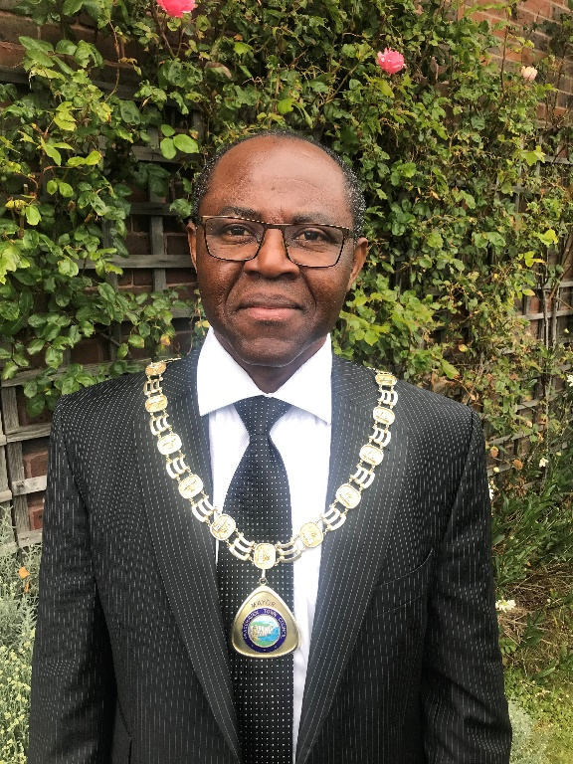

Figs 2, 3 & 4

Figs 5 & 6

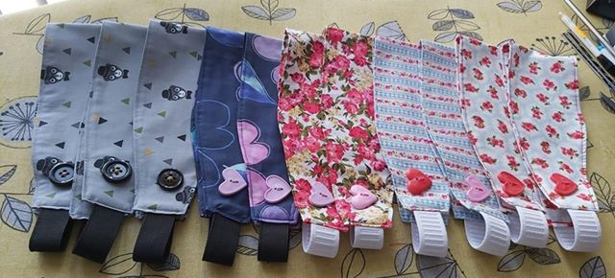

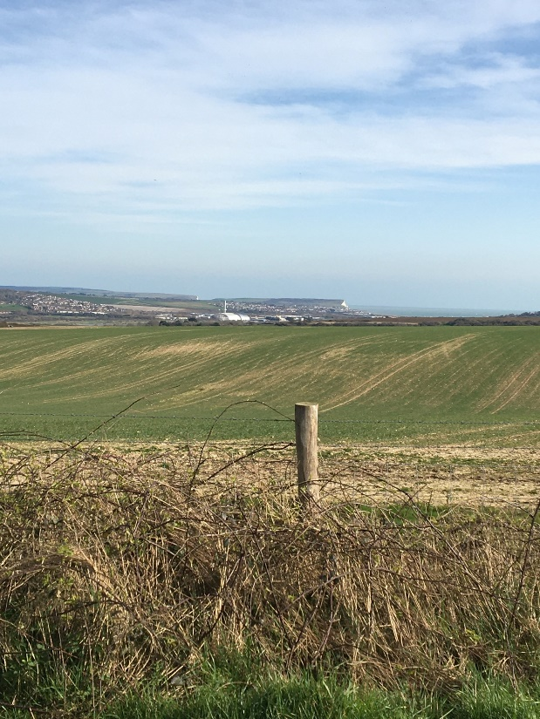

Figs 7 & 8
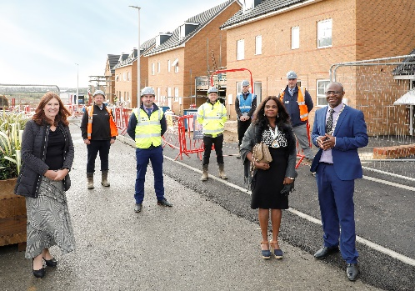

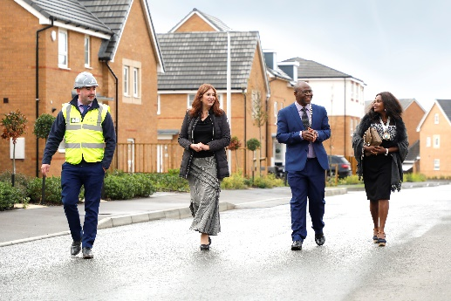

Figs 9, 10 & 11
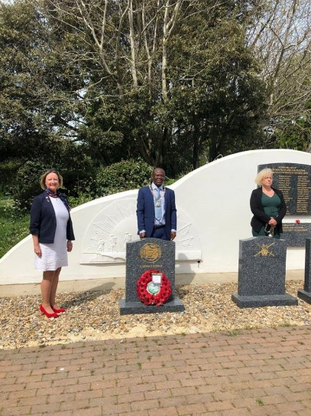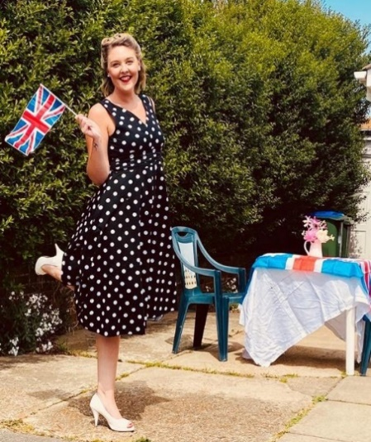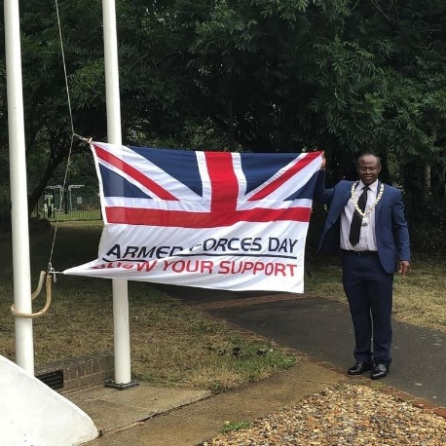

Fig 12

Fig 13
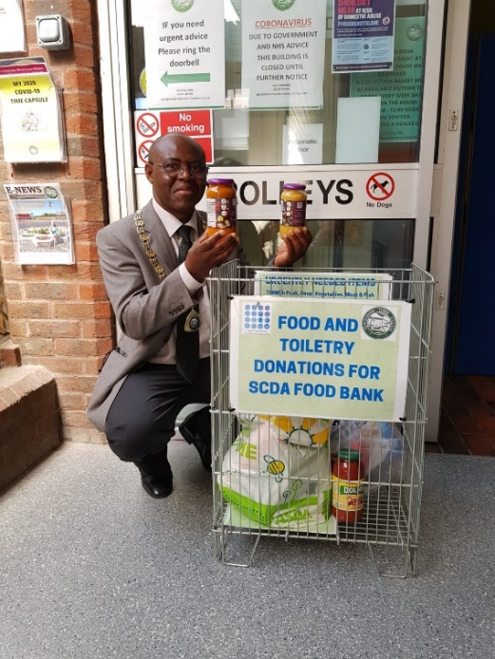

Fig 14 Fig 15
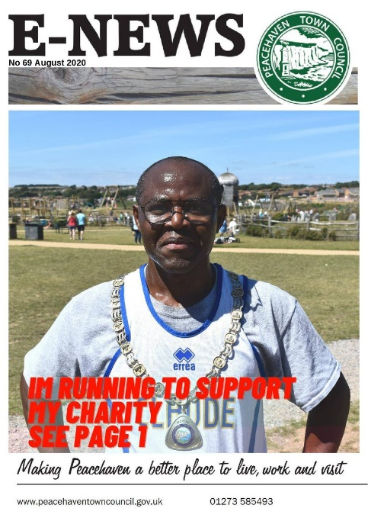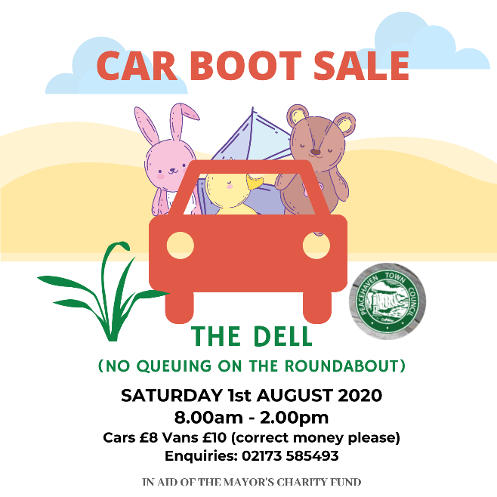

Figs 16, 17 & 18

Fig 19
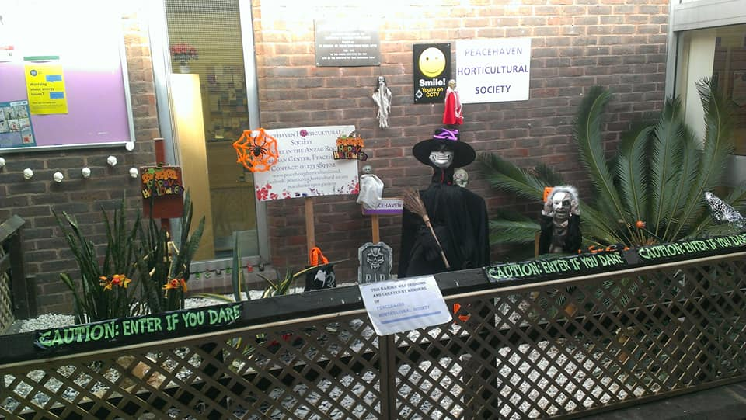

Figs 20 & 21

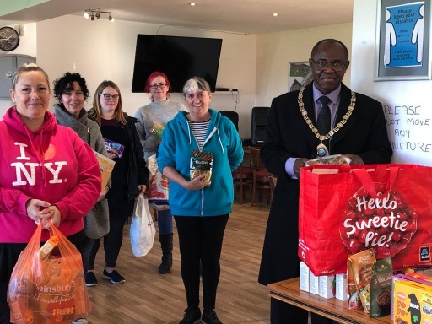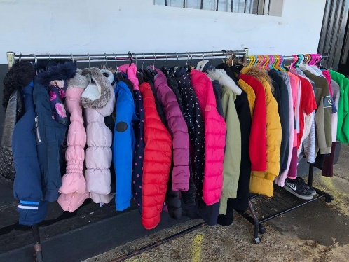

Figs 22 & 23

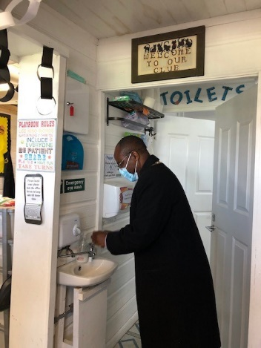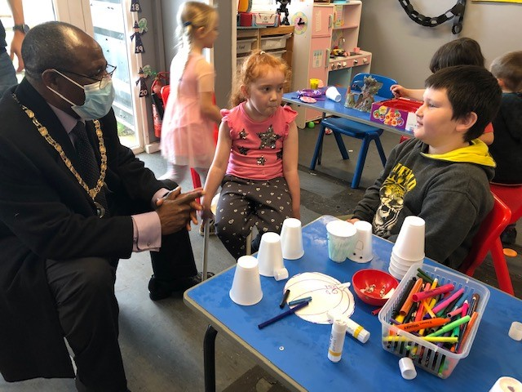
Figs 24 & 25
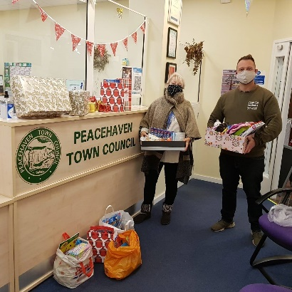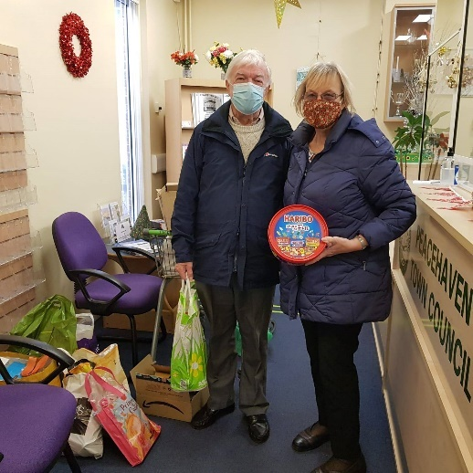

Figs 26, 27, 28, 29 & 30
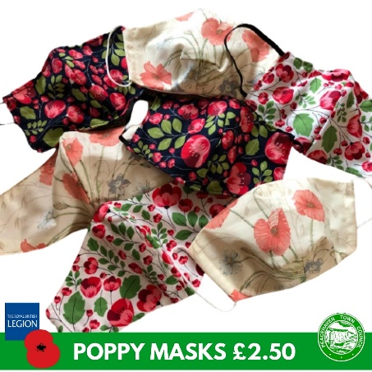

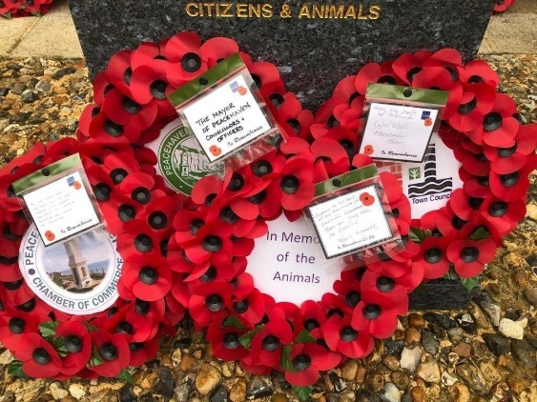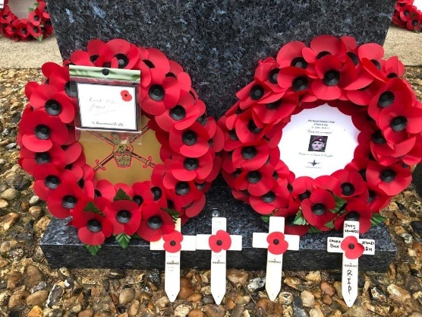

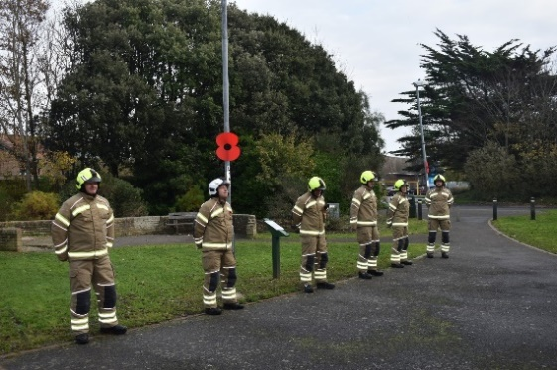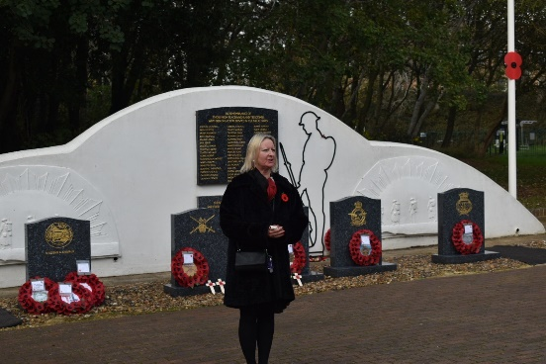

Fig 31

Fig 32

Figs 33 & 34
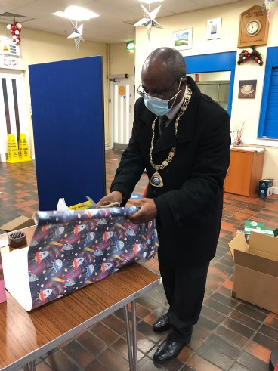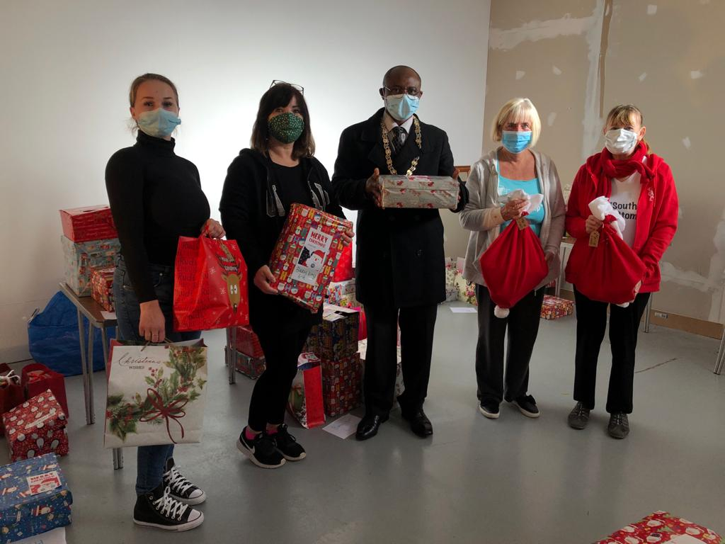

Fig 35
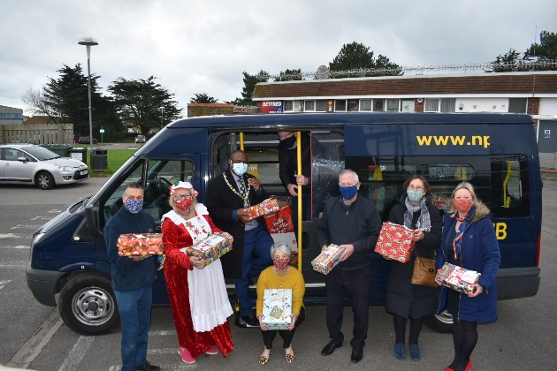

Figs 36 & 37
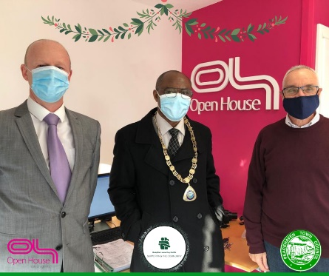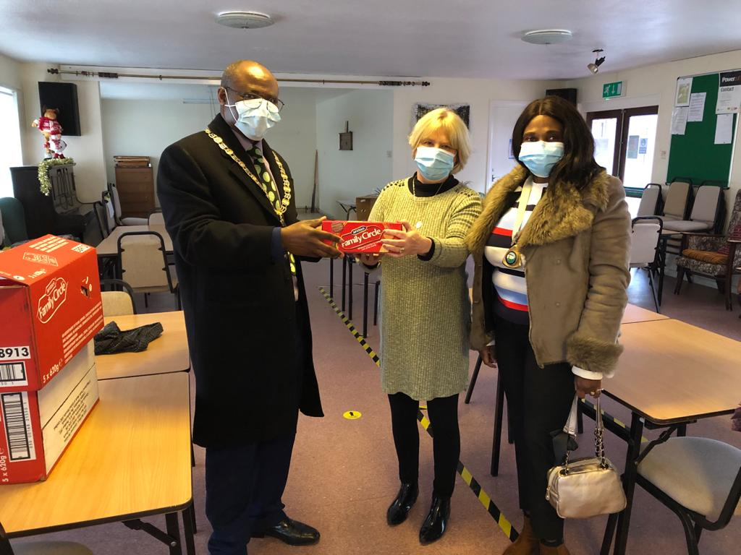

https://www.facebook.com/236861203082964/videos/521069302150094
https://www.peacehaventowncouncil.gov.uk/childrens-time-capsule-workbook/
https://www.peacehaventowncouncil.gov.uk/wp-content/uploads/2020/04/E-News-May-2020.pdf https://www.peacehaventowncouncil.gov.uk/wp-content/uploads/2020/07/E-News-August-2020.pdf https://www.facebook.com/PeacehavenTownCouncil/videos/2168416649968913
https://www.peacehaventowncouncil.gov.uk/e-news-magazine/
https://www.facebook.com/PeacehavenTownCouncil/videos/1757118041092947
https://www.peacehaventowncouncil.gov.uk/wp-content/uploads/2020/07/E-News-August-2020.pdf
https://www.facebook.com/PeacehavenTownCouncil/videos/1180111135677353
https://www.facebook.com/PeacehavenTownCouncil/videos/301168021173989
https://www.facebook.com/PeacehavenTownCouncil/videos/1351181521889115
https://www.facebook.com/PeacehavenTownCouncil/videos/4114382471908379
https://www.facebook.com/PeacehavenTownCouncil/videos/380755613046016
https://www.facebook.com/PeacehavenTownCouncil/videos/280968043237724
https://www.facebook.com/PeacehavenTownCouncil/videos/449120256479654
https://www.facebook.com/PeacehavenTownCouncil/videos/1225062447894943
https://www.facebook.com/PeacehavenTownCouncil/videos/403551217623021
https://www.facebook.com/maverickbarberco/videos/414036403131170
https://www.facebook.com/PeacehavenTownCouncil/videos/1729570830534420
https://www.facebook.com/PeacehavenTownCouncil/videos/156697786216312

