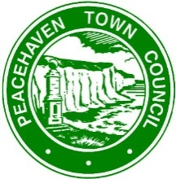
Nomination Form

Peacehaven Community Award 2021

To be submitted by Friday 16th April 2021

THE PERSON NOMINATED:
Name:
Address: (must be a resident of Peacehaven)

Telephone Number:
E-mail:
Age (if known)
FIRST PERSON MAKING THE NOMINATION
Name:
Address:

Postcode:
Telephone Number:
E-mail:
SECOND PERSON MAKING THE NOMINATION
Name:
Address:

Postcode
Telephone
E-mail
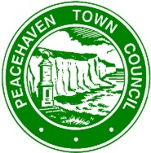
Peacehaven Community Award 2021

- To help the panel decide who deserves this award, please explain how many people benefited from the help of your nominated person, and how this was achieved:

- Please explain why you think the person you are nominating should receive the award

- How long has the person you have nominated been worked in the role you have nominated them for?

- How long have you known the person you have nominated?

How the information you provide will be used:
General Data Protection Regulations – Any personal information such as name, postal address, telephone number, and email address given via this nomination form will only be used to provide a requested service, kept for as long as necessary to provide that service and will not be disclosed to any other third party without your prior permission or unless we are required to do so by law.

