Peacehaven Town Council
Meridian Centre, Meridian Way
Peacehaven, East Sussex, BN10 8BB
Tel: 01273 585493
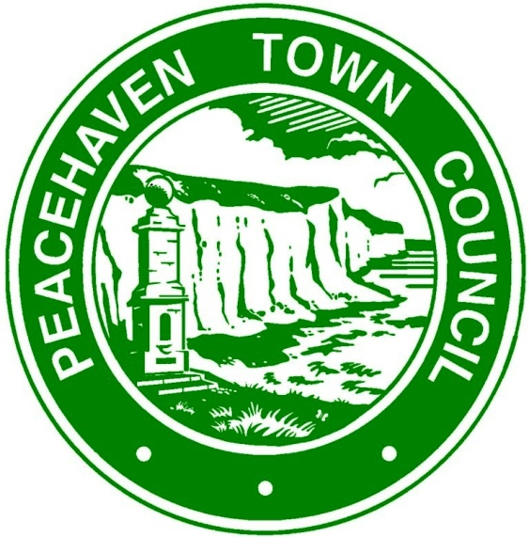

EMERGENCY COMMUNITY GRANT
APPLICATION FORM

The Town Council invites grant applications, which primarily support local organisations and which directly benefit residents of the Town.
1. NAME OF ORGANISATION: ………………………………………………………………………….
If application is granted, payments will be made by cheque:
Account Name Payee:……………………………………………………………………………………
Postal Address to send cheque to…………………………………………………………………….
……………………………………………………………………………………………………………….

2. ADDRESS:
Contact Name: ………………………………………………………………………………………………
Email Address: .…………………………………………………………………………………………….
Telephone Number: …………………………………………….

3. VAT REGISTERED: YES / NO

4. REGISTERED CHARITY: YES / NO  Charity Registration No: ……………………….. |  | 5. DATE ORGANISATION ESTABLISHED:

6. DESCRIPTION OF ORGANISATION INCLUDING AIMS

7. MEMBERSHIP

Total Membership / Service Users: …………………….

Membership / Service Users resident in Peacehaven …………………..

8. REASON FOR GRANT REQUEST:
(Details to be provided of how the grant will be used. How many Peacehaven residents will benefit from this application? Please include financial information to support your request.)

9. AMOUNT OF GRANT REQUESTED
(See Peacehaven Town Council Emergency Community Grants Policy. If you are registered for VAT, it should not be included in the amount requested)

10. WHO HAVE YOU APPLIED TO FOR OTHER GRANTS RELATING TO COVID:
(e.g. organisations applied to and amount requested / amount received)

11. HAVE YOU APPLIED TO LEWES DISTRICT COUNCIL FOR A COVID RELATED GRANT?

12. FINANCIAL INFORMATION:
(Please complete details below)
NOW
Current Assets
Current Cash Balance
Current Income
Current Expenditure

Signature ……………………………............. Date …………….........
(person authorised to apply for and on behalf of the organisation named in Item 1)

Please return your completed form to Peacehaven Town Council, Meridian Centre, Meridian Way, Peacehaven, BN10 8BB or email to townclerk@peacehaventowncouncil.gov.uk

