Peacehaven Town Council
Meridian Centre, Meridian Way
Peacehaven, East Sussex, BN10 8BB
Tel: 01273 585493
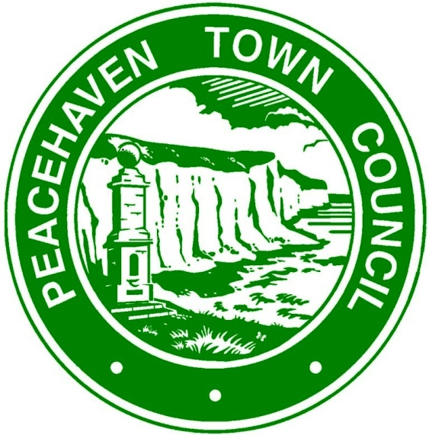

GRANT APPLICATION FORM

The Town Council invites grant applications, which primarily support local organisations and which directly benefit residents of the Town.
1. NAME OF ORGANISATION:
If application granted, please provide bank account details. All grants will be paid by BACS transfer:
Account Name: ……………………………………………………………………………………………..
Sort Code: ………………………………………………
Account Number: ……………………………………..

2. ADDRESS:
Contact Name: ………………………………………………………………………………………………
Email Address: .…………………………………………………………………………………………….
Telephone Number: …………………………………………….

3. VAT REGISTERED: YES / NO

4. REGISTERED CHARITY: YES / NO  Charity Registration No: ……………………….. |  | 5. DATE ORGANISATION ESTABLISHED:

6. DESCRIPTION OF ORGANISATION INCLUDING AIMS

7. MEMBERSHIP

Total Membership / Service Users: …………………….

Membership / Service Users resident in Peacehaven …………………..

8. REASON FOR GRANT REQUEST:
(eg. details of project together with numbers of those involved in the project, members and/or others, equipment, event, How many Peacehaven residents will benefit from this application?)

9. PROJECT END DATE: …………………………………………

10. AMOUNT OF GRANT REQUESTED
(See Peacehaven Town Council Grants Policy. If you are registered for VAT, it should not be included in the amount requested)

11. ENVIRONMENTAL IMPACT
(The council has declared a “Climate Emergency”, how will your grant contribute to limiting the effects of climate change? Does your project have any negative effects on climate change and how will you mitigate this?)
12. WHO HAVE YOU APPLIED TO FOR OTHER GRANTS:
(e.g. organisations applied to and amount requested / amount received)

13. DETAILS OF PREVIOUS GRANT APPLICATIONS TO PEACEHAVEN TOWN COUNCIL:
(if you received a grant last year please provide details of how it was used)

14. FINANCIAL INFORMATION:
(Please complete details below and either attach last year’s audited accounts or audited summary of accounts for your organisation).
 | NOW | ONE YEAR AGO
Current Assets
Current Cash Balance
Annual Income
Annual Expenditure

Signature ……………………………............. Date …………….........
(person authorised to apply for and on behalf of the organisation named in Item 1)

Notes:
The Town Council considers grant applications from local organisations each year and successful applications do not imply an automatic future success – each is considered on its merits and against availability of funds. Please see Peacehaven Town Council Grants Policy.

Depending on circumstances, organisations that are successful in their grant application may be invited to attend a presentation ceremony for publicity purposes.

Please return your completed form to Peacehaven Town Council, Meridian Centre, Meridian Way, Peacehaven, BN10 8BB or email to townclerk@peacehaventowncouncil.gov.uk

