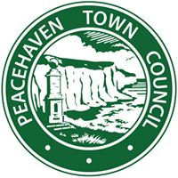
PEACEHAVEN TOWN COUNCIL
TOWN COUNCIL OFFICE
MERIDIAN CENTRE
MERIDIAN WAY
PEACEHAVEN
EAST SUSSEX
BN10 8BB

Tony Allen
TOWN CLERK
TELEPHONE: (01273) 585493
FAX: 01273 583560
E-MAIL: Townmanager@peacehaventowncouncil.gov.uk

Commercial Health & Fitness Activities in Parks

Introduction
Peacehaven Town Council has introduced a charging scheme for commercial activity providers (i.e. who charge clients for services) who wish to use its parks and greenspaces. This licence is primarily intended for health & fitness class operators.
In recent years outdoor personal health & fitness classes, boot camps and other forms of commercial activity have become increasingly popular in our parks and greenspaces. Whilst acknowledging that these types of activities can be good for the health and wellbeing of residents the Council wants to ensure that activities are appropriate to the site and cause no nuisance.
This scheme will ensure that residents can easily determine whether an operator has a relevant qualification, has appropriate insurance and has addressed relevant health and safety requirements.
If your activity is classed as a one off event, as opposed to a short term or ongoing activity class, different rules apply.
Please contact the Information Officer,
Peacehaven Town Council, Meridian Centre, Meridian Way, Peacehaven,
East Sussex, BN10 8BB
Email: info@peacehaventowncouncil.gov.uk
Telephone: 01273 585493

Fees
There is an annual administration fee of £25 plus VAT
and an annual licence fee (zero rated VAT) of £25
All fees are payable in advance with the application form. If your application is unsuccessful, the licence fee will be refunded. If your application is approved you will be issued with a licence to operate.
Commercial Health & Fitness Activity in Parks
Registration / Licence Application Form
All sections of this registration form must be fully completed to ensure you have considered the safety of all those participating in your classes.
Please return this form at least 4 weeks prior to the proposed start date of the classes.
No commercial activity may take place on Council land without written permission from the Council and without the relevant fees being paid by the applicant.
This form is primarily for the use of fitness classes, if you are considering applying for any other activity please contact us first.
We aim to acknowledge your application within five working days of receipt.
Licences are valid for twelve months from the date of issue.

Please note that on occasions one off special events will take priority and you may need to amend your normal operational procedures on such occasions.
Any activity or equipment that you use must not cause any damage to the park.
Equipment should not be left unattended after the completion of sessions.
All litter should be removed or placed in the bins provided.

Commercial Health & Fitness Activity in Parks
Registration / Licence Application Form
Contact Details:
Name of Organisation / Company name
Applicants Name
Address
Telephone Number: |  | Mobile Number:
Email address:

You will need to provide copies of the following documents:
Risk Assessment | Attached?
Proof of Public Liability Insurance  (with a minimum indemnity of £5million) | Attached?
A site map showing where the activity will take place within the venue | Attached?
Safeguarding and Child Protection Policy (where relevant) | Attached?
DBS checks (where relevant) | Attached?
Details of your emergency procedures (e.g. emergency arrangements, access points, named responsible person, contact details, first aid arrangements, nearest hospital) | Attached?
Copies of relevant health and fitness sector qualifications | Attached?
Copies of first aid certificate | Attached?
Please complete one form for each venue and activity
Venue / Activity Details:
Venue
(including a precise location)
Description of Activity
Name of person responsible for delivery
Proposed Start Date |  | Proposed Finish Date
Start Time |  | Finish Time
Days of the Week | Mon Tue Wed Thu Fri Sat Sun
Are you proposing to use any special equipment or temporary structures? |  |  |  | Yes No
If yes please provide details
Will you be using any amplified instruction? |  |  |  | Yes No
Will you be using any amplified music? |  |  |  | Yes No
Are you proposing to play any copyrighted recorded music? |  |  |  | Yes No
If yes, have you obtained any necessary permission for the use of copyrighted material? |  |  |  | Yes No

Please complete one form for each Trainer / Operator / Member of staff involved in the delivery. Include all relevant Health and Fitness and First Aid qualifications.
Trainer / Operator / Staff Qualifications:
Name:
Qualification & Level |  | Awarding Organisation | Date of Issue
New/Additional Trainers
If any new trainers will be delivering or supporting you in delivering your classes and you have not already advised us you should complete a copy of this page of the registration form and submit it and any supporting documentation prior to starting delivery.

Declaration
I confirm that the information I have provided on this form is true, complete and accurate and that I have read, understood and agreed to the accompanying terms and conditions.
Signature:
Name:
Date:
Please send the completed form to:
Information Officer, Peacehaven Town Council, Meridian Centre, Meridian Way, Peacehaven, East Sussex, BN10 8BB
Email: info@peacehaventowncouncil.gov.uk
If you have any queries please contact us on 01273 585493

General Data Protection Regulation 2018 - Privacy Notice
How we use any information you give us about yourself and others:
The personal information which you give in your application will be managed in accordance with General Data Protection Regulation 2018. It will only be used in the processing of your application and to collate anonymised statistics. Information may be shared with; other council departments, the council’s service delivery partner Amey, the Police and PPL & PRS music licensing organisations. We will not reveal personal details to anyone else unless:
- You ask us to reveal the information, or we have your permission to do so
- We are required or permitted to do so by law
- It is required by law enforcement agencies
- There is a duty to the public to reveal the information, e.g. to other government bodies, tax authorities or regulatory bodies
Electronic records relating to event applications are normally held for a maximum of 36 months.
When you give us information about another person, you need to ensure you have the consent of that person to pass these details on to Peacehaven Town Council.
Details of the Council’s overarching Privacy Policy can be found using this link: https://www.peacehaventowncouncil.gov.uk/policies/

REPs Categories
The REPs Categories framework is built on standards developed by the industry for the industry that underpin job roles within the health and fitness sector. They are the entry point for new members coming in as qualified exercise professionals.
As you join the register at Level 2 you can see a career pathway through to Level 4, with additional Level 3 categories should you want to work with these specific populations, and non-levelled categories for other career areas.
All categories are underpinned by qualifications, and your qualification will indicate your level of membership. Any industry experience or continuing professional development (CPD) that you undertake will be at the same level of your qualification, so your qualification acts as a prerequisite to further develop your skills and knowledge. As you move up the register, you will be able to increase the level of training in accordance with the new qualifications you achieve. At the same time, you can have the confidence that new skills learnt at each level are covered by your REPs insurance.
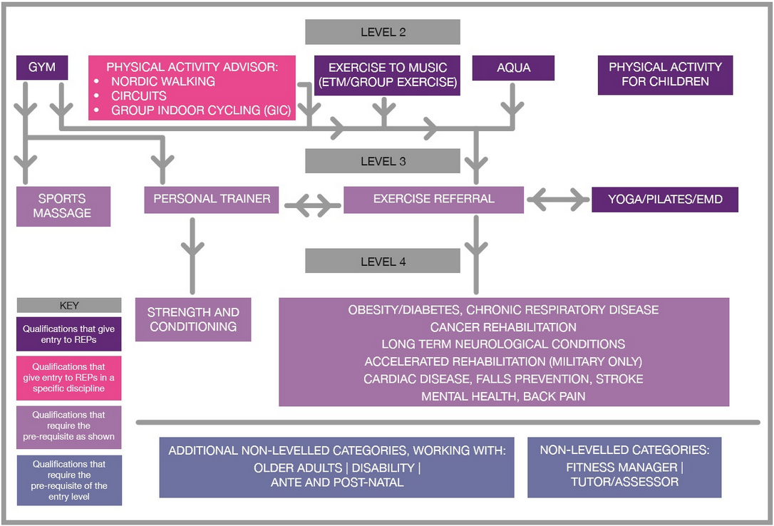

https://www.exerciseregister.org/reps-categories

