Councillors on this Committee:
EX OFFICIO
Cllr. C Cheta, Cllr. J Harris

Cllr S Griffiths (Chair), Cllr C Collier, Cllr Sharkey, Cllr R White, Cllr L Symonds, Cllr Seabrook

22nd April 2021
Dear Committee Member,

You are summoned to a meeting of the Grants Sub-Committee which will be held on-line (Zoom) on Thursday 29th April 2021 at 7:30pm

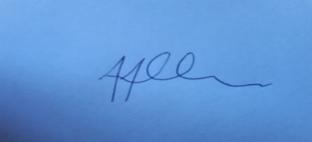

Tony Allen
Town Clerk

A G E N D A

GENERAL BUSINESS

- GSC036 CHAIRS ANNOUNCEMENTS
- GSC037 PUBLIC QUESTIONS

There will now be a 15 minute period when members of the public may ask questions (which have been submitted in writing and received by 12 noon on the day of the meeting) on any matters that affect the Town. Please email the Town Clerk for access to this meeting.

- GSC038 TO CONSIDER APOLOGIES FOR ABSENCE & SUBSTITUTIONS
- GSC039 TO RECEIVE DECLARATIONS OF INTEREST FROM COMMITTEE MEMBERS
- GSC040 TO APPROVE & SIGN THE MINUTES OF WEDNESDAY 11TH NOVEMBER 2020
- GSC041 TO DISCUSS AND AGREE RECOMMENDATIONS FOR GRANT APPLICATIONS FOR
ROUND 1 2021/2022

DATE OF NEXT MEETING – TO BE AGREED

