15th April 2020

Members of Peacehaven Town Council are summoned to the virtual Council meeting to be held on-line (Zoom) on Tuesday 21st April 2020 at 7.30pm.

Tony Allen
Town Clerk
A G E N D A

ZOOM ACCESS CODE FOR THIS MEETING CAN BE OBTAINED BY EMAILING THE CLERK

- C590 Welcome, introductions, meeting protocols and any general announcements.
- C591 Public session.
- C592 To approve apologies for absence.
- C593 To receive declarations of interests.
- C594 To adopt the minutes of the previous Council meeting held on the 24th March 2020 (P3-P6)
- C595 To resolve to defer the Annual Meeting of Council; current appointments
continue.
- C596 To highlight any remaining PTC support requirements with Government, other Councils and voluntary organisations, etc.
- C597 To receive minutes, actions, Chairmen’s reports and urgent referrals from
Committees & Working Parties.
  - Policy & Finance Committee:-
    - Financial reports. (P7-P14)
    - Request for a new PTC laptop PC.
  - Planning & Highways Committee:-
    - Processing of planning applications. (Page 15)
  - Personnel Committee:-
    - Recruitment of a Senior Projects Officer.
    - To note the DRAFT public meeting minutes of the 17th March 2020. (P16)
  - Leisure, Amenities & Environment Committee:-
    - To note the DRAFT meeting minutes of the 17th March 2020. (P17-P21)
  - Civic & Events Committee:-
    - To note the DRAFT meeting minutes of the 25th February 2020. (P22-P26)
  - Business Plan & E-Comm’s Committee:-
    - To note the DRAFT meeting minutes of the 10th March 2020. (P27-P30)
  - Climate Change Working Party.
  - CIL Working Party.
- C598 To receive the report from the Neighbourhood Development Plan Steering Group. (P31-P36)
- C599 To discuss any requirement for holding Committee, Sub-Committee and Working Party meetings.

CONFIDENTIAL

In accordance with Standing Order 3(d) and the Public Bodies (Admission to Meetings) Act 1960, Section 1, in view of the confidential nature of the business to be transacted, the public and press are excluded from the discussion of the following items:-

- C600 Policy & Finance Committee:-
  - To discuss making financial arrangements for our lessees and renters.
  - To look at an overview of loss of income considerations.
  - To receive a staffing report.
- C601 Personnel Committee:-
  - To note the DRAFT confidential meeting minutes of the 17th March 2020.
  - To receive a staffing report.
- C602 Date of next meeting.

Minutes of an Emergency meeting of Peacehaven Town Council, held in the Main Hall, Community House, Meridian Centre, at 3.00pm on Tuesday 24th March 2020

NOTE: This meeting was held under strictly controlled conditions, with approved separation of participants and sanitization measures in place.

Present – Mayor Cllr Claude Cheta, Cllr Sue Griffiths, Cllr Dawn Paul, Cllr David Seabrook, Cllr Catherine Gallagher, Cllr Lucy Symonds, Cllr Emilia Simmons.
Officers; Town Clerk, Tony Allen.

- C574 MAYOR’S REPORT & ANNOUNCEMENTS
No announcements.

- C575 PUBLIC QUESTION TIME
No members of the public were present.

- C576 CORONA VIRUS – LATEST POSITION AND ACTIONS REQUIRED
The Clerk introduced his paper, which was received and discussed, with updates in this fast-moving situation highlighted.

Impacts on working arrangements, procedures, ongoing works, internal and external communications and payments and receipts were discussed. Clerk to arrange a discussion regarding the Council’s lessees and hirers affected regarding possible help and financial support measures that the Council can implement.

Cllr Symonds highlighted on-line training opportunities and will pass the details on to the Clerk.

Clerk to investigate and set-up a.s.a.p. improved ‘electronic’ and phone communications to allow Councillors and staff to better interact remotely, including the holding of virtual meetings; a number of methods and sources of advice were suggested.

Reaching the c.20% of people who do not use these means of communicating was also discussed. Use of leaflets/posters in supermarkets, chemists, Government Hub & Newhaven Food Bank parcels was suggested for further investigation.

It was resolved to ratify the emergency actions taken to-date, including:-
- The Summer Fair scheduled for the 11th July will be cancelled.
- The Mayor’s reception scheduled for the 25th April will be postponed.
- The Annual Town Meeting scheduled for the 21st April will be postponed.
- All other Community House events, bookings and activities, including the café, cancelled from the 18th March 2020, until further notice.
- All football games and practice sessions have been cancelled.
- Refunds will be given for activities cancelled by the Council.
- The current Mayor will continue in post until Council can hold its Annual meeting.

It was resolved to agree authority for any additional actions required, including:-
- Working from home.
- Safe working externally.
- Ongoing maintenance, health & safety measures required.
- To reassure all staff that they will be looked after and paid, whatever the impact is on their job, or whatever personal measures they need to take to mitigate the impact of the virus.
- Flexibility in working practices and type of work undertaken; including community support work.

It was resolved to introduce emergency powers which, when necessary, suspend Standing Orders, Financial Regulations, Committees etc. Terms-of-Reference, and give the Clerk delegated authority (in liaison with the Chairman of Council, Committee Chairmen and other Councillors and Officers as appropriate), particularly with regard to:-
- Spending authority and levels.
- Making recommendations on planning applications.
- Holding Council and Committee meetings, or alternatively to deal with urgent related matters.
- Staffing matters day-to-day.
- Buildings/estates management.
- Payments & other financial requirements.

Advice from Government, ESCC, LDC and solicitors to inform decisions as necessary.

The Clerk to keep a clear record of these required actions and then submit them as an agenda item to the Council for approval and minuting when normality returns.

- C577 TO CONSIDER APOLOGIES FOR ABSENCE
Apologies for absence were approved from Deputy Mayor Cllr Job Harris, Cllr Lynda Duhigg, Cllr Gloria Hill, Cllr Isobel Sharkey, Cllr Lyn-Mai Mills, Cllr Chris Collier, Cllr Alan Goble,
Cllr Alan Milliner, Cllr Wendy Veck, Cllr Ron White.

- C578 TO RECEIVE DECLARATIONS OF INTERESTS FROM MEMBERS
There were no declarations of interests.

[Clerk’s Note:- Items 4 & 5 were taken before Item 3}.

- C579 TO ADOPT THE MINUTES OF THE PREVIOUS COUNCIL MEETING HELD ON
THE 14th JANUARY 2020
It was resolved to adopt the minutes as a true record.

- C580 TO RECEIVE THE MINUTES, ACTIONS, CHAIRMEN’S REPORTS & REFERRALS FROM COMMITTEES & WORKING PARTIES
  - Policy & Finance Committee:-
    - To note and receive the minutes of the 18th February & 10th March 2020 – received.

  - Planning & Highways Committee:-
    - To note and receive the minutes of the 4th February & 3rd March 2020 -– received.
    - Minutes of the ESCC SLR meeting held on the 24th January 2020– received.

  - Personnel Committee:-
    - To note and receive the minutes of the 18th February– received.

  - Leisure, Amenities & Environment Committee:-
    - To note and receive the minutes of the 21st January– received.

  - Civic & Events Committee:-
    - To note and receive the minutes of the 25th February 2020– received.
    - Town Twinning update – noted that the Committee had resolved not to proceed in this matter.

  - Business Plan & E-Comm’s Committee:-
    - To note and receive the minutes of the 28th January & 10th March 2020 – received.

  - Climate Change Working Party:-
    - WP/Action Plan update
    - To agree the Terms-of-Reference for the Working Party
    - To agree the Single Use Plastic Policy
It was resolved to defer this item.

  - CIL Working Party – No new updates or reports to be received.

- C581 TO RECEIVE A REPORT FROM THE NEIGHBOURHOOD DEVELOPMENT PLAN STEERING GROUP (NDPSG):-
  - Notes from the public meeting held on the 24th February 2020 – received.
  - NDP progress chart – received and noted.

- C582 TO RECEIVE REPORTS FROM COUNTY & DISTRICT COUNCILLORS - No new updates or reports to be received.

- C583 TO RECEIVE REPORTS FROM MEMBERS REPRESENTING THE COUNCIL ON
OUTSIDE BODIES – Councillors to send any reports to the Clerk for circulation.

- C584 SUSSEX POLICE CCTV PARTNERSHIP – The report from Cllr Symonds was
noted; for further discussion at a later date.

- C585 ANNUAL TOWN MEETING:-
  - Arrangements
  - Mayor’s awards
  - Annual Town report
It was resolved to defer this item.

- C586 YOUNG MEN’S YOUTH PROVISION AT THE JOFF
It was resolved to defer this item.

CONFIDENTIAL
NOTE: In accordance with Standing Order 3(d) and the Public Bodies (Admission to Meetings) Act 1960, Section 1, in view of the confidential nature of the business to be transacted, the public and press were excluded from the discussion of the following items:-

- C587 CONFIDENTIAL REPORTS & ACTIONS TO RECEIVE & RATIFY FROM THE
PERSONNEL COMMITTEE
The Committee’s Action Plan was noted and received.
It was noted that the starting date for the newly appointed Groundsman had been deferred by mutual agreement.
It was resolved that the recruitment process for the new Senior Projects Officer would continue.
It was resolved that the annual review of Council’s staffing structure and salaries by the newly set up Working Party would be deferred.
It was resolved that, apart from the changes approved by the Policy & Finance Committee in relation to two individuals, only the standard pay increments required under the Council’s employment policy would be paid for now, along with any cost of living increase which is automatically applied to pay scales by the Government.

- C588 SALES LEDGER (AGED DEBTS) WRITE-OFFS
The Finance Administrator’s paper was noted and discussed. It was resolved to take the action as proposed in this paper.

- C589 DATE OF THE NEXT SCHEDULED MEETING – To be advised.

There being no further business, the meeting closed at 15:52.

20/04/2020 Peacehaven Town Council  18:02  Summary Income & Expenditure by Budget Heading 20/04/2020 |  |  |  |  | Committed  Expenditure | Funds  Available  (35,323)  1,305  3,020  5,000  1,047  2,625  (8,456)  (1,124)  2,400  1,699  15,975  3,282  (12,357)  (6,648)  (2,340) | Page 1  % Spent  125.2%  106.4%  55.0%  0.0%  24.5%  0.0%  91.7%  77.0%  81.3%  138.3%  2.6%  105.0%  95.6%  32.8%  45.2%  50.2%  36.4%  104.4%  69.8%  86.2%  117.0%  0.0%  0.0%  0.0%  0.0%
Month No: 12  100 General Administration Income  Expenditure  Movement to/(from) Gen Reserve  110 Civic Events Expenditure  120 Marketing Income  Expenditure  Movement to/(from) Gen Reserve  130 Neighbourhood Plan Expenditure  200 Planning & Highways Expenditure  300 Grounds Team General Exp Expenditure |  | Cost Centre Report |  | Variance  Annual Total  (144,253)  (35,323)  1,305  (495)  3,020  5,000  1,047  2,625  6,801  (8,456)  26,300  (1,124)  370  2,400  1,699  5,902  15,975  (698)  3,282  10,797  (12,357)  (60,080)  (6,648)  (5,365)  (2,340)
 |  | Actual Year To Date  717,568  590,398  127,170  1,595  495  980  (485)  0  11,593  8,765  29,549  30,516  (967)  700  23,524  (22,824)  8,110  1,170  6,940  1,401  5,948  9,125  (3,177)  16,398  7,578  8,820  67,303  85,057  (17,755)  60,080  6,648  53,432  5,365  2,340  3,025 | Current  Annual Bud  573,315  555,075  2,900  0 4,000  5,000  12,640  11,390  36,350  22,060  27,000  22,400  8,480  3,570  3,100  11,850  25,100  15,700  10,860  78,100  72,700  0  0  0  0
310 Sports Park  - Big Park  - Gateway Cafe  320 Play Areas  330 Amenity Area  355 The Hub | Income  Expenditure  Movement to/(from) Gen Reserve  Income  Expenditure  Movement to/(from) Gen Reserve  Income  Expenditure  Movement to/(from) Gen Reserve  Expenditure  Income  Expenditure  Movement to/(from) Gen Reserve  Income  Expenditure  Movement to/(from) Gen Reserve
360 Community House Income
Expenditure
Movement to/(from) Gen Reserve
400 Water Leak Income
Expenditure
Movement to/(from) Gen Reserve
430 Summer Fair Income
Expenditure
Movement to/(from) Gen Reserve
440 Christmas Market Income  Expenditure |  | 3,500  1,039 | 0  0 | (3,500)  (1,039) |  | (1,039) | 0.0%  0.0%
Movement to/(from) Gen Reserve
2,461

Continued over page
915,016  781,731 | 750,795  750,795 | (164,221)  (30,936) | 0 | (30,936) | 121.9%  104.1%
Grand Totals:- Income
20/04/2020  18:02  Month No: 12 | Peacehaven Town Council  Summary Income & Expenditure by Budget Heading 20/04/2020  Cost Centre Report |  |  | Page 2
 | Actual Year Current Variance To Date Annual Bud Annual Total | Committed  Expenditure | Funds Available | % Spent
Expenditure
Net Income over Expenditure
133,285
0
(133,285)
133,285
Movement to/(from) Gen Reserve

Peacehaven Town Council
18:01 Detailed Balance Sheet - Excluding Stock Movement
Month 12 Date 20/04/2020
20/04/2020
Page 1
A/c
Description
Actual
Current Assets
102
Debtors Control
20,169
105  118  201  202  210  506  566 | VAT Control A/c  Deposit Aqua  Current Bank A/c  Reserve Account  Petty Cash  Total Current Assets  Current Liabilities  Mayor's Appeal  Deposits Received  Total Current Liabilities  Net Current Assets | 5,991  50  224,388  180,015 520  7,146  922 | 431,133  8,067  423,066  423,066
Total Assets less Current Liabilities
Represented by :-

301 Current Year Fund |  | 133,285
310 General Reserves |  | 86,131
326 Elections |  | 8,000
329 Purchase Reserve |  | 20,000
350 P/H Youth Task Group |  | 4,000
352 CIL |  | 33,924
355 Big Park |  | 69,080
357 Pavilion Roof & Boiler |  | 7,000
362 Neighbourhood Plan |  | 3,806
370 Capital Receipts Reserve |  | 57,839
Total Equity
423,066

Date : 20/04/2020 Peacehaven Town Council Page 3
A/c Code
Account Name
Centre
Centre Name
Debit
Credit
Time: 18:01 Trial Balance for Month No: 12 User : ZM
Account Number Order
102 | Debtors Control |  |  | 20,169.05
105 | VAT Control A/c |  |  | 5,991.18
118 | Deposit Aqua |  |  | 50.00
201 | Current Bank A/c |  |  | 224,387.51
202 | Reserve Account |  |  | 180,015.21
210 | Petty Cash |  |  | 520.00
310 | General Reserves |  |  | 86,130.61
326 | Elections |  |  | 8,000.00
329 | Purchase Reserve |  |  | 20,000.33
350 | P/H Youth Task Group |  |  | 4,000.00
352 | CIL |  |  | 33,923.83
355 | Big Park |  |  | 69,080.45
357 | Pavilion Roof & Boiler |  |  | 7,000.00
362 | Neighbourhood Plan |  |  | 3,806.00
370 | Capital Receipts Reserve |  |  | 57,838.96
506 | Mayor's Appeal |  |  | 7,145.95
566 | Deposits Received |  |  | 921.50
1001 | Precept | 100 | General Administration | 536,289.00
1005 | Grants - Lewes DC | 100 | General Administration | 30,176.00
1010 | CIL Income | 100 | General Administration | 130,409.65
1013 | Income from Photocopying | 100 | General Administration | 412.97
1016 | Housing Benefit Claims LDC | 100 | General Administration | 16,228.81
1017 | Foodliner Sales | 100 | General Administration | 537.04
1025 | Rent & Service Charge | 310 | Sports Park | 14,093.64
1025 | Rent & Service Charge | 316 | Gateway Cafe | 8,110.20
1039 | S/P Cats | 310 | Sports Park | 3,540.00
1041 | S/P Telephone Masts | 310 | Sports Park | 4,250.00
1043 | S/P Football Pitches | 310 | Sports Park | 2,710.60
1043 | S/P Football Pitches | 315 | Big Park | 520.00
1044 | Hire of the Dell | 330 | Amenity Area | 4,888.00
1045 | Event Sponsorship | 120 | Marketing | 495.00
1045 | Event Sponsorship | 430 | Summer Fair | 3,150.00
1045 | Event Sponsorship | 440 | Christmas Market | 2,700.00

Date : 20/04/2020 Peacehaven Town Council Page 3
A/c Code
Account Name
Centre
Centre Name
Debit
Credit
Time: 18:01 Trial Balance for Month No: 12 User : ZM
Account Number Order
1046 | Stall Income (Events) | 430 | Summer Fair | 1,400.00
1046 | Stall Income (Events) | 440 | Christmas Market | 800.00
1050 | Allotment Rent | 100 | General Administration | 600.00
1050 | Allotment Rent | 330 | Amenity Area | 1,060.00
1061 | S/P Court Hire | 310 | Sports Park | 4,954.80
1069 | C/H Police Room | 360 | Community House | 1,365.00
1070 | C/H Phoenix Room | 360 | Community House | 5,189.74
1072 | C/H Copper Room | 360 | Community House | 11,500.00
1075 | C/H Charles Neville | 360 | Community House | 6,565.78

1076 | C/H Main Hall | 360 | Community House |  | 20,733.24
1077 | C/H Anzac Room | 360 | Community House |  | 10,818.31
1078 | C/H Main Kitchen | 360 | Community House |  | 1,068.04
1079 | C/H Anzac Kitchen | 360 | Community House |  | 448.36
1080 | C/H Foyer | 360 | Community House |  | 2,224.69
1081 | C/H Equipment Hire | 360 | Community House |  | 1,004.00
1084 | Sports Pavilion | 355 | The Hub |  | 16,397.82
1091 | Cinema Income | 360 | Community House |  | 5,149.21
1092 | Electricity Feed-in Tariff | 360 | Community House |  | 486.15
1094 | Other Customer & Client Receip | 100 | General Administration |  | 300.00
1094 | Other Customer & Client Receip | 315 | Big Park |  | 180.00
1094 | Other Customer & Client Receip | 430 | Summer Fair |  | 815.19
1100 | Interest Received | 100 | General Administration |  | 1,292.94
1200 | Income from Recharges | 360 | Community House |  | 750.00
1301 | Filming | 100 | General Administration |  | 650.00
1309 | Other Income | 100 | General Administration |  | 661.99
1441 | Water Leak Refund | 400 | Water Leak |  | 60,079.82
1999 | Suspense Account | 100 | General Administration |  | 10.00
4001 | Salaries | 100 | General Administration | 363,513.40
4002 | Employer N.I Contributions | 100 | General Administration | 25,776.16
4003 | Employer Pension Contributions | 100 | General Administration | 57,858.78
4004 | Overtime | 100 | General Administration | 5,369.22

Date : 20/04/2020 Peacehaven Town Council Page 3
A/c Code
Account Name
Centre
Centre Name
Debit
Credit
Time: 18:01 Trial Balance for Month No: 12 User : ZM
Account Number Order

4010 | CIL Expenditure | 100 | General Administration | 6,870.67
4011 | Training | 100 | General Administration | 1,860.10
4101 | Repair/Alteration of Premises | 200 | Planning & Highways | 199.86
4101 | Repair/Alteration of Premises | 310 | Sports Park | 1,014.38
4101 | Repair/Alteration of Premises | 315 | Big Park | 4,449.08
4101 | Repair/Alteration of Premises | 316 | Gateway Cafe | 517.71
4101 | Repair/Alteration of Premises | 320 | Play Areas | 1,329.60
4101 | Repair/Alteration of Premises | 330 | Amenity Area | 1,314.54
4101 | Repair/Alteration of Premises | 355 | The Hub | 623.67
4101 | Repair/Alteration of Premises | 360 | Community House | 9,284.31
4103 | Annual Servicing Costs | 355 | The Hub | 1,230.32
4111 | Electricity | 200 | Planning & Highways | 1,076.77
4111 | Electricity | 310 | Sports Park | 6,477.03
4111 | Electricity | 316 | Gateway Cafe | 302.74
4111 | Electricity | 355 | The Hub | 1,755.50
4111 | Electricity | 360 | Community House | 7,354.69
4112 | Gas | 355 | The Hub | 1,427.15
4112 | Gas | 360 | Community House | 2,785.41
4121 | Rents | 315 | Big Park | 10,920.00
4122 | Service Charge | 360 | Community House | 28,199.51

4131 | Rates | 315 | Big Park | 3,351.73
4131 | Rates | 355 | The Hub | 769.47
4131 | Rates | 360 | Community House | 15,466.50
4141 | Water Services | 310 | Sports Park | 3,649.82
4141 | Water Services | 320 | Play Areas | 71.49
4141 | Water Services | 330 | Amenity Area | 1,487.52
4141 | Water Services | 360 | Community House | 10,503.78
4141 | Water Services | 400 | Water Leak | 6,648.00
4151 | Fixtures & Fittings | 300 | Grounds Team General Exp | 161.86
4151 | Fixtures & Fittings | 355 | The Hub | 8.73
4151 | Fixtures & Fittings | 360 | Community House | 352.02
4161 | Cleaning Costs | 310 | Sports Park | 6,716.00

Date : 20/04/2020 Peacehaven Town Council Page 3
A/c Code
Account Name
Centre
Centre Name
Debit
Credit
Time: 18:01 Trial Balance for Month No: 12 User : ZM
Account Number Order

4161 | Cleaning Costs | 360 | Community House | 1,866.00
4162 | Cleaning Materials | 360 | Community House | 1,355.13
4163 | Personal Hygiene | 360 | Community House | 2,366.91
4164 | Trade Refuse | 300 | Grounds Team General Exp | 78.00
4164 | Trade Refuse | 310 | Sports Park | 5,417.75
4164 | Trade Refuse | 330 | Amenity Area | 847.61
4166 | Skip Hire | 315 | Big Park | 680.00
4171 | Grounds Maintenance Costs | 200 | Planning & Highways | 175.00
4171 | Grounds Maintenance Costs | 310 | Sports Park | 7,241.10
4171 | Grounds Maintenance Costs | 330 | Amenity Area | 2,022.55
4171 | Grounds Maintenance Costs | 355 | The Hub | 1,763.41
4171 | Grounds Maintenance Costs | 360 | Community House | 595.54
4173 | Fertilisers & Grass Seed | 315 | Big Park | 3,018.45
4202 | Repairs/Maintenance of Vehicle | 300 | Grounds Team General Exp | 3,951.20
4203 | Fuel | 300 | Grounds Team General Exp | 3,673.84
4204 | Road Fund License | 300 | Grounds Team General Exp | 260.00
4212 | Mileage Costs | 100 | General Administration | 272.69
4301 | Purchase of Furniture/Equipmen | 100 | General Administration | 60.65
4301 | Purchase of Furniture/Equipmen | 330 | Amenity Area | 3,453.12
4302 | Purchase of Materials | 315 | Big Park | 150.00
4303 | Machinery Mtce/Lease | 315 | Big Park | 954.78
4304 | Catering | 300 | Grounds Team General Exp | 60.00
4305 | Uniform | 300 | Grounds Team General Exp | 579.99
4305 | Uniform | 360 | Community House | 369.95
4306 | Printing | 100 | General Administration | 6,074.55
4307 | Stationery | 100 | General Administration | 2,025.66
4311 | Professional Fees - Legal | 100 | General Administration | 8,957.80
4312 | Professional Fees - Other | 100 | General Administration | 42,065.90
4314 | Audit Fees | 100 | General Administration | 2,659.15
4315 | Insurance | 100 | General Administration | 9,574.67

Date : 20/04/2020 Peacehaven Town Council Page 3
A/c Code
Account Name
Centre
Centre Name
Debit
Credit
Time: 18:01 Trial Balance for Month No: 12 User : ZM
Account Number Order

4321 | Bank Charges | 100 | General Administration | 58.00
4322 | BACS Charges | 100 | General Administration | 473.39
4323 | PDQ Charges | 100 | General Administration | 604.79
4325 | Postage | 100 | General Administration | 1,781.50
4326 | Telephones | 100 | General Administration | 4,691.78
4326 | Telephones | 316 | Gateway Cafe | 350.00
4327 | Computers | 100 | General Administration | 12,618.79
4328 | Website | 120 | Marketing | 373.33
4329 | Advertising | 100 | General Administration | 134.00
4329 | Advertising | 120 | Marketing | 512.00
4329 | Advertising | 430 | Summer Fair | 248.00
4330 | Newsletter | 120 | Marketing | 95.00
4331 | Mayor's Allowance | 100 | General Administration | 1,500.00
4332 | Mayor's Reception | 110 | Civic Events | 200.00
4333 | Members Allowance | 100 | General Administration | 2,250.00
4334 | Members Training | 100 | General Administration | 1,960.00
4335 | Civic Expenses | 110 | Civic Events | 1,394.89
4341 | Grants | 100 | General Administration | 18,045.54
4342 | Subscriptions | 100 | General Administration | 3,576.97
4343 | Contributions to Provisions | 100 | General Administration | 6,000.00
4500 | Event Staff Overtime | 430 | Summer Fair | 1,086.08
4600 | Cinema Costs | 360 | Community House | 4,557.50
4850 | Grass Cutting Contract | 200 | Planning & Highways | 10,141.29
4900 | Miscellaneous Expenses | 100 | General Administration | 50.00
4900 | Miscellaneous Expenses | 430 | Summer Fair | 1,006.00
4900 | Miscellaneous Expenses | 440 | Christmas Market | 1,038.62
4999 | Write Off | 100 | General Administration | 3,714.28
Trial Balance Totals :
1,212,863.62
1,212,863.62
Difference 0.00

PLANNING APPLICATIONS – DELEGATED DECISIONS
LW/20/0111  16 Seaview Road  Peacehaven  Case worker James Emery | Proposed new cladding to exterior  Peacehaven Town Council Recommends Approval
LW/20/0142  15 Ashmore Close Peacehaven East Sussex BN10 8AQ  Case worker Sarah Sullivan | single storey rear and side extension  Comments  No objections to this from neighbours  Peacehaven Town Council Recommends Approval

LW/20/0179  6 Telscombe Road  Peacehaven  BN10 8AH  Case worker  Anna Clare | Demolition of existing home office and construction of new annex accommodation  Comments  detached property on a large plot and does not overlook or create any problem with their neighbours  Peacehaven Town Council Recommends Approval

LW/20/0158  217 South Coast Road  BN10 8LA  Case worker  Sarah Sullivan | Replacement signage and shop front replacing  Peacehaven Town Council Recommends Approval

LDC Planning Decisions

LW/20/0072  6 Downland Ave  Peacehaven | Planning application for loft conversion  Lewes DC Grants permission  Peacehaven’s Planning & Highways Committee Supported this application.
DRAFT Minutes of the meeting of the Peacehaven Town Council Personnel Committee held in the ANZAC ROOM, Community House, Meridian Centre at 6.00pm on Tuesday 17th March 2020
Present – Cllr. David Seabrook (Chairman), Cllr. Chris Collier, Cllr. Cathy Gallagher, Cllr. Isobel Sharkey, Cllr. Lucy Symonds, Cllr Lynda Duhigg, Cllr Gloria Hill.
Town Clerk Tony Allen. Civic & Marketing Officer, Deborah Donovan.
- E098 PUBLIC QUESTION TIME
No members of the public were present.
- E099 CHAIRMAN’S ANNOUNCEMENTS
The Chairman welcomed everyone to the meeting and read out the safety and housekeeping announcements.
- E100 TO CONSIDER APOLOGIES FOR ABSENCE
Apologies were accepted from Cllr C Cheta, Cllr. A Milliner, Cllr J Harris and Cllr W Veck.
- E101 TO RECEIVE DECLARATIONS OF INTERESTS FROM MEMBERS
Cllr Hill as the step Aunt of Mrs Donovan.
- E102 TO ADOPT THE MINUTES OF 18th FEBRUARY 2020 MEETING
It was resolved to adopt the public and confidential minutes as a true record.

NOTE: In accordance with Standing Order No. 3(d) and the Public Bodies (Admission to Meetings) Act 1960, Section 1, in view of the confidential nature of the following business to be transacted, the public and press were excluded from the discussion of the following items.
- E103 RECRUITMENT OF A REPLACEMENT GROUNDS PERSON
Cllr Seabrook updated the Committee on the outcome of the recruitment process and informed the meeting that this position had been offered to a very well qualified candidate.
- E104 RECRUITMENT OF A SENIOR PROJECTS OFFICER
Cllr Seabrook updated the Committee on the progress of the recruitment process, noting that the closing date is the 27th March 2020.
[Mrs Donovan left the meeting for the following item].
- E105 ANNUAL REVIEW OF STAFFING STRUCTURE & STAFF SALARIES/INCREMENTS
The Clerk’s paper was noted and discussed.
It was resolved that there was a need for a complete impersonal review of staffing structures.
It was resolved to form a Working Party to carry out this task.
It was resolved to make initial recommendations for Council’s agreement.
- E106 CHAIRMAN’S & CLERK’S BRIEFING ON ONGOING PERSONNEL MATTERS & ACTIONS
REQUIRED
The Action Plan produced by the Clerk was noted and discussed.
Cllr Seabrook reported on ongoing issues and actions.
- E107 DATE OF THE NEXT MEETING – TO BE AGREED

There being no further business, the meeting closed at 19:59.

DRAFT Minutes of the meeting of the Leisure, Amenities & Environment Committee held in Community House, Meridian Centre at 7.30pm on Tuesday 17th March 2020

Present: Cllr S Griffiths (Chair of Committee), Cllr E Simmons, Cllr C Cheta, Cllr L Mills, Cllr D Seabrook, Cllr G Hill, Cllr C Gallagher, Cllr I Sharkey, Cllr D Paul, Cllr L Symonds.
In Attendance: Kevin Bray Parks Officer, Tony Allen Town Clerk, Victoria Onis Admin Officer,

GENERAL BUSINESS

- LA 401 CHAIR ANNOUNCEMENTS
The Chair welcomed everyone to the meeting and read out the housekeeping and safety notices.
The Chair congratulated the football club for reaching the RUR Cup final for second year running.
The volunteer’s community garden event was a success and hoping to hold an orchard volunteer event on Saturday.
The chair attended a hand over of some bicycles from PCS school to Sustrans.

- LA 402 PUBLIC QUESTION TIME
No members of the public were in attendance.

- LA 403 TO CONSIDER APOLOGIES FOR ABSENCE & SUBSTITUTIONS
All committee members were present.

- LA 404 TO RECEIVE DECLARATIONS OF INTEREST FROM COMMITTEE MEMBERS
There were no declarations of interests made.

- LA 405 TO APPROVE AND SIGN THE MINUTES OF THE MEETING OF THE LEISURE AND AMENITIES COMMITTEE MEETING HELD ON 21st January 2019
Adoption of the minutes were proposed by Cllr Simmons, seconded by Cllr Sharkey and agreed as a true record.
All agreed
- LA 406 FINANCE UPDATE
Cllr Gallagher mentioned that the document seemed to be incomplete and layout not as easy to understand as the previous updates. The Town Clerk commented that the Finance Officer will be happy to go through the Finance documents, at any time with Committee members.

- LA 407 DDA PATHWAY REPORT
The Parks Officer’s report was noted and discussed.
It was resolved to resurface the whole length of the bridle path down to the Café to be put to the CIL Working party. Supplementary measures to address issues with the existing pathway to be investigated.
Proposed Cllr Gallagher
Seconded Cllr Seabrook
All in favour.

- LA 408 FLINT WAY PATH REPORT
The Parks Officer’s report was noted and discussed.
It was resolved to construct a new footpath from Flint Way to Centenary Park and Sussex Driveways was selected from the quotes obtained.
Project and costs to be put to the CIL working party.
Proposed Cllr Gallagher
Seconder Cllr Hill
All in favour.

- LA 409 CENTENARY PARK SAND
The Parks Officer’s report was noted and discussed.
The importance of not allowing Centenary Park to deteriorate was agreed and it was resolved that the Grounds Officer obtain more quotes for rubber mulch surfaces and costs.
Proposed Cllr Paul
Seconded Cllr Symonds
All in agreement

- LA 410 FOOTBALL PITCH REPORT
The Parks Officer’s report was noted and discussed.
It was discussed and resolved to repair the two pitches/carry out the recommended works for this year and monitor, with no commitments for next year. It was noted that S.106 monies can be used to offset the costs of this work.
Proposed Cllr Paul
Seconded Cllr Simmonds
All in agreement

- LA 411 DELL PLAYGROUND UPDATE
The Parks Officer’s report was noted and discussed, with safety concerns noted. The potential use of S.106/CIL monies was noted and will be discussed further following the required surveys.

- LA 412 SWING SEAT REPLACEMENT
The Parks Officer’s report was noted and discussed.
It was resolved to purchase a new nest swing seat for the playground at Firle Road and Onlineplaygrounds LTD was selected from the quotes obtained. It was noted that funding for this will come from the new 2020/21 budget.
Proposed Cllr Seabrook
Seconded Cllr Cllr Paul
Agreed by Majority.

- LA 413 CAFÉ SINK REPORT
The Parks Officer’s report was noted and discussed.
It was resolved to replace the sink and units at the Café like-for-like and to consult with the lease holder with regards payment by them for any extra attachments/fittings if required.
Proposed Cllr Paul
Seconded Cllr Seabrook
All in agreement

- LA 414 BOWLS CLUB LETTER REPORT
The Parks Officer’s report was noted and discussed.
It was resolved to not allow to the felling of a healthy Oak tree and also not to allow the Committee to put a gate in the fence opening out on to the entrance road; this is due to safety and proposed future pathway reconstruction.
Proposed Gallagher
Seconded Cllr Paul
All in agreement
- LA 415 TREE PLANTING REQUEST REPORT
The Parks Officer’s report was noted and discussed.
It was resolved to refuse permission for tree planting in this area in Foxhill. The trees would need to grow significantly in order to disperse road noise, which then could lead to complaints of causing shade and overhanging branches in the future. There are also a number of drains in this area and the roots in the future may affect underground services.
Proposed Cllr Hill
Seconded Cllr Cheta
All in agreement

- LA 416 SEWAGE PUMPS
The Parks Officer’s report was noted and discussed.
It was resolved to replace the pumps like for like and the parks officer to look for two more quotes. It was noted that S.106/CIL monies can be used for this purpose.
Proposed Cllr Gallagher
Seconded Cllr Paul
All in agreement.
- LA 417 CHIPPER REPORT
The Parks Officer’s report was noted and discussed.
Alternative disposal methods for Green Waste were discussed and it was noted that the BioGen facility at Newhaven no longer available to PTC.; next nearest facility is in Isfield.
It was proposed that the Parks Officer will obtain quotes for Chippers and provide a further report detailing the benefits of various options, including costings and environmental impacts, to be brought to next Committee.
Proposed Cllr Gallagher
Seconded Cllr Paul
All in Agreement

- LA 418 THE DELL CIL BID / PROJECT UPDATE
Cllr Griffith’s report was noted and discussed.
It was agreed that the Town Clerk will write a letter to the nearby residents to canvass them regarding the proposed project of wildflower planting. Before sending the letter, it was asked that the Town Clerk sends the draft to the Committee Chairman to confirm content.
- LA 419 COMMUNITY NOTICE BOARD AT THE DELL
Cllr Griffith’s report was noted and discussed.
Cllr Gallagher noted that the Community notice board was not agreed at the last Committee meeting, only the interpretation board agreed. Also, she felt that this new proposal for a free-standing Community Board is not in the right position to be seen.
Cllr Gallagher suggested that a future plan for the Dell needed more consideration and an alternative plan involving more consultation needs to be put forward.
It was resolved that this item needs more investigation and benefits of its use given and to be put to the signage working party.
Proposed Cllr Cheta
Seconded Cllr Paul
All in agreement
- LA 420 BANNER BOARD AT THE DELL
The Marketing Assistant’s report was discussed and noted It was resolved to refuse a new banner board being positioned at the Dell
Proposed Cllr Mills
Seconded Cllr Seabrook
Agreed by majority (3 abstained)
- LA 421 HUB WORKING PARTY UPDATE
The Parks Officer’s report was noted and discussed.
- LA 422 HUB WORKING PARTY TERMS OF REFERENCE
Cllr Griffith’s report was noted and discussed.
It was resolved to adopt the Terms of Reference with the proviso that, in view of the overlap, Item 2 on is changed to reflect the need for this WP to liaise with and report to the Business Plan Committee and the Neighbourhood Development Plan Steering Group.
Proposed Cllr Paul
Seconded Cllr Sharkey
Agreed by majority (2 abstained)
- LA 423 PROJECT LIST FOR PRIORITISING
The Parks Officer’s report was noted and discussed.
It was resolved to prioritize the following items. Parks Officer to be responsible for allocating priorities for future meetings of the Committee and put to the CIL working party:-
- g) Increase the height of wire fence attached to the wooden play area fences to stop dogs entering the areas, for completion before Easter.
- m) Outside toilet upgrade (to solve blocking issue)
- n) Renewing the sewage pumps (obtain quotes)
Proposed Cllr Gallagher
Seconded Cllr Sharkey
All in Agreement
- LA 424 STAFF UPDATE REPORT
The Parks Officer’s report was noted and discussed.
It was noted that a New Grounds Team member is starting on 1st April.
- LA 425 PROJECT UPDATE
The Parks Officer’s report was noted and discussed.
It was proposed to leave the MUGA court open for a trial period of a 1 month
Proposed Cllr Gallagher
Seconded Cllr Mills
All in agreement
- LA 426 WORKS UPDATE
- The Parks Officer’s report was noted and discussed.
27 LA 427 TO CONFIRM DATE OF NEXT MEETING AS THE 5th May 2020

There being no further business, the meeting closed at 9.10pm

DRAFT Minutes of the meeting of the Civic & Events Committee held in Community House, Meridian Centre at 7.30pm on Tuesday 25th February 2020

Present: Cllr Duhigg (Chair) Cllr Hill (Vice Chair), Cllr Paul, Cllr Goble, Cllr Mills, Cllr Simmons, Cllr Milliner, Cllr Symonds, Cllr Veck
In Attendance: Cllr Seabrook
In Attendance: Deborah Donovan - Civic Communications Officer, Karen Bray - Information Officer, Victoria Onis - Admin & Support Officer

GENERAL BUSINESS

- CE12 CHAIR ANNOUNCEMENTS
The Chairman welcomed everyone to the meeting and read the Health and Safety announcement

- CE13 PUBLIC QUESTION TIME
Q. A Resident spoke of benefits of the Mini Markets for the Community. As a user of the Market, he has seen a decline of the number of people using the Market and Café over the last couple of years. The resident has suggested the markets are not advertised well enough and possibly more could be done to attract interest. It was also mentioned that the Peacehaven Town Councils website has not been updated for some time.
A. The Civic Officer informed the Resident that the website is currently undergoing changes and the Marketing Assistant is working through the Town Council’s website updating and refreshing the information A Working Group which will be focusing on advertising and drumming up interest for these kinds of Events.
Q. A Resident has historical information on Peacehaven and would like to bring the Committee’s attention the phrasing for the ‘100th Anniversary of the first house in Peacehaven’ Event in October. The resident pointed out that it is actually the ‘100th year since the first Housing Development’ by Charles Neville, in Seaview Avenue. The first house was built in 1911 and the first housing development in 1920.
A. The Civic Officer thanked the Resident for this information and this will be looked at and amended.

- CE14 TO CONSIDER APOLOGIES FOR ABSENCE & SUBSTITUTIONS
All members of the Committee were present.

- CE15 TO RECEIVE DECLARATIONS OF INTEREST FROM COMMITTEE MEMBERS
There were no such declarations
- CE16 TO APPROVE AND SIGN THE NON-CONFIDENTIAL MINUTES OF THE 11th JUNE 2019
It was resolved to adopt the minutes as a true record.
Proposed Cllr Paul
Seconded Cllr Hill
All in Favour

- CE34 A VERBAL REPORT FROM CLLR. PAUL ON THE SUCCESFULL RESOLUTION RUN WHICH TOOK PLACE ON 5th JANUARY

Cllr Paul reported on the success of the Resolution run that she had the pleasure of organising. The family fun run using the 5k parkrun course to the Big park was in aid of the Mayors charities.

The event was a success, with roughly 110 people taking part on the day from the tiniest tots upwards, raising the sum of £264.34.

- CE35 A VERBAL UP-DATE FROM CLLR. SYMONDS ON THE PROGRESS OF THE CHARITY FOOTBALL MATCH
Cllr Symonds updated the Committee on the proposed Charity Football Match. It has been decided that, due to all suggested dates in May for the Charity Match clashing with other local events, the Match will be postponed until next year.

- CE36 A REPORT REGARDING THE FORTHCOMING CIVIC EVENTS, INCLUDING THE EVENTS CALENDAR
The Civic & Marketing Officer, Deborah Donovan, gave an update on the next Civic Event, the Celebration of the 75th Anniversary of V E Day on Friday 8th May, 3.00pm to 7.30pm.

The Civic Officer also requested help & support from the Committee to make the following Celebrations, events to remember.

- Summer Fair Saturday - 11th July 10-4pm
- 100th Year Celebrations of the first housing Development by Charles Neville in Seaview Ave.
- Remembrance Parade & Service - Sunday 10th November, 10.30am at the Joff car park
- Carol Concert Friday 11th December – Commencing 3.30-3.45
- Christmas Market Saturday 12th December

As well as the above Civic Events there are the following other Community Events, for which support is requirement.

BINGO 6th March, 17th April, 15th May, 19th June, 3rd July, 14th Aug, 18th Sept, 9th October, 20th Nov.

QUIZ 3rd April, 5th June, 17th July, 2nd Oct.
WRESTLING 14TH March, 24th Oct.
- CE37 A REPORT TO SUGGEST A COUNCILLOR/VOLUNTEERS FACILITIES EVENT WORKING PARTY WHO WILL ORGANISE FORTHCOMING FUNDRAISING EVENTS
It was discussed and resolved to have a Facilities Event Working Party to support Peacehaven Town Council’s Fundraising Events. The Lead Officer for this group will be Karen Bray. Councillors interested in supporting the Group are Cllr Paul, Cllr Symonds, Cllr Veck and Cllr Hill and the first meeting will be held on March 19th at 10-12
Proposed Cllr Symonds
Seconded Cllr Veck
All in Favour

- CE38 A REPORT TO UP-DATE THE REFORMATION OF OUR TWINNING TOWNS
It was discussed and agreed to not reform the Twinning Association due to costs & time involved.

Proposed Cllr Duhigg
Seconded Cllr Mills
It was Agreed by Majority

- CE39 A REPORT REFERENCE THE COMMUNITY SUMMER EVENT
The Civic & Marketing Officer updated the Committee on this year’s Summer Fete, which will be held on Saturday 11th July from 11am-4pm at Centenary Park.

The Civic & Marketing Officer has received sponsorship so far from Barratt Homes & S E Water and is in contact with other possible sponsors and the Facilities Event Working Party will be actively researching further activities.

Cllr Seabrook also informed the Committee that plastic straws and stirrers will be illegal from April 2020 so would like this to be on the terms of conditions for stall holders.

Cllr Seabrook also noted that the last Summer Fete the clear up of the park was made worse by the amount of spray foam and glitter which was being sold on some of the stalls, this kind of product is not eco friendly and would like to see this excluded from stalls this year and a reduction of single use plastic.

Cllr Seabrook has agreed to report back to the Committee, with suggestions of how the Town Council can helps towards making the Summer Fete Eco Friendly.

- CE40 A REPORT FROM THE YOUTH MAYOR – FORTH COMING ELECTIONS
No report received

- CE41 DATE OF NEXT MEETING TUESDAY 9th JUNE 2020
There being no further business, the meeting closed at 21.10
DRAFT Minutes of the meeting of the Business Planning & E-communications Committee, held in the Anzac Room, Community House, Meridian Centre, at 6.30pm on Tuesday 10th March 2020

Present –, Cllr Isobel Sharkey, Cllr David Seabrook, Cllr Chris Collier, Cllr Catherine Gallagher, Cllr Wendy Veck,

Officers; Civic & Marketing Officer, Deborah Donovan; Matt Gunn Marketing & Communications Assistant

- BPEC025 TO CONSIDER APOLOGIES FOR ABSENCE

Cllr Duhigg- Bad Back
Cllr Harris- Unwell
Cllr Milliner- Unwell
Cllr Symonds- Work Commitments
Town Clerk- Unwell

- BPEC026 TO RECEIVE DECLARATIONS OF INTEREST FROM COMMITTEE MEMBERS
No declarations were made.

- BPEC027 TO APPROVE AND SIGN THE MINUTES OF THE MEETING HELD ON TUESDAY 28th January 2020
It was resolved to adopt the minutes as a true and accurate record.

- BPEC028 PUBLIC QUESTION TIME
There were no public questions.

- BPEC029 TO DECIDE ON OUR VISION & AIM FOR THE BUSINESS PLAN

Cllr Gallagher felt the vision & aim provided in the paper lacked two important elements Environment & Sustainability. Cllr Gallagher then presented her examples to the committee;
- To achieve a sustainable future, protecting and enhancing the natural and historic environment
- Encouraging and supporting business to create local employment
- Supporting a healthy and happy community
- Maximising our assets and keeping costs to residents at a reasonable level.
Cllr Seabrook also said he has ten possible vision statements which he will share with the committee members via email after the meeting to review.
Cllr Veck stated how she would like to encourage more businesses to start up in the town to increase employment. Also she said it is important to bring some sustainable tourism to the town.
Cllr Sharkey proposed that we need to try to get people invested in the town so there are businesses, leisure and good education.
Cllr Collier stated that we need to focus on community wealth building as a priority.

It was agreed that all ideas should be sent to the marketing assistant to collate all of the ideas into one document.

- BPEC030 TO DISCUSS/REVIEW THE INTERNAL REVIEW OF THE COUNCILS SERVICE DELIVERY PLAN FROM 2011/12

Cllr Gallagher introduced the internal review to the committee and explained how herself, Cllr Milliner, Cllr Seabrook, The Town Clerk and The Marketing Assistant had looked through the document and removed everything that is no longer relevant and outlined what has been achieved.

- BPEC031 TO DISCUSS THE LOCALITY BUSINESS PLAN TEMPLATE & GUIDE

Cllr Seabrook confirmed that the Locality guide is a good guide to help us build our plan.

- BPEC032 TO RECEIVE AN UPDATE FROM THE HUB BUILDING WORKING PARTY

Cllr Seabrook confirmed that the short-term works planned in the Hub will take place hopefully in the Easter Holidays.
Cllr Seabrook also confirmed that the Hub working party will be asking stakeholders for their thoughts on how the hub could be improved further.

- BPEC033 TO DISCUSS WAYS TO MAXIMISE REVENUE FROM CURRENT ASSETS

Cllr Collier suggested that each committee could come up with suggestions of how we can increase revenue in each area.

Cllr Seabrook suggested that the eleven bus shelters should be used for advertising as well as the planters in the town.

Cllr Wendy Veck Suggested that we could use the lampposts for advertising, with ‘flag advertising’ similar to what they have on Brighton beach. Cllr Veck also suggested the back of community house could be used to advertise events.

- BPEC034 TO DISCUSS THE FUTURE OF THE E NEWS AND PRINTED COMMUNICATIONS.

Cllr Gallagher outlined her concerns on the amount of time it takes the marketing assistant to produce and Edit the E-news on a monthly basis, she suggested that a quarterly publication may be more beneficial.

Cllr Wendy Veck outlined the importance of keeping the E-News as a monthly magazine as it is good to keep people up to date with what the council is doing and it she also stated that the E-news Sustains itself through advertisement so does not cost the council.

Cllr Collier Said that it is important that councillors allow the officers to have full control of the E-News with no interference.

The committee agreed for the marketing assistant to ask for samples of a high-quality printed copy from Tansleys Printers.

- BPEC035 TO DISCUSS AND ADD ITEMS TO THE INTERNAL PLAN 2020/2021

Cllr Collier proposed that each committee should feed their own ideas into the 2020/2021 plan and report back to the business plan committee.

- BPEC036 DATE OF THE NEXT MEETING –
The next meeting will take place on Tuesday 14th April at 7.30pm.
*The Meeting Closed at 19:17*

Business Planning & E-communications Committee Action Plan follows:-

MEETING  DATE | TASK | ACTION | PERSON RESPONSIBLE | STATUS/COMMENTS
10/3/20 | TO DECIDE ON OUR VISION & AIM FOR THE BUSINESS PLAN | all ideas should be sent to the marketing assistant to collate all the ideas into one document. | Matt- (marketing assistant) | No Visions Sent through to the marketing assistant  I will chase up councillors on 31/3/20  As of 9/4/20 only one visions has been sent to the marketing assistant
10/3/20 | EACH COMMITTEE TO COME UP WITH IDEAS TO INCREASE REVENUE | Lead officer for each committee to add an agenda item asking for ideas to increase revenue for their next meeting. | All lead officers | Currently no committee meetings taking place
10/3/20 | TO SEE SAMPLES OF A HIGH-QUALITY PRINTED E_NEWS | the marketing assistant to ask for samples of a high-quality print-ed copy from Tansleys Printers. | Matt- (marketing assistant) | Printers are currently closed due to covid-19 however marketing assistant has emailed Dan at Tansleys who has provisionally agreed.
10/3/20 | TO DISCUSS AND ADD ITEMS TO THE INTERNAL PLAN 2020/2021 | each committee should feed their own ideas into the 2020/2021 plan and report back to the business plan committee.  Marketing assistant to email all lead officers | Matt- (marketing assistant) | As no meetings are taking place, the internal plan has been sent to each committee chair and lead officer, so far we have received recommendations from the LAE committee and from the Civic and events committee
10/3/20 | MINUTES TO BE CHECKED BY CHAIR | Minutes to be checked by vice chair as chair wasn’t at the last meeting | Matt- (marketing assistant) | Cllr Cathy Gallagher checked and happy with minutes although need to highlight action points

REPORT FROM CATHY GALLAGHER, CHAIR OF STEERING GROUP
PEACEHAVEN AND TELSCOMBE NEIGHBOURHOOD PLAN
14th April 2020

Contained in the papers for the Council Meeting 24th March at 7.30pm which was cancelled due to Covid 19 lockdown, there was a coverage of the work undertaken during the early months of the year.
Referring to those papers gives a background for current events.
On the 9th April a Zoom Meeting was held by myself and Jim Boot, Community Consultant.
This was attended by both Town Clerks, Council Representatives, Steering Group Committee members and 2 members of the public who are contributing their professional services, Gaston Mallia and Rachel Brown.
Minutes will be available in due course.

KEY FOCUS
COMMUNCATION to achieve greater Public Participation.
A team is now in place who will work to use many different multi- media channels.
MASTERPLANNING OF MERIDIAN CENTRE AND SURROUNDING AREA
Plans for a full day workshop where the AECOM Team would feedback their initial findings have had to be postponed due to lockdown.
Instead on 24th April there will be a Virtual Meeting for 2 hours to feedback and consult.
Arrangements to be confirmed but if anyone wishes to be involved please let me know.

The Brief for this project is:
“To develop a masterplan creating a new Town Centre for Peace haven, focusing primarily on the Meridian Centre Site but taking into account some of the surrounding areas: retaining many of the community uses but with the addition of up to 100 homes; encourage and create new links and connections with the surrounding areas; create a transport hub in the new town centre.
To produce a concept plan including “Design Plans”

PLANNING MASTERS DEGREE STUDENTS FROM UNIVERSITY OF BRIGHTON
There will be a feedback session in May, either virtual or physical, by the Post Graduate Students covering the following topics in relation to Peacehaven and Telscombe.
Their brief is
“To critically analyses the planning context of the area or theme and recommend viable planning policy and design solutions that can be incorporated into future versions of the draft Neighbourhood Plan or associated guidance.
Transport and Air Quality
Town Centre
Plotlands and Downland Fringe
Diversifying the economy
Climate and Coastal Change
Again if you would like to be involved please let me know.

TREASURED LOCAL GREEN SPACES, CAR PARKS AND HERITAGE
Collation of spaces and identification of items requiring protection in NDP are being identified.
The importance of the Cliff Top, SSSI , Marine SSSI and Biosphere are being documented.
Working with us we have a volunteer Dr Maureen Berg who is Principal Lecturer in Plant Ecology at University of Brighton.
Dr Berg is researching and writing this part of the NDP.

Car Parks and Heritage are identified and will continue to be part of The NDP and discussions with LDC and ESCC.

M E R I D I A N C E N T R E A R E A D E V E L O P M E N T
What would you like to see included?
Select any ideas from A to i and list them in your priority order.
You can select as many as you want, or none.
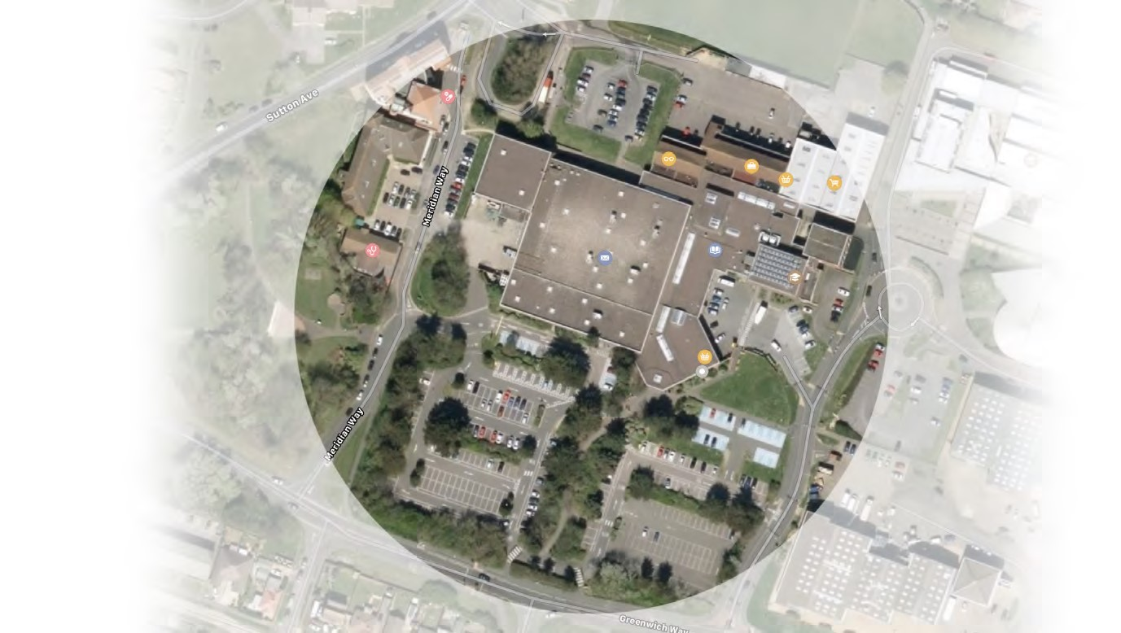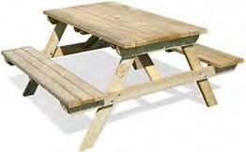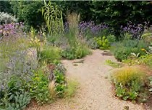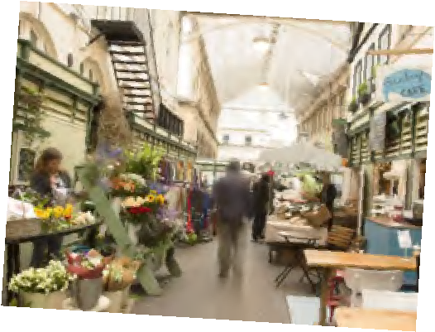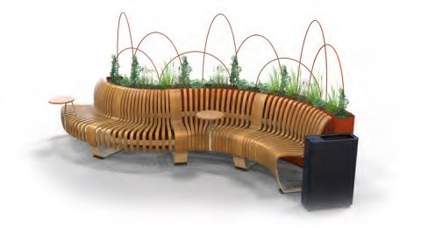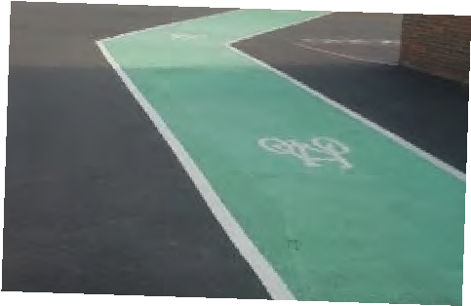
A.
B.
C.
Childrens play area
Pedestrianised street
H.
Grass picnic area
Public seating
D.
Weekend markets
F.
Cycle path & bike racks
E.
Covered shopping area
i.
G.
Planted gardens
Enterprise businesses units
M E R I D I A N C E N T R E A R E A D E V E L O P M E N T
What would you like to see included?
Survey Results 1 - Total Number of votes
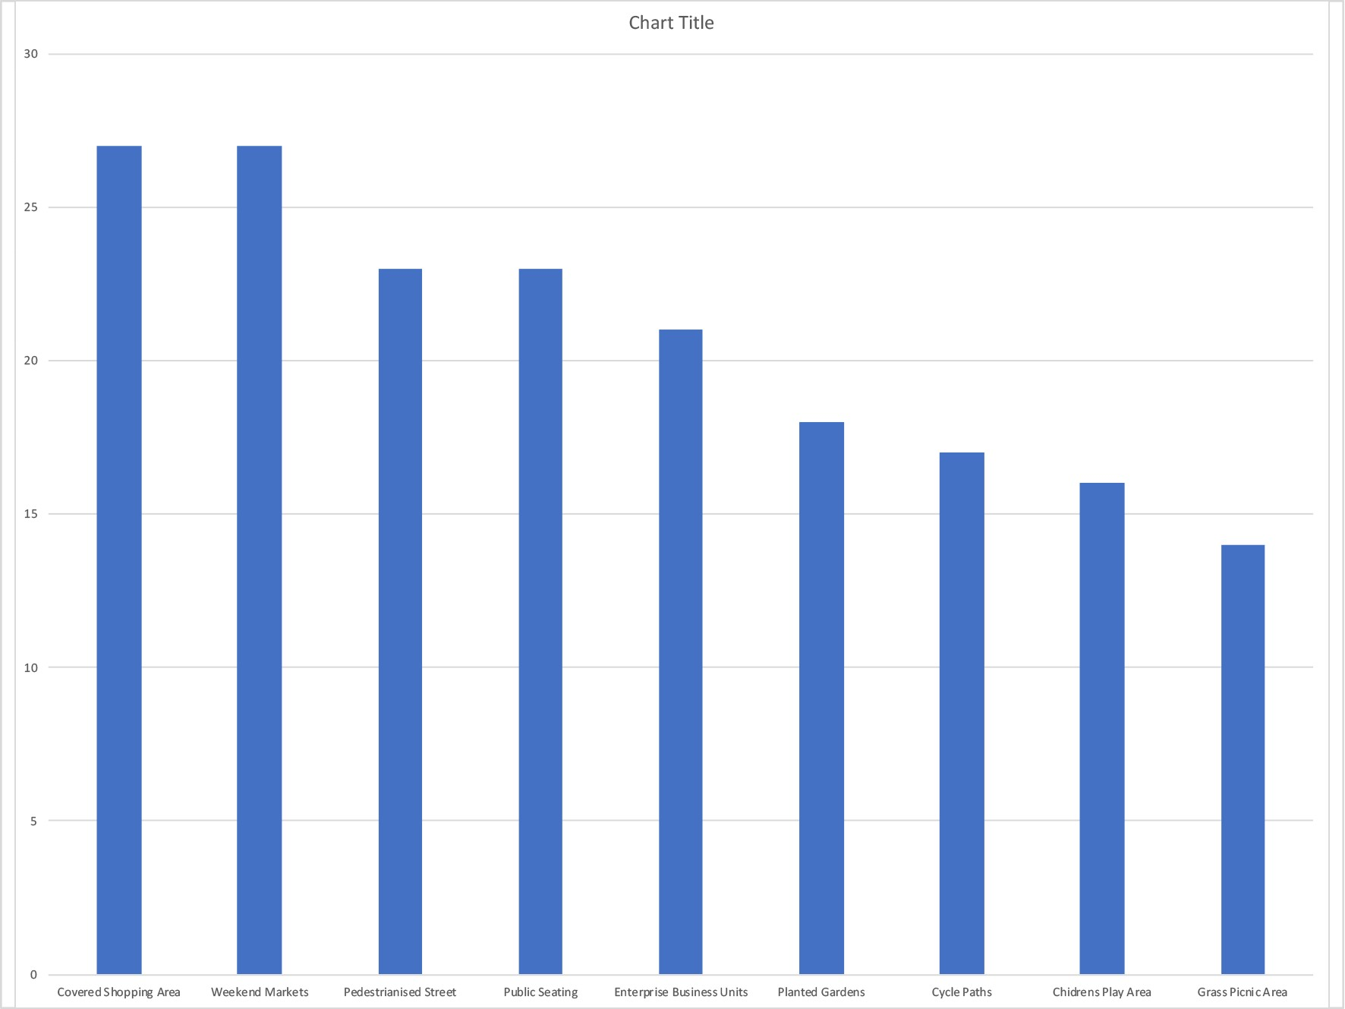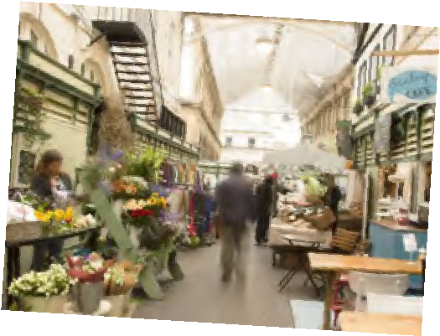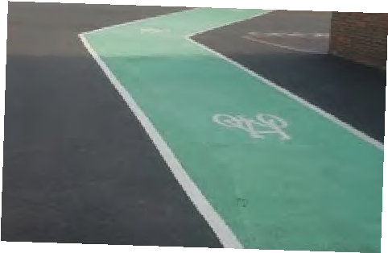
A.
B.
C.
Childrens play area
Pedestrianised street
Grass picnic area
Public seating
D.
Weekend markets
F.
Cycle path & bike racks
E.
Covered shopping area
i.
G.
Planted gardens
Enterprise businesses units
M E R I D I A N C E N T R E A R E A D E V E L O P M E N T
What would you like to see included?
Most popular choices
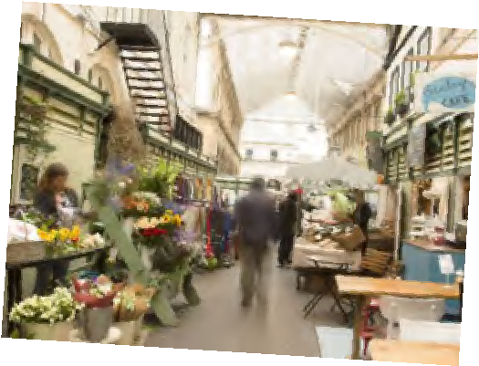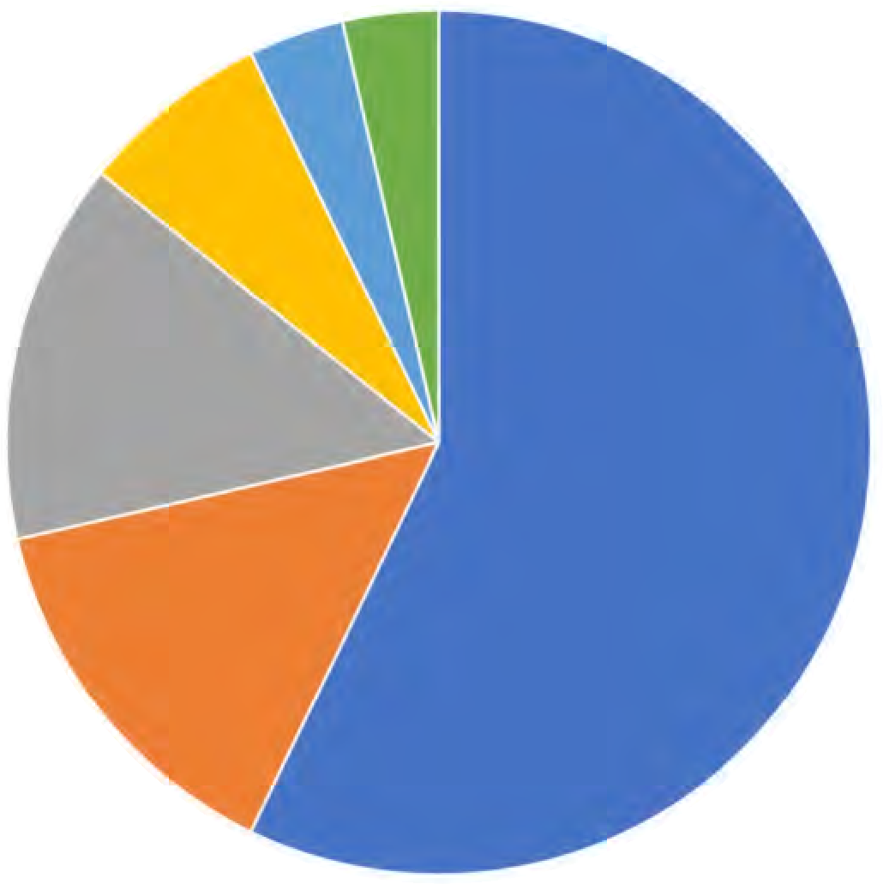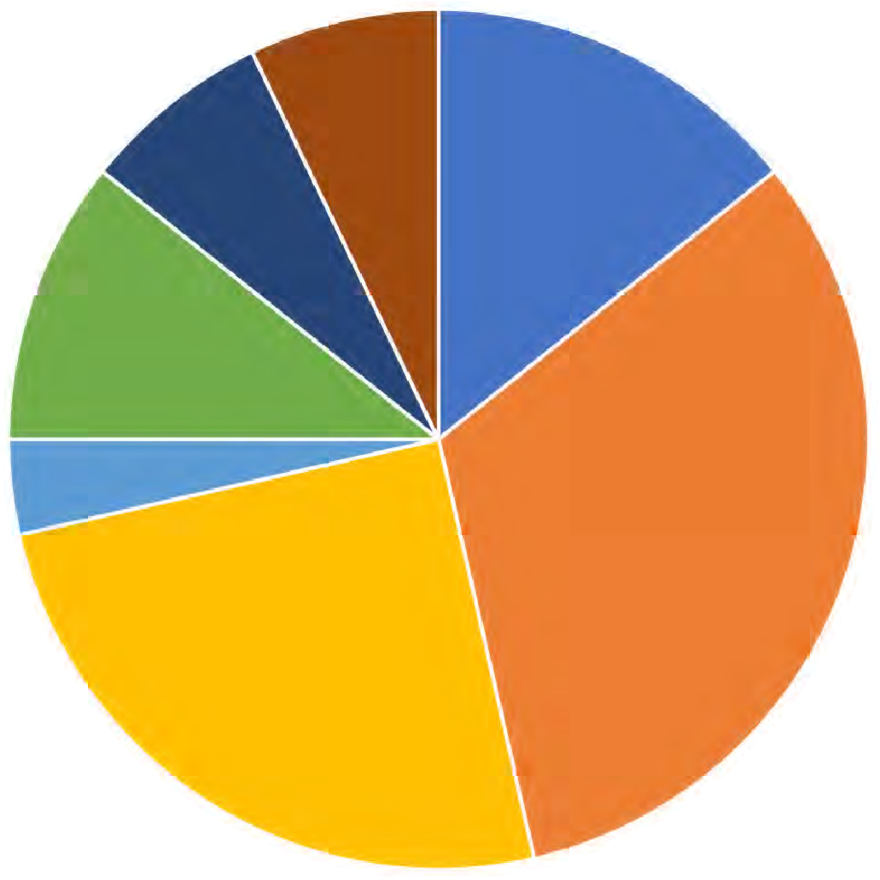E. C.
i.
Planted gardens
G.
Enterprise businesses units
Covered shopping area
D.
Weekend markets
Public seating
B.
Pedestrianised street
1
st Choice
2
nd Choice
3
rd Choice
M E R I D I A N C E N T R E A R E A D E V E L O P M E N T
What would you like to see included?
All choices
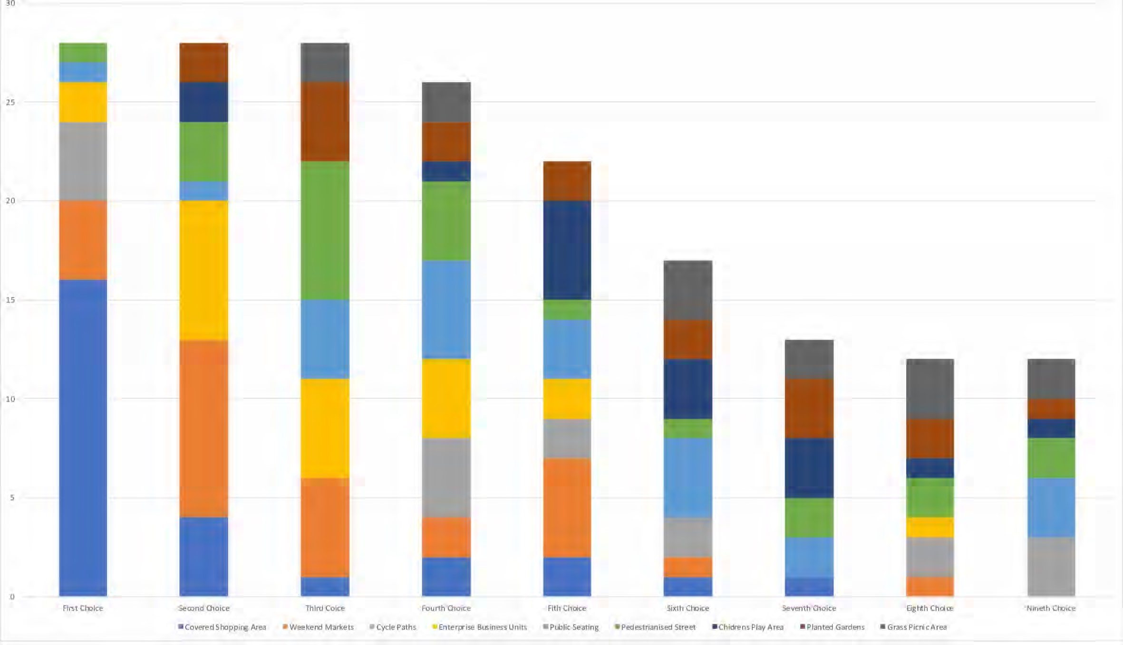
1
st
2
nd
3
rd
4
th
5
th
6
th
7
th
8
th
9
th

