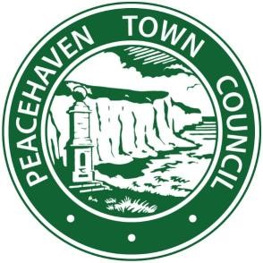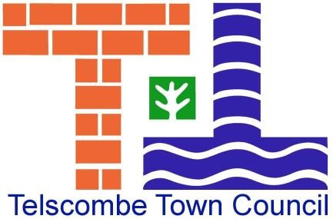
PEACEHAVEN AND TELSCOMBE TOWN COUNCILS
Call for Sites for Residential or Business Development SUBMISSION FORM August – October 2018

Please complete this form if you would like to suggest land for future development in the neighbourhood area of Peacehaven, Telscombe or East Saltdean
Please use a separate form for each site submitted. You must attach a 1:1250 scale Ordnance Survey map with the boundaries of the site clearly marked in red
Suggested sites should be able to accommodate the following:
- Sites of a minimum size of 0.2ha with capacity to accommodate a minimum of 5 dwellings
- Sites to accommodate employment uses
- If you have aspirations for alternative uses than those above we would also like to hear from you. In particular, we would welcome details of land that you may wish to see taken forward to provide wider community benefits

Inclusion of land for consideration in the Assessment does not imply that the site is suitable for development either now or in the future
Please return completed forms to: Peacehaven or Telscombe Town Councils, no later than 31st October 2018
Peacehaven Town Council, Community House, Greenwich Way, Peacehaven BN10 8BB
Telscombe Town Council, 360 South Coast Road, Telscombe Cliffs, E Sussex, BN10 7ES
Please note that providing this information on this form is not confidential. By submitting this form to Peacehaven and Telscombe Town Councils you are agreeing to the Town Councils sharing this information with the Peacehaven and Telscombe Neighbourhood Plan Steering Group, with Lewes District Council and the South Downs National Park Authority

CONTACT DETAILS
Name

Company/Organisation

Address

Telephone
Email

Agent (if applicable)
Name

Company/Organisation

Address

Telephone
Email

SITE DETAILS
Address of Site

Site Area (ha)

Current use of site

Relevant planning history
(including planning references, if known)

Has the site been previously submitted through SHELAA? | YES/NO
If yes, please provide reference (if known)

PROPOSED USES
Housing
If housing is proposed, please indicate the nature of the use | - Housing (C3 use)  - Residential Institutions (C2 use)  - Student accommodation  - Older People  - Gypsy and Travelling Show People  - Other (please specify)
Indication of potential capacity (minimum 5 units)
Indication of existing buildings to be demolished | (Please include the number of dwellings or commercial floor space)
Indication of dwelling types (mix)
Indication of tenure (market/affordable/starter homes)

Anticipated density (dwellings per hectare)
Economic
If business development is proposed, please indicate the nature of the proposed use (please tick all that apply) | - A1 (shops)  - A2 (Financial and Professional Services)  - A3 (Restaurants and Cafes)  - A4 (Drinking Establishments)  - A5 (Hot Food Takeaways)  - B1 (Business)  - B2 (General Industrial)  - A8 (Storage and Distribution)  - C1 (Hotels)  - D1 (Non-Residential Institutions)  - D2 (Assembly and Leisure) □ Other (please specify)
Indication of proposed floor space | (Please specify floor area for each use proposed)
Indication of existing buildings to be demolished | (Please include the number of dwellings or commercial floor space)

SUITABILITY
(Please indicate constraints which may affect the proposed use/actions required to address them)
Physical Factors | Yes/No | If yes, please provide further details
Suitable available access to the site.
Topography and landscape features.
Ground conditions.
Contamination.
Agricultural land grading
(Please indicate if grade 1, 2 or 3a).
Landfill site/proximity to a landfill site.
Proximity to the strategic road network.
Proximity to public transport.
Proximity to day to day facilities.
Utilities infrastructure (gas, oil, water, telecommunications etc).
Other (please specify)

Natural Environment | Yes/No | If yes, please provide further details
National and local ecological designations

Trees on site

Tree Preservation Orders

Flooding (Please indicate zone area, 1, 2, 3a or 3b)
Historic landscape designations

Presence of historic buildings

Archaeological or geological interest
Conservation Areas

Noise and Pollution
Impact on neighbouring properties
Public rights of way
Other (please specify)

Policy Factors | Yes/No | If yes, please provide further details
Is the site previously developed land?
Is the site greenfield?

Is the site located within the defined settlement?
Is the site located within the countryside?
Is the site located within the Green Belt?
If outside of a defined settlement, is the site adjacent to an existing settlement?
Other (please specify)

AVAILABILITY
What is your/your clients interest in the land | - Owner  - Lessee  - Option holder/conditional contract  - Other (please specify)
If you are not the owner, or the site is in multiple ownership, please submit the name(s), address(s) and contact details of all owners(s)
(Please continue on a separate sheet, if necessary, and provide a plan showing extent of individual land holdings)
Have the owners of all parts of the site indicated support for its development?

Is there a housebuilder/developer(s) involved in the site? | YES/NO
If YES, please specify
(if more than one, please give details of each)

- Name of Company:

- Nature of Legal Interest in the land (owner/option to purchase/pre emption agreement):

Legal Constraints
(Please indicate legal constraints which may affect the availability of the site/how they can be overcome)
Constraint | Yes/No | If yes, please provide further details
Unresolved multiple ownership
Ransom strips
Tenancies
Covenants
Other (please specify)
ACHIEVABILITY
Please indicate which of the specified periods could work commence on the development | - Within 5 years (2018 – 2023)  - Within 6-10 years  - Within 11-15 years  - Within 16-20 years  - 20 years plus
If any constraints have been identified, are they likely to affect the achievability/timing of the development? (Please give details)
Are there any viability issues which would affect the development? (Please give details)
Once work has commenced, how many years do you think it would take to complete the site?

