PEACEHAVEN, TELSCOMBE & EAST SALTDEAN NEIGHBOURHOOD PLAN
IT’S OUR COMMUNITY

We need to start working out how we want our towns to be
developed and what we need
to provide for future generations
We need your help to work with Peacehaven, Telscombe and East Saltdean to develop a plan which will be used to help make
planning decisions in the future
What is a neighbourhood plan?
In 2011 the Localism Act reformed the planning system to enable local people more say in determining how their local areas are developed. This has enabled local groups to work with Town Councils to set out a vision for the places they live, study and work

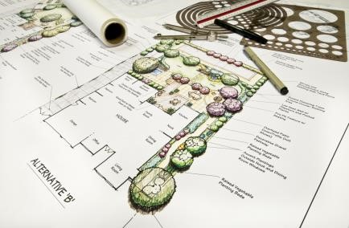
This can include identifying where you think new homes, shops leisure facilities or employment opportunities are to be built and what these buildings should look like within the local area.

A Neighbourhood Plan will give local people an increased ability to influence planning decisions in the local area, and as such will need to be representative of the people that work and live in the towns.

Peacehaven and Telscombe Town Council have already started an early part of this process by having the two towns along with East Saltdean, defined as a Neighbourhood Planning Area, but the Towns would like to enlist the assistance of local people within the local community to help ensure that the vision created is one that is representative of the local area

WHAT ARE THE BENEFITS OF PRODUCING A NEIGHBOURHOOD PLAN

It is not compulsory for Town Councils to prepare a Neighbourhood Plan, however there are a number of benefits which may make developing a Neighbourhood Plan desirable.

- Preparing a Neighbourhood Plan will help the community play a greater role in creating the future of your local area, it can help shape employment growth, housing, education and health provision.

- It will bring local residents, businesses, local groups, landowners and Councils together to share ideas and build a consensus about what needs to be done in the local community.

Shaping the future of our town is important for future generations

THE POWER OF NEIGHBOURHOOD
PLANNING
Neighbourhood planning is designed to provide a set of tools to help get the right types of development in the right place. It can help provide enhanced local services and capture what is distinctive about the neighbourhood

•One town’s neighbourhood plan protects eight areas of local green space and those spaces have been identified for environmental, recreational or historic significance where only in very special circumstances will development be allowed to happen
•Another helps support proposals to turn particular disused buildings into office space and helps to support the development of business within the boundary of the market town
•One small town used its neighbourhood plan to support the High Street, it developed a policy to support developments and changes of use in the town centre that promote the vitality and viability of the High Street. Developments outside the town centre that impinge on the health of the High Street, will not be permitted unless in special circumstances

Further info:

www.mycommunity.org.uk
www.locality.org.uk
www.rtpi.org.uk
www.pas.gov.uk

Neighbourhood Plans are a positive tool in shaping the local area. While they can decide where and what types of development can happen, they cannot be used to prevent development that has already been identified by the District or County Council in their plans. Neighbourhood Plans are a good tool for bringing people together and identifying what community projects people would like to see developed in their area and a good way for town councils to work with residents to identify areas of improvements .Once a neighbourhood plan is adopted then will be used by the planning authority in making planning decisions in the neighbourhood area.

Please come along to our Public meetings and

HAVE YOUR SAY

Your views matter. For any other information on the Neighbourhood Plan, please see

Peacehaven Town Council: 01273 585493
Telscombe Town Council: 01273 589777

Please return your completed questionnaire by 30th June 2018

