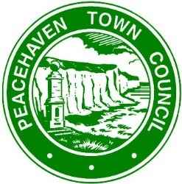

Peacehaven Town Council

Code of Conduct for Members

(Reviewed August 2018)

As a member or co-opted member of Peacehaven Town Council I have a responsibility to represent the community and work constructively with our staff and partner organisations to secure better social, economic and environmental outcomes for all.

In accordance with the Localism Act provisions, when acting in this capacity I am committed to behaving in a manner that is consistent with the following principles to achieve best value for our residents and maintain public confidence in this authority.

The Seven Principles of Public Life

Selflessness
1. Members should serve only the public interest and should never improperly confer an advantage or disadvantage on any person.

Integrity
2. Members should not place themselves in situations where integrity may be questioned, should not behave improperly and should on all occasions avoid the appearance of such behaviour. Members should show integrity by consistently treating other people with respect, regardless of their race, age, religion, gender, sexual orientation, disability or position, for example as an officer or employee of the authority.

Objectivity
3. Members should make decisions in accordance with the law and on merit, including when making appointments, awarding contracts, or recommending individuals for rewards or benefits.

Accountability
4. Members should be accountable to the public for their actions and the manner in which they carry out their responsibilities, and should co-operate fully and honestly with any scrutiny appropriate to their particular office.

Openness
5. Members should be as open as possible about their actions and those of their authority, and should be prepared to give reasons for those actions.

Honesty

6. Members should not place themselves in situations where their honesty may be questioned, should not behave dishonestly and should on all occasions avoid the appearance of such behaviour. Members should declare any private interests relating to their public duties and take steps to resolve any conflicts arising in a way that protects the public interest.

Leadership
7. Members should promote and support these principles by leadership, and by example, and should act in a way that secures or preserves public confidence.

