PEACEHAVEN TOWN COUNCIL STREET LIGHTS
1. Highway /our cottage (wooden post) x 1
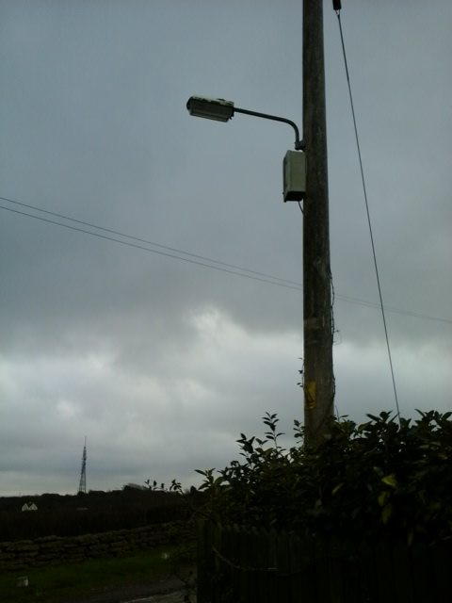
2. Blakeney ave (wooden post) x1
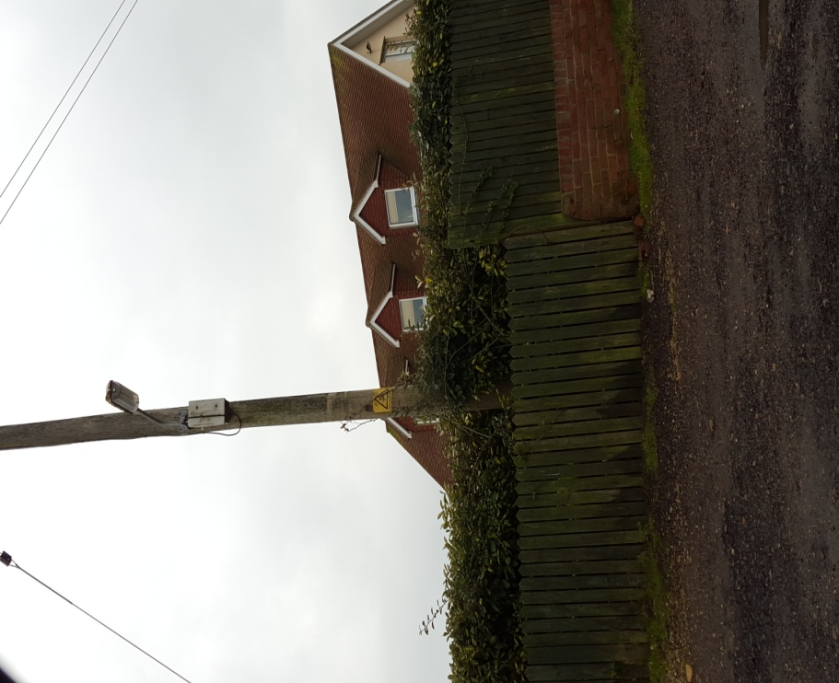

3. Roderick ave / gold land (wooden post) x 1
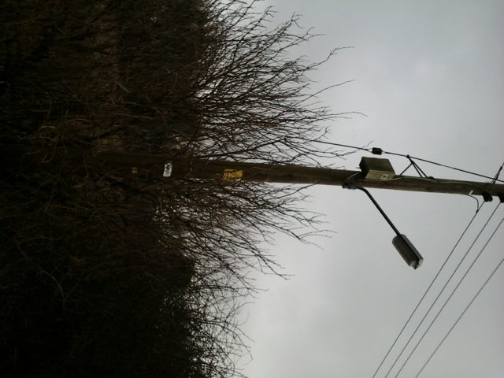

4. Roderick ave/ valley road (wooden post) x 1
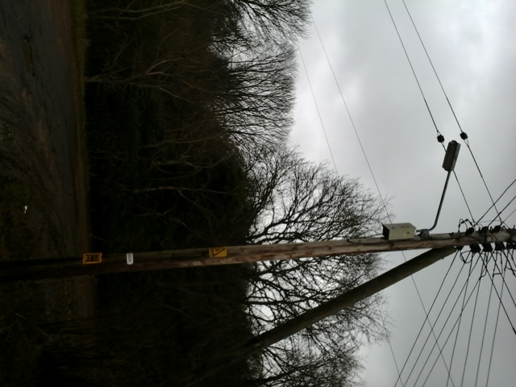

5. Roderick ave/ the lookout (wooden post) x1
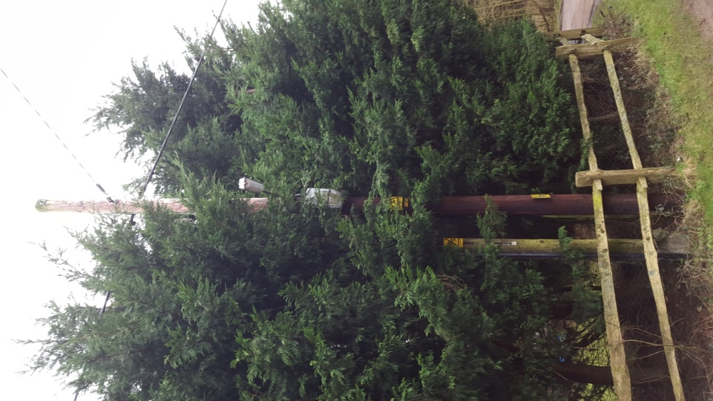

6. Firle road play areas (metal posts) x2
