PEACEHAVENS BENCHES

COAST ROAD NORTH
CAVEL AVE METAL IN NEED OF REPAIR OR REPLACEMENT
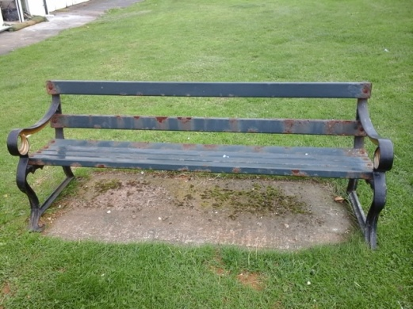
EDITH AVE WOOD IN GOOD CONDITION IN REMEMBERANCE OF GEORGE SMITH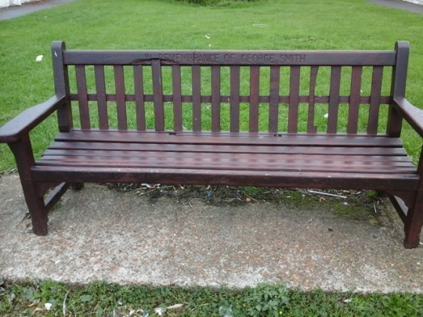
HORSHAM AVE WOOD AND METAL NEEDS ATTENTION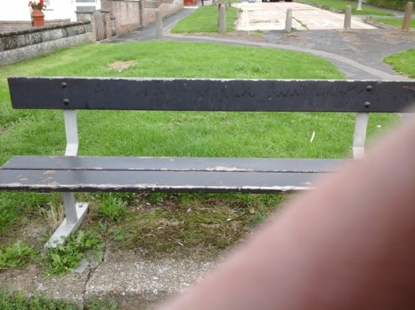
BRAMBER AVE WOOD AND METAL NEEDS ATTENTION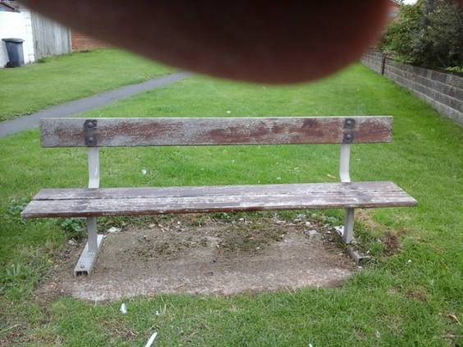
STEYNING AVE PLASTIC IN GOOD CONDITION JOHN KING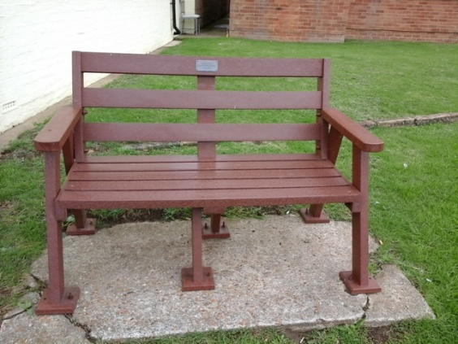
VICTORIA AVE WOOD AND METAL NEEDS ATTENTION (CAFÉ CHAINS PICNIC TABLE TO IT OVER NIGHT)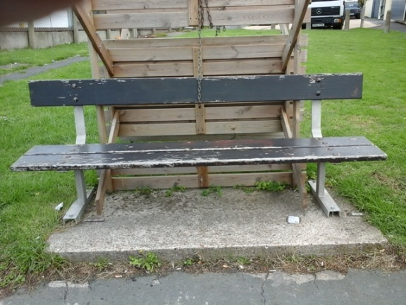
BOLNEY AVE PLASTIC GOOD CONDITION ANTHONY BRINDLEY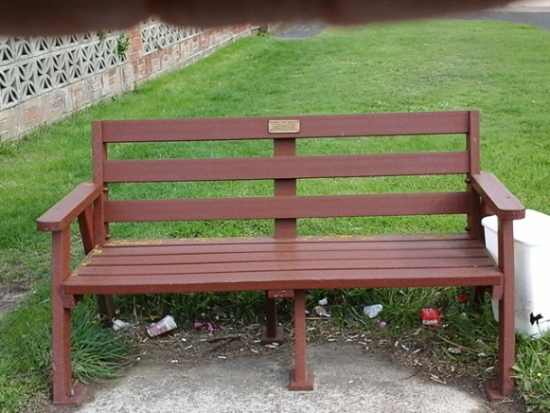
BOLNEY AVE WOOD NEEDS ATTENTION WILLIAM WOOLFORD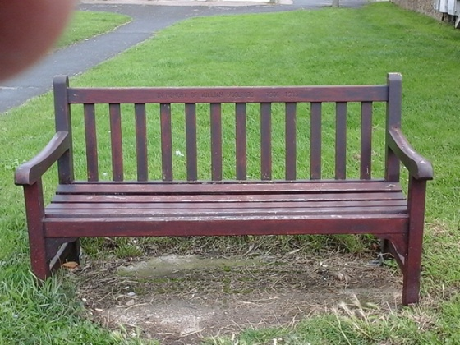
CAPEL AVE PLASTIC GOOD CONDITION
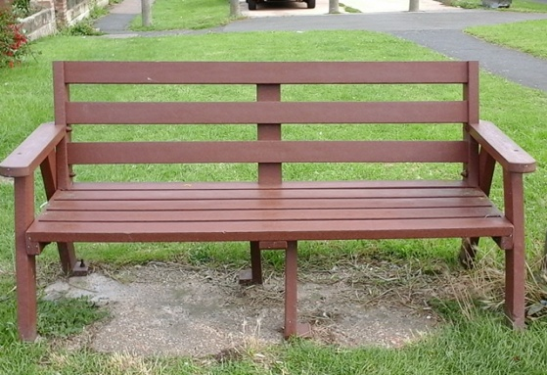
CAPEL AVE PLASTIC GOOD CONDITION GEOFF TURNHAM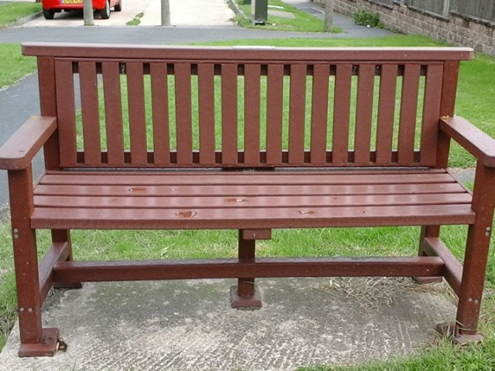
SLINDON AVE WOOD AND METAL NEEDS ATTENTION
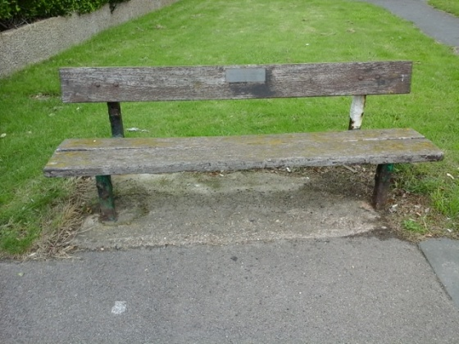

GLADYS AVE PLASTIC GOOD CONDITION
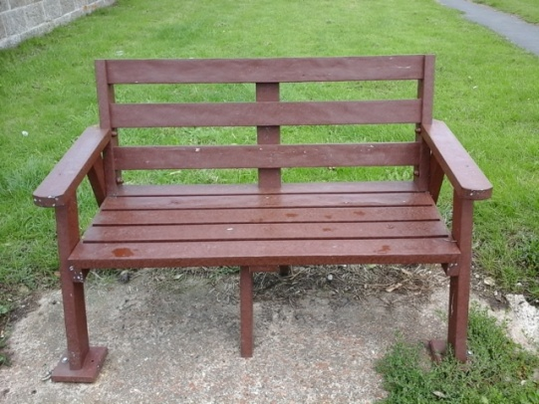
FRIARS AVE PLASTIC GOOD CONDITION
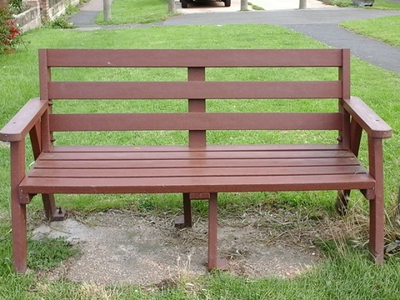
CORNWALL AVE WOOD AND MEATL NEEDS ATTENTION
ENA AMOS AND HILDA HELLIER

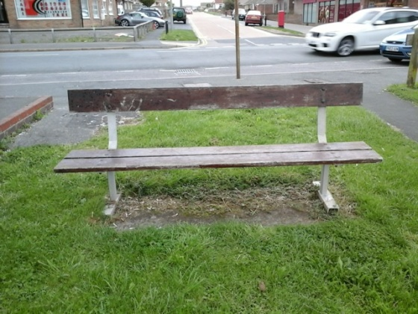

COAST ROAD SOUTH
SLINDON AVE WOOD NEEDS ATTENTION LESLIE JAMES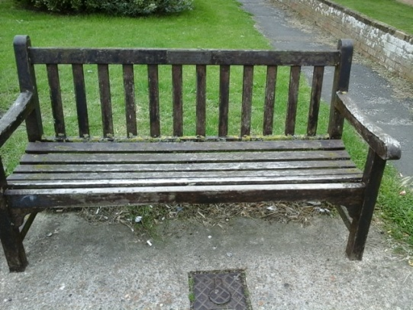
VICTORIA AVE WOOD AND METAL NMEEDS ATTENTION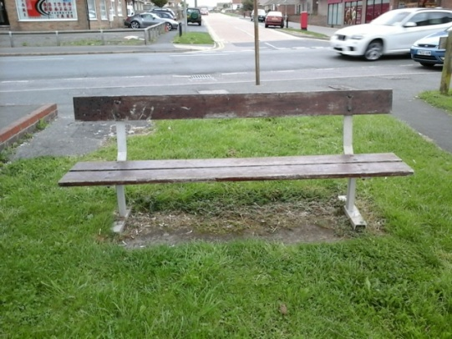
DOROTHY AVE WOOD AND METAL NEEDS ATTENTION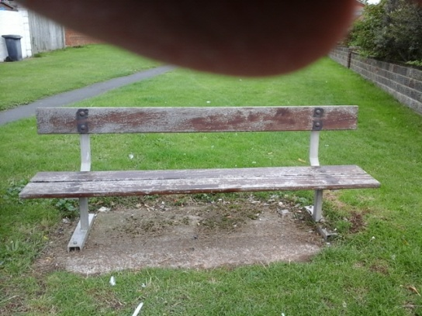

MERIDIAN MONUMENT
2 BENCHES WOOD NEED ATTENTION
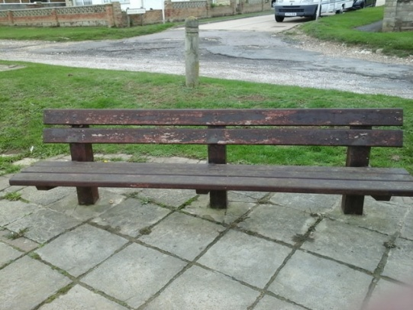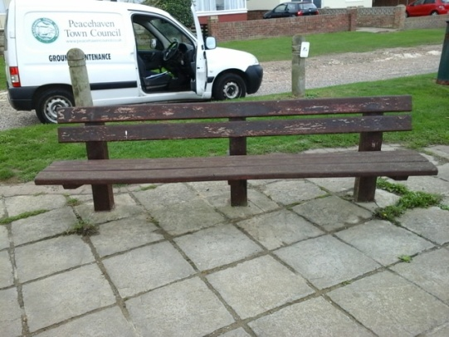
THE DELL (EAST)
PLASTIC GOOD CONDITION JOYCE WHITMILL
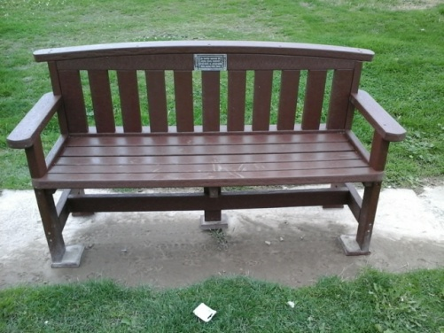
PLASTIC GOOD CONDITION DARREN ROACHFORD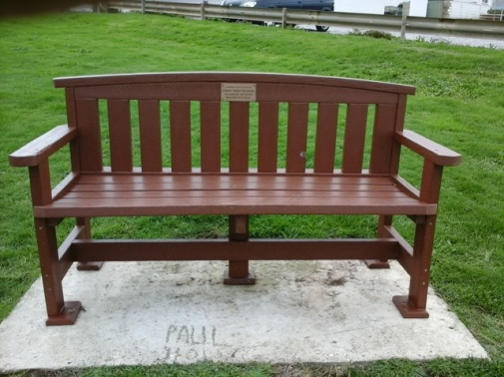
PLASTIC GOOD CONDITION JOHN ROBINSON
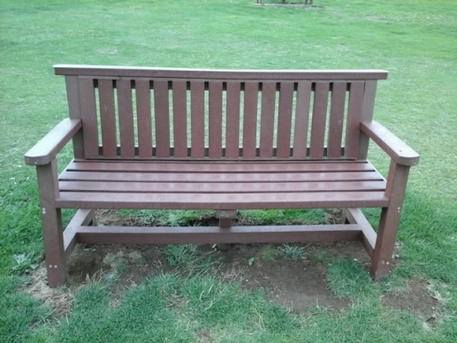
WOOD NEEDS ATTENTION HARVEY GOODWIN
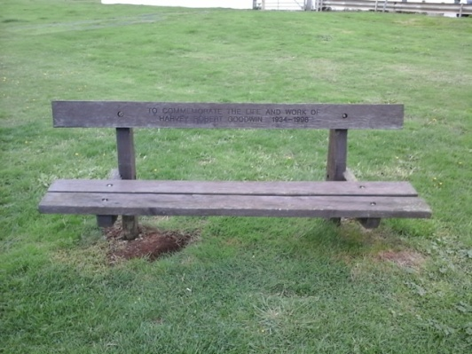
PICNIC TABLES X 2 PLASTIC GOOD CONDITION
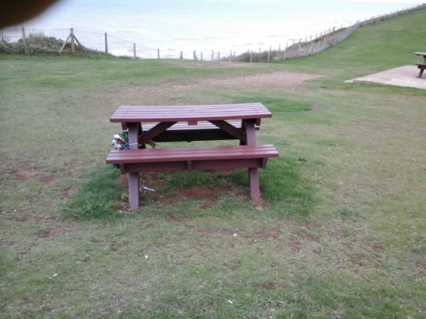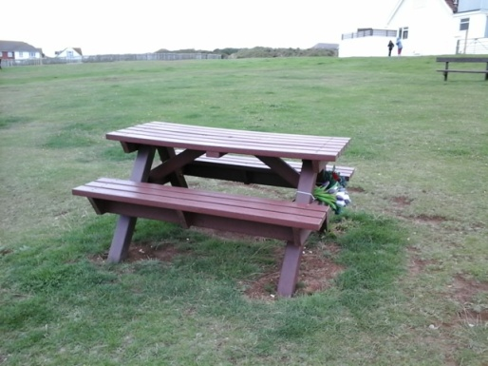
PLASTIC GOOD CONDITION CRAIG HYDER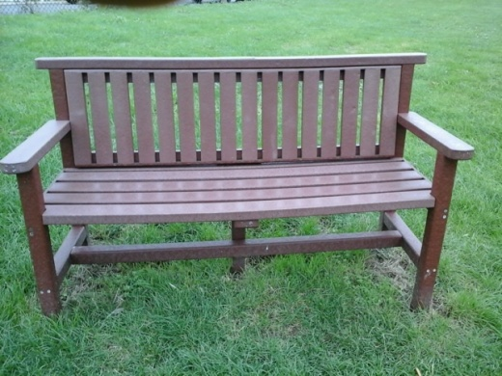
PLASTIC GOOD CONDITION DARREN EISNOR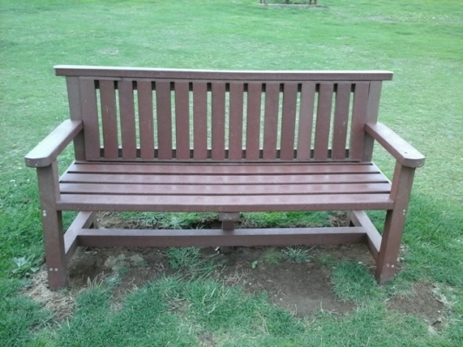

THE DELL (WEST)
WOOD GOOD CONDITION LEE BRADBURY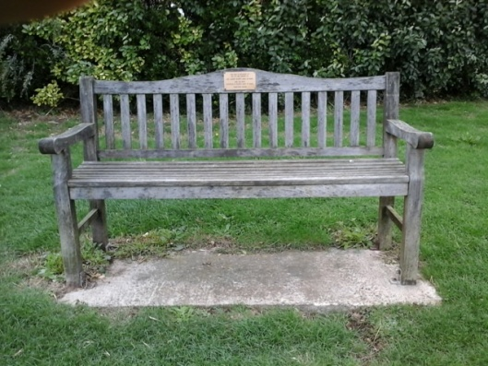
PLASTIC GOOD CONDITION ERIC NEALE
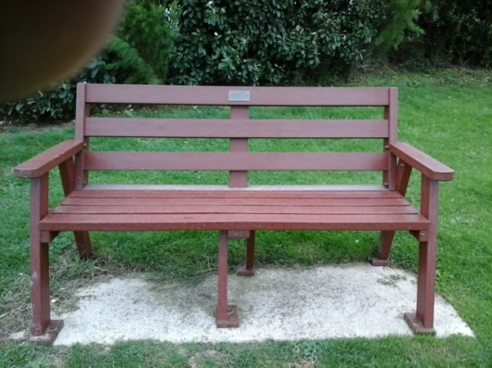
PLASTIC AND METAL NEEDS ATTENTION ROBIN ALLEN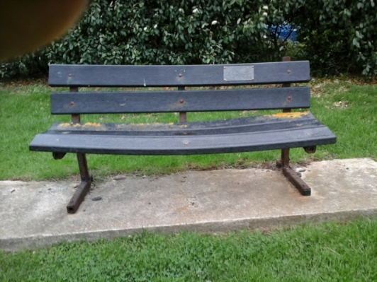
PLASTIC GOOD CONDITION SUE WILLIAMS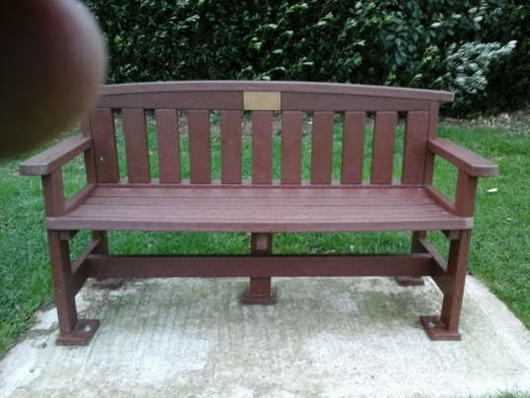

Epinay Park
Wood good condition repaint needed
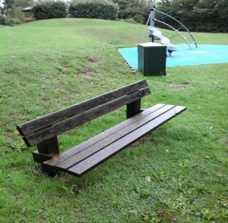
Wood good condition repaint
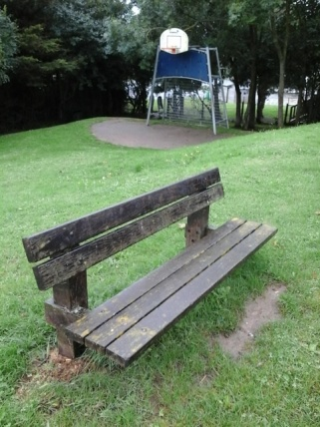
Wood good condition repaint
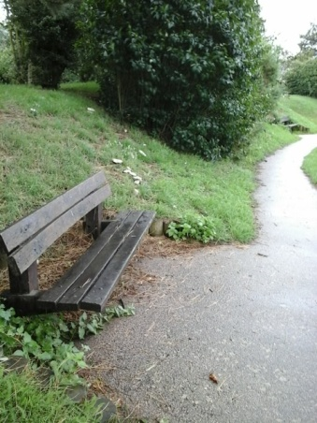

Wood good condition repaint
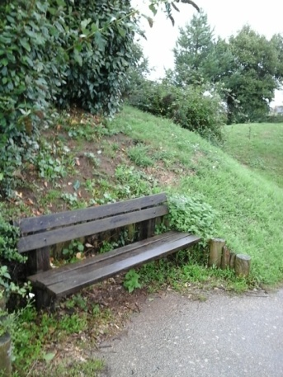
Wood good condition repaint
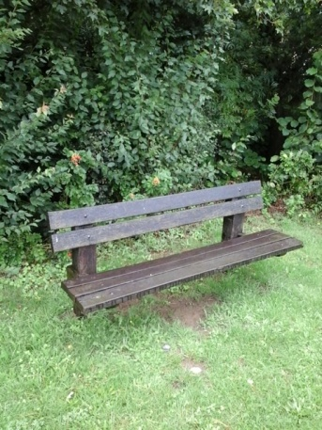
Wood slight damage repaint
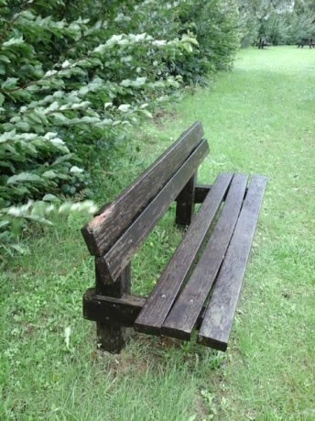

Howard Peace Park
Wood/ concrete very good condition Kenneth Sprague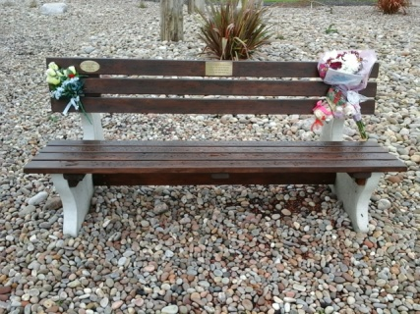
Wood/ concrete very good condition Leanne Peace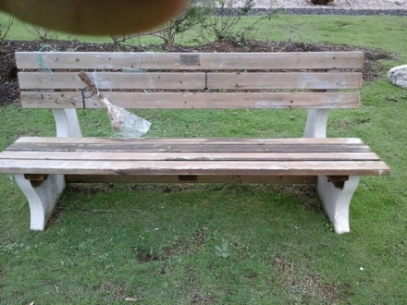
Wood good condition Joan Lesley Keys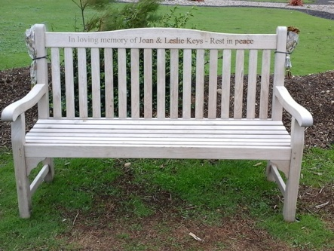
Plastic good condition Richard Bingham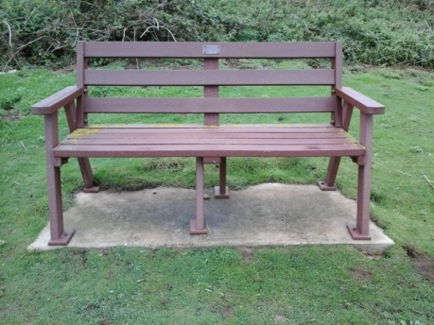
Wood very good condition Leslie Farncombe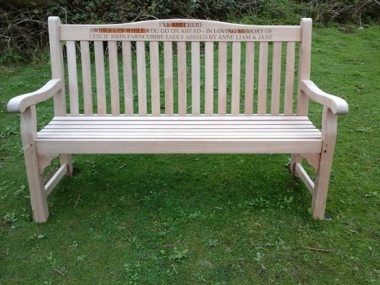
Wood/ concrete very good condition Jean Quantrill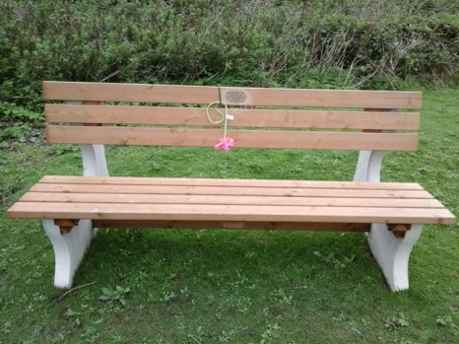
Plastic very good condition Noel Etches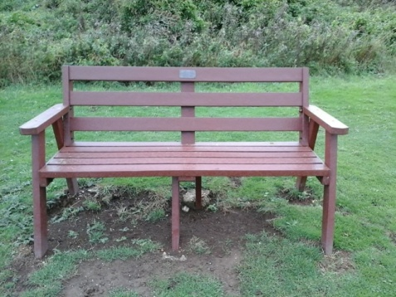
Plastic very good condition Vernon Robinson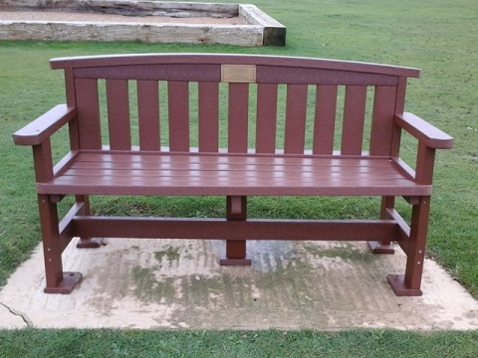

Plastic very good condition Don New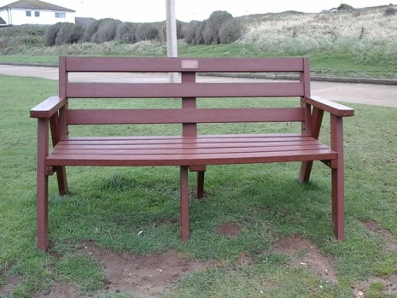
Plastic very good condition Jack/ Win Spanswick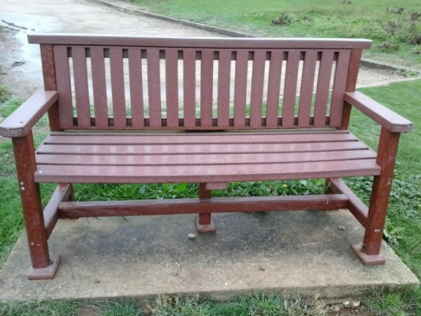
Firle Road play area
Wood/ metal good condition repaint
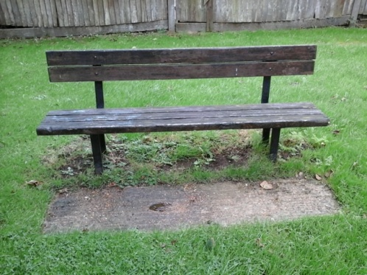
Metal very poor condition refurbishment needed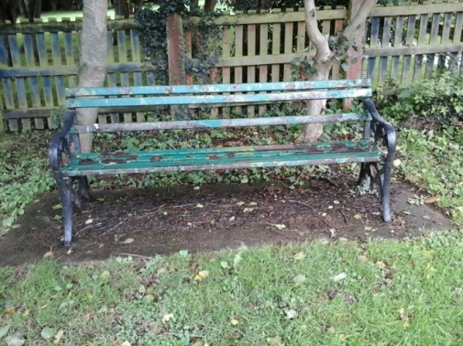

Wood/ metal ok condition re paint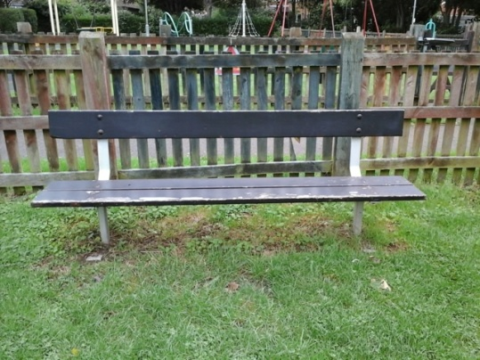
The Oval
South side wood ok condition repaint 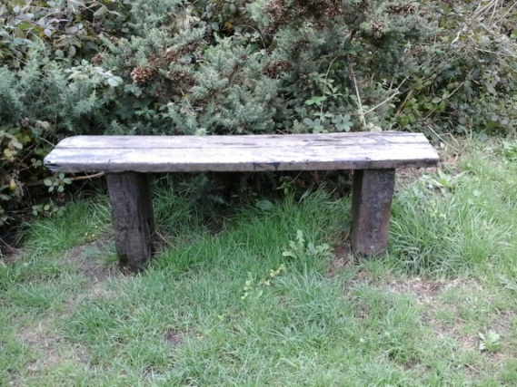
West side plastic picnic table very good condition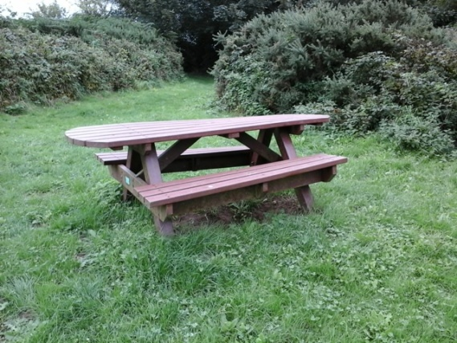
East side wood/ concrete Vandalised replacement needed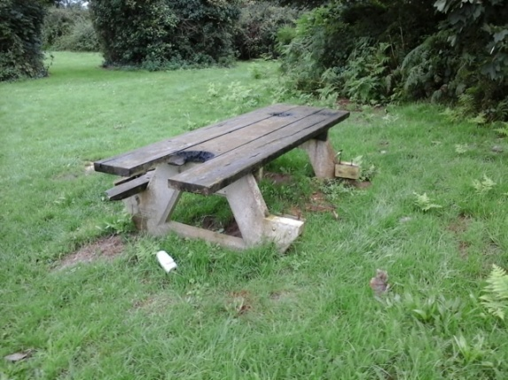
East side wood ok condition needs painting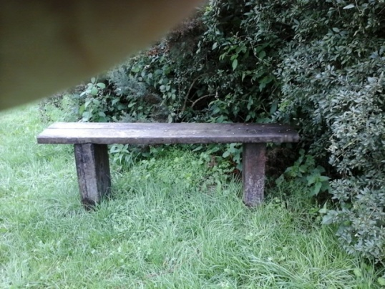
East side wood ok condition needs repainting