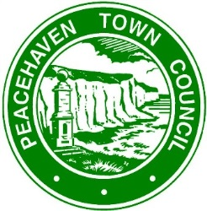

Sports Park & Centenary Park hire charges

• The charges as detailed below for the hire of Centenary Park

• Peacehaven charities will receive a 20% discount on the Charitable Rate

• Officers of the Council have flexibility with regards to the charitable rate

Description | Commercial Rates |  | Community Groups/  Charitable Events
 | Hourly Rate | Day Rate | Hourly Rate | Day Rate
Whole Park | £100 | £500 | £50 | £250
Skate Park | £50 | £250 | £10 | £50*
Pitches (inc. changing rooms) | Current rate £38.45 per hour |  | Current rate £38.45 per hour
Junior Pitches | Current rate £14.60 per hour |  | Current rate £14.60 per hour
MUGA Pitch | Current rate £28.50 per hour |  | Current rate £20.00 per hour
Eastern Area by Gateway Cafe | £50 | £250 | £10 | £50
Central Quadrant | £50 | £250 | £10 | £50
Car Park/Grass Matted Area | £50 | £250 | £10 | £50

*Use and hire will be free to recognised local skate groups

