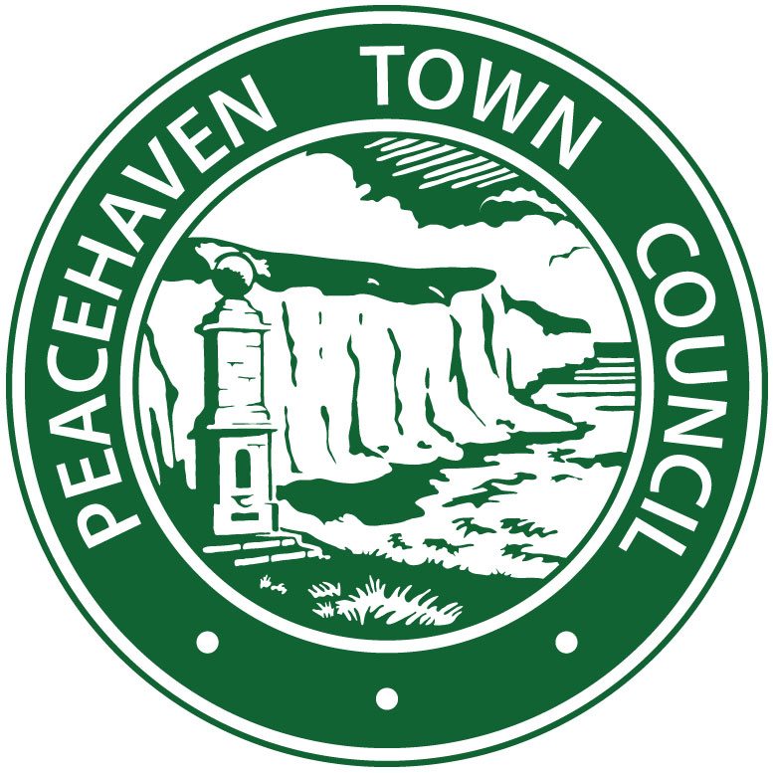

Peacehaven Town Council
Business Strategy
September 2016 – May 2019

We at the Town Council have a duty to achieve the best for the town. To do this we must consider our ways of working and ensure we have a long term strategy in place. The best way to do this is in the form of a Business Plan

Our Plan must include:

- The design & delivery of the services we provide
- The way in which we prioritise and allocate our resources
- The way that we use our resources to ensure value for money

This Plan is designed to form a long-term vision for the Council. Many of the issues identified may take a number of years to reach fruition. Many will require significant amounts of money. The Business Plan will be reviewed annually. The Plan will be published and we will seek feedback, report on our progress and remain flexible and open to change

The purpose of the Plan is to:

- Set out the objectives and plans for the Town Council, whilst recognising the needs and wishes of our residents and community groups. This will ensure that we have a common vision for Peacehaven;
- ​Help the Town Council fulfil its role within the community;
- Communicate the Town Council’s vision and plans to local people;
- ​Provide a basis for local people to become involved in shaping the future of their village.

Our Business Plan will explain to our community what we are doing and how we intend to meet their needs. It will directly communicate our vision and plans for Peacehaven.

Please tell us what you think about it. We welcome your comments and would particularly appreciate your views on its content and format.

If you require any further information that would help you understand what we are trying to achieve, please let us know. We can also provide additional information on the issues raised in the Plan.

The Town Council will follow the Council’s Best Practise protocols at all times. Our Mission Statement can be found on the Town Council notice board and the website www.peacehavencouncil.co.uk

Contact details:
Town Manager – Claire Lacey
Community House, Meridian Centre, Greenwich Way, Peacehaven BN10 8BB
Email: ​clairelacey@peacehavencouncil.co.uk
Website: http://www.peacehavencouncil.co.uk/
Facebook: https://www.facebook.com/Peacehaven-Town-Council-236861203082964/

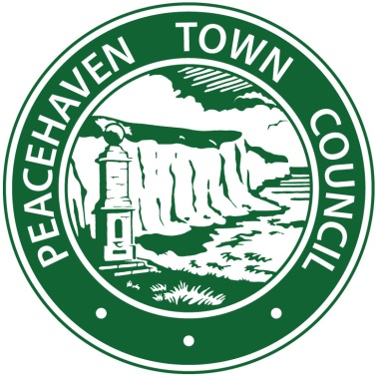

THE TOWN COUNCIL

- The Town Council has seventeen Members, your Councillors
- Each Councillor must be elected by the community every four years
- Councillors are unpaid
- They give their time freely to support and develop the community
- The Councillors are supported by a Town Manager / Clerk to the Council and Council Officers
- Council Officers ensure that all statutory and legal requirements are complied with
- Council Officers work to implement the wishes and decisions of the Council

The current councillors photographs and details can be found on the Town Council notice boards and on the website www.peacehavencouncil.co.uk

WHAT WE DO –
AN EFFECTIVE, TRANSPARENT AND OPEN COUNCIL

Our areas of responsibility include:

- The Management of the Town Council’s budget and the setting of the Towns Precept (money from Council Tax)
- Maintenance of Centenary Park (AKA Big Park) and Sports Facilities, including the Hub, MUGA, Café, Bowls Club, Football Club and play equipment
- Maintenance of car park at Sports Ground, Piddinghoe Avenue
- Ownership and maintenance of allotment sites
- Ownership and maintenance of Meridian Pillars/Obelisk on South Coast Road and on the Meridian Line
- Ownership and maintenance of The Dell Park and Play area, including the play equipment
- Ownership and maintenance of Firle Road Park and Play area, including the play equipment
- Ownership and maintenance of Epinay Park and Play area, including the play equipment
- Ownership and maintenance of The Oval Park and conservation area
- Ownership and maintenance of Howards Park (AKA Peace Park) including the petanque area
- Ownership and maintenance of 11 bus shelters around the town on SCR and N and W Peacehaven
- Ownership and maintenance of 6 street lights / attached to ESCC lampposts
- Ownership and maintenance of 21 refuse bins / dual waste
- Ownership and maintenance of 42 benches around the town / sponsored by local residents
- Ownership and maintenance of 12 Wooden planters / sponsored by residents and businesses
- Management of grass cutting of verges around the town (map available on website)
- Consider and comment on planning applications within the Town / call in at Lewes District Planning where required
- Provide feedback on consultations received to Lewes District Council and East Sussex County Council

We also represent the wishes of Peacehaven Town Council to East Sussex County Council. These representations are on issues such as highways and footpath repairs. The Council Officers work with Sussex Police in areas concerned with crime and anti-social behaviour

The Council works with other governmental bodies and non-governmental organisations to represent the community of Peacehaven.

The Town Council is represented on a number of external organisations, including those listed on the website http://www.peacehavencouncil.co.uk/council-services/councillors/

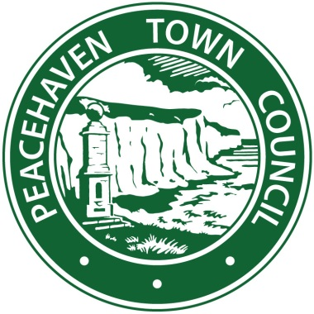

The Town Council holds meetings every 2 months. Members of the public are always welcome to attend – link to website with dates http://www.peacehavencouncil.co.uk/council-services/coffee-mornings-2013/

Full Town Council take place every two months.
Standing Committees are in place to make decisions on specific issues. These include Policy and Finance Committee, Leisure and Amenities Committee and Planning and Highways Committee

In addition, the planning committee may also meet weekly to discuss any planning applications which require calling in prior to the District Planning authority meeting / if there are any planning applications for consideration

When, and if, necessary extraordinary meetings may also be called.

The Annual Town Meeting is held between 1 March and 1 June (inclusive) each year. This meeting is an open to everyone in our community. Residents may ask questions of their councillors.

All public meetings are advertised publically. Three clear days notice will given to notify our community of these meetings. These are displayed on the website, on Facebook, Twitter, Enews and on public notice boards

COMMUNICATION STRATEGY

The work of the Town Council is vital to the operation of our town and our community. Community involvement and interaction is essential and the Council will work to keep our residents informed of Council decisions, plans and actions.

Clear Communication to residents by the Council is essential in order that residents understand what the Council is doing to benefit our community. We will listen to the views of local people and make representations on their behalf whenever possible. We will promote our work via the ENewsletter, Facebook, banner boards, in notice boards and on our website.

It is essential that the Council Communicates with our Community on a regular basis. We ensure that the Council’s work and deliberations are conveyed to residents. Communication must be in a format that is easily understood. This will encourage feedback and allow residents to influence decision making and ensure our decisions reflect the wishes of our community

The Town Council’s website has been running for many years and hosts policy documents, financial statements and minutes to previous meetings, as well as contact details and pecuniary interests of the Councillors. The Facebook page was set up in 2014 and this provides quick reaction to problems in the town. With many ‘friends’, it allows us to get information around the town quickly.

The Town Council will:

- Find ways to encourage residents to attend Council meetings ensuring that residents see how the Council operates and understand our decision making process
- Continue to review its communications via Social Media (Facebook page and website) and investigate ways to improve and enhance them
- Continue to publish monthly ENewsletters. Whilst ensuring that our email list is kept up to date and relevant
- Issue press releases about important matters as and when required
- Continue to review its policies and procedures to ensure that it is run in a legal and professional manner

HOW WE WORK – COMMITTEES AND TASK GROUPS

As well as holding monthly meetings the Town Council sets up of a number of focussed committees and working / task groups, responsible for key areas of the town. These groups and their responsibilities are detailed below:

Planning Committee

The Planning Committee meet at a quorate meeting to discuss planning applications submitted in the town. It provides a response to the District Council, as a statutory consultee. In addition planning applications are considered during main Council meeting.

Planning applications, considered by the Council, range from simple decisions, such as the installation of a service box in a layby, to more complex and controversial applications such as applications for large housing developments. The committee also oversees the maintenance and replacement of bus shelters, street light repairs and replacements and public benches on the highway, reporting any significant to ESCC SLR Committee (external body with LDC and ESCC representatives)

Leisure and Amenities Committee

The Leisure and Amenities Committee makes decisions in relation all public space in the town, with the exception of designated areas (Memorial Park, Cliff top / The Promenade). The committee oversees grass mowing on verges, the maintenance and replacement of public benches, advertising boards, litter and dog bins and looks after any council property affecting our local environment.

We have a Grounds team that look after all aspects of our playing fields. Their work includes regular inspections of play equipment in our six play areas (Firle Road, Epinay Park, The Dell, Big Park Play areas and the Skatepark Basin). They take care of any maintenance issues relating to Parks and Community Sports areas.

Our allotment sites are monitored by the Information Office with quarterly inspection reports made available to the Leisure and Amenities Committee. Our work includes the maintenance of grass cutting, trees and allocating allotments on a rotational basis to Peacehaven residents only.

Community Engagement / Events / Mayor Support

The group acts as a voice and facilitator in relation to issues and projects involving third parties that do not fall into one of the other Council groups. This would include the painting of white lines on our roads, dealing with Southern Rail, pilot projects on our Highways, organising events and supporting our Mayor. This includes Volunteers and Councillors

Grants and Employment Sub Committees

This group is made up of the Chairman from the other task groups and committees. It meets once or twice a year, as necessary, to discuss employment issues and more importantly the budget and Precept for the future year.

Policy and Finance Committee

The Council must set its own policies whilst meeting statutory guideline changes for local councils. Council policies are updated to reflect statutory changes. This includes reviewing Standing Orders, Financial Regulations and other documents on an annual basis, or as required.

Neighbourhood Plan Steering Committee

This group are creating a Neighbourhood Plan for our town. The group is led by residents; it is supported by the Town Council. The group has financial links to external organisations such as ACRE, this is in line with the Lewes District Core Strategy. The Neighbourhood Plan should be published during 2018. The plan is being created in partnership with Telscombe Town Council
Peacehaven Task Force

Volunteers, including Councillors and Residents have been working on amenities around the town. The Task Force works within charitable guidelines and pays only for materials for works such as painting fences, litter picking and small fundraising activities. The group is intending to raise a legal constitution and become a charity in their own right. This will allow then to bid for grants and donations to support Town Enhancements. Risk assessments are carried out by Council Officers for each project assisted by the Chair of the relevant Committee.

Heritage Working Group

Volunteers and Councillors are working together to devise a heritage trail for Peacehaven. A working group has been created to examine projected costs to create a trail for the recreational areas in our town. This group will feed its findings and recommendations to Leisure and Amenities Committee.

Big Park Project

The Big Park, Centenary Park, was opened by the Duke of Gloucester in 2015. The Big Park was created as a result of a £1.4 million grant to the town. This grant was given to enhance an area of land, owned by Lewes District Council, which is now leased to Peacehaven Town. The total cost of the Park was in excess of £2.2 million. The Park has provided amenities for residents of all ages ensuring inclusion for all. The maintenance is now a responsibility for the Town as the Park was handed over to us in May 2016. The Park is still undergoing improvements and new build projects. These include a cycle hire facility, more parking spaces and other facilities including a wheelchair swing. Three Councillors and One Council Officer sit on this Committee, which could now become Trustee run.

OUR THREE YEAR PLAN

These focussed working groups / task groups meet on a regular basis. They discuss their areas of responsibility and agree actions to be taken. Some actions are reactionary, such as fixing a bench. Other actions may be strategic relating to projects to bring future improvement to the town.

- Reactionary actions are resolved through our committee council meetings.
- Strategic objectives require more planning and discussion.
- Our business plan sets out our strategic objectives during the next three years.

STRATEGIC OBJECTIVES

Our strategic objectives are defined as:

• To help create a socially inclusive, caring and economically viable community. A community which embraces all its residents irrespective, of age, culture, income, race or religion and which seeks to develop their wellbeing, knowledge, understanding and mutual co-operation

• To provide high quality, efficient, cost effective and sustainable services

• To promote and encourage the provision of a range of leisure, social, recreational and community educational facilities in the Town

• To provide a channel for the views and expressions of the local community and to be responsive to its needs and aspirations

• To develop partnership and agency working with public and private sectors in terms of resources and finance for the benefit of the community

• To develop the role of the Council under the concept of the Quality Councils scheme and to maintain Quality status of the Council in accordance with the requirements of the scheme

• To liaise with and support local community associations.

• To develop and work in partnerships with residents, local businesses and local organisations

• To develop Council meetings as a method of public engagement

• To improve the Town Councils role within the local community

• To be an advocate for local residents and business to address local issues

To meet these objectives, we need to identify specific projects and areas for improvement. Some of our specific objectives for 2016-2019 are:

• Gain entry to and Build on Quality Council Status to improve partnership working with Principal Local Authorities

• Seek to engage with the business community

• To produce a Neighbourhood Plan

• To provide more allotments for Peacehaven residents

• To attempt to alleviate parking and traffic issues along the South Coast Road

• To produce a ‘tourism/visitor guide’ booklet, including the Meridian Line

• To enhance and educate the residents on the Towns history, archaeological huts in the Big Park, Meridian walks, heritage boards etc

To compile and maintain an emergency plan for the parish in the format required by the County Council Emergency Planning Officer, including an Emergency Flood Plan

• To encourage and help develop more facilities for all ages

To strengthen Town Council/Police relationships at the operational level

To support the existing Community Speed Watch group / working with SLR

To ensure that Councillors are trained to erect the Town Council’s Vehicle Activate Sign (VAS) in accordance with the County’s VAS policy / working with ESCC Highways

To ensure that Councillors attend training courses to keep them up to date

To establish and maintain a working relationship between Town Council and Neighbourhood Watch

To implement a Good Practise Guide and consider planning applications in the Town, to comment accordingly, in line with general planning policy

To report any planning or environmental infringements to the appropriate authority

