Peacehaven Town Council
Meridian Centre, Meridian Way
Peacehaven, East Sussex, BN10 8BB
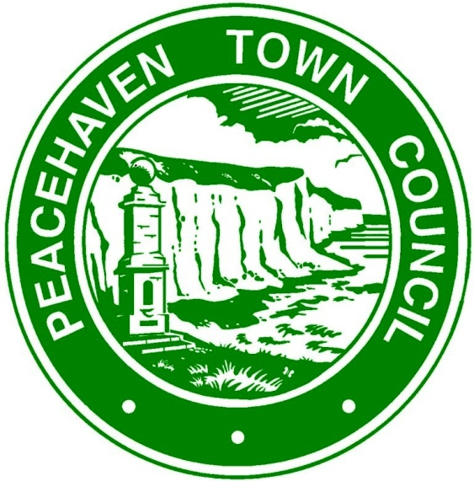

GRANT APPLICATION FORM
The Town Council invites grant applications, which primarily support local organisations and which directly benefit residents of the Town as much as possible.
1. NAME OF ORGANISATION:
If application granted, cheque to be made payable to: (if different from above)

2. ADDRESS:
CONTACT NAME:
EMAIL:
TEL. NO:

3. VAT REGISTERED: YES /NO

5. DATE ORGANISATION ESTABLISHED:

4. REGISTERED CHARITY: YES / NO
Charity Registration No: …………………..

6.DESCRIPTION OF ORGANISATION:

7. MEMBERSHIP
Total Membership:
Membership Resident in Peacehaven Town:

8. REASON FOR GRANT REQUEST:
(eg. details of project together with numbers of those involved in the project, members and/or others, equipment, event)

9. WHO HAVE YOU APPLIED TO FOR OTHER GRANTS:
(e.g. organisations applied to and amount requested)

10. AMOUNT OF GRANT REQUESTED:
(Maximum grant application considered is £750)

£……………….................

11.DETAILS OF PREVIOUS GRANT APPLICATIONS TO THE TOWN MAYOR:
(Please enter year and if successful amount of grant received)

12. FINANCIAL INFORMATION:
(Please complete details below and either attach last year’s audited accounts or audited summary of accounts for your organisation).
 | NOW | ONE YEAR AGO
Current Assets
Current Cash Balance
Annual Income
Annual Expenditure

Signature ……………………………............. Date …………….........
(person authorised to apply for and on behalf of the organisation named in Item 1)
Notes:
The Town Council considers grant applications from local organisations each year and successful applications do not imply an automatic future success – each is considered on its merits and against availability of funds.
Depending on circumstances, organisations that are successful in their grant application may be invited to attend a presentation ceremony for publicity purposes.

